Go to Zendesk and Click on the box ACU/OR Department.

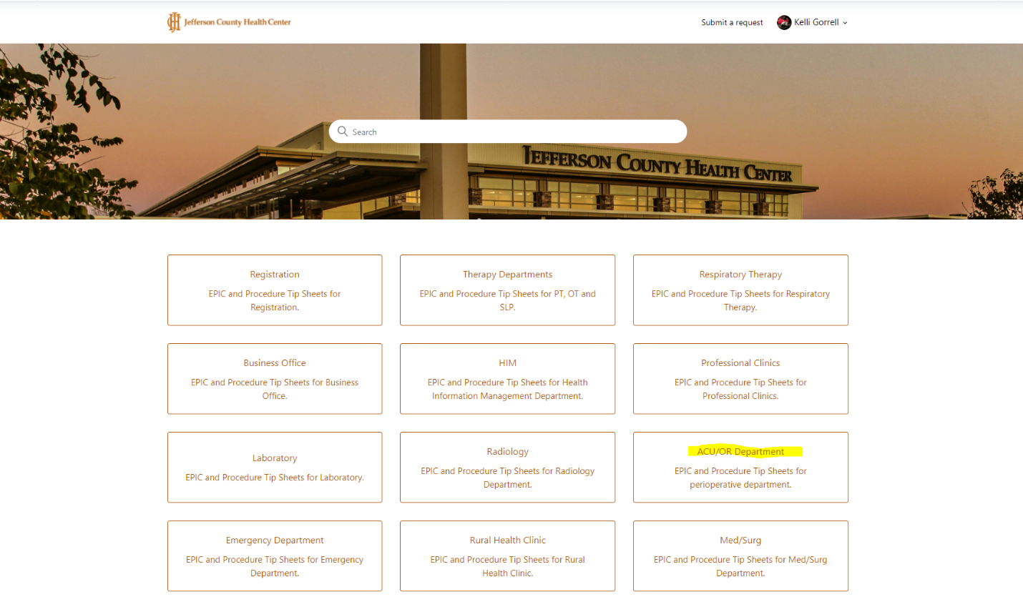

The page below will open. There are Sections for Blood, General Info, Anesthesia and Downtime Procedures. Click on the topic you need a tip sheet for.

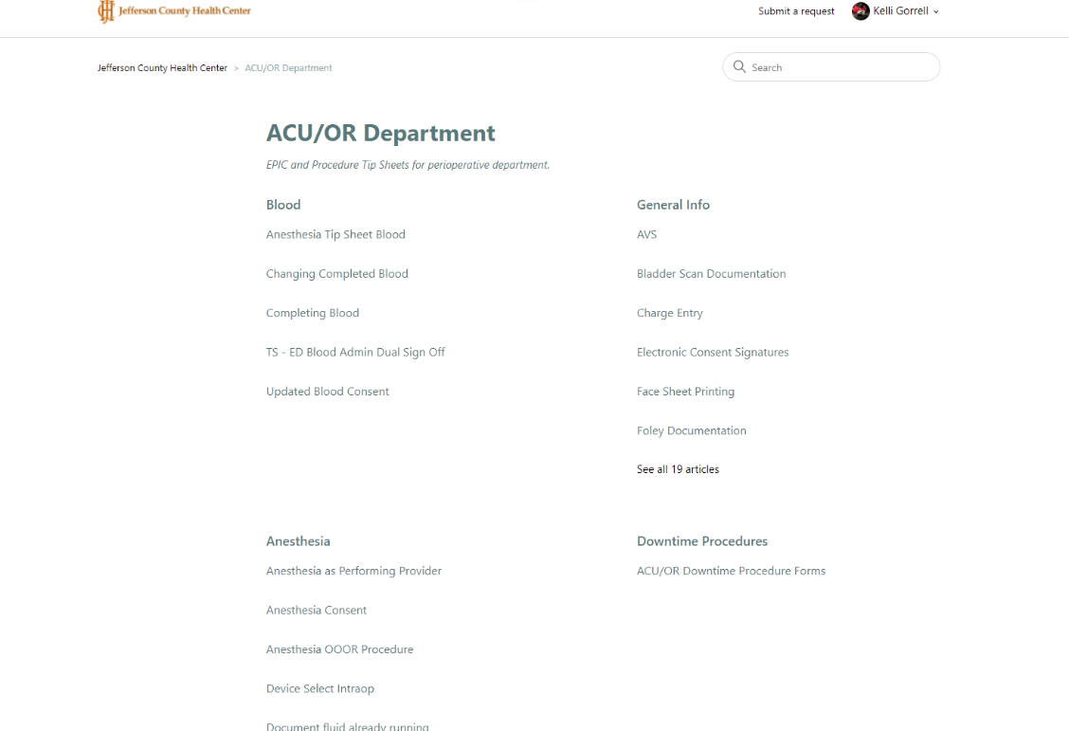

When it opens some of the topics have several articles in a list on the left side. Highlight the one you need and then click on the link next to the paperclip icon towards the middle of the screen (as highlighted below). This will open the PDF or Word Document containing the tip sheet.

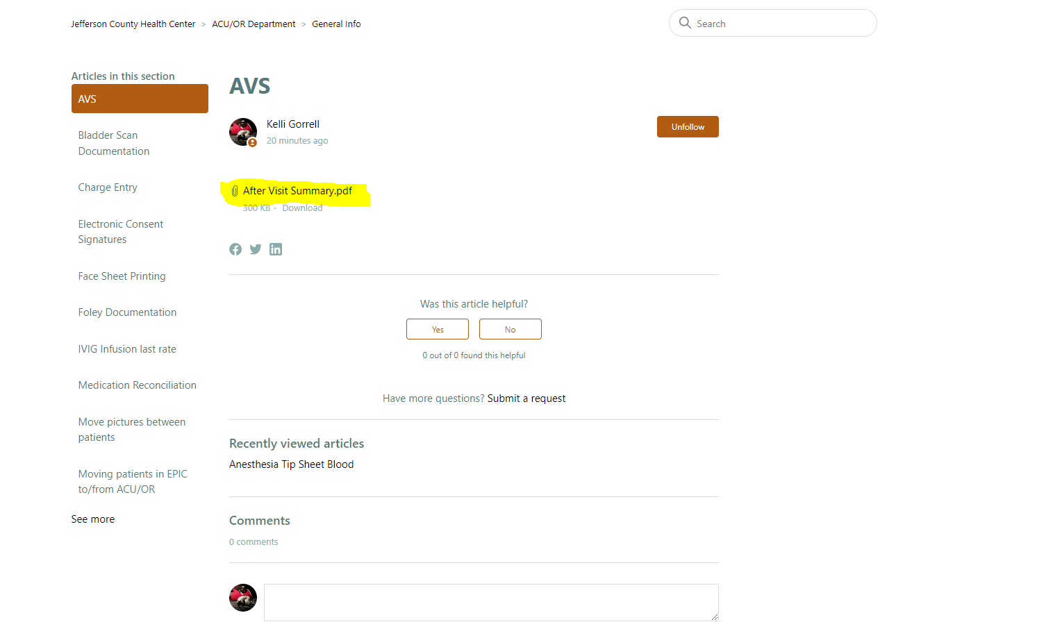
If you are logged in to Zendesk you can also rate whether the article was helpful or not and can click on submit a request if you would like to make a ticket in Zendesk asking for more information or with suggestions to improving the tip sheet.

