How to print a JCHC face sheet.
- From patient station find patient.

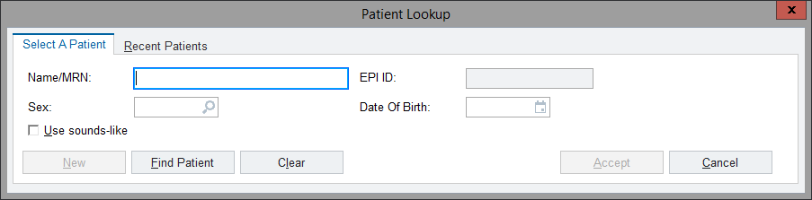

- Highlight the admission/appointment/office visit you are needing a face sheet from and click Print forms.

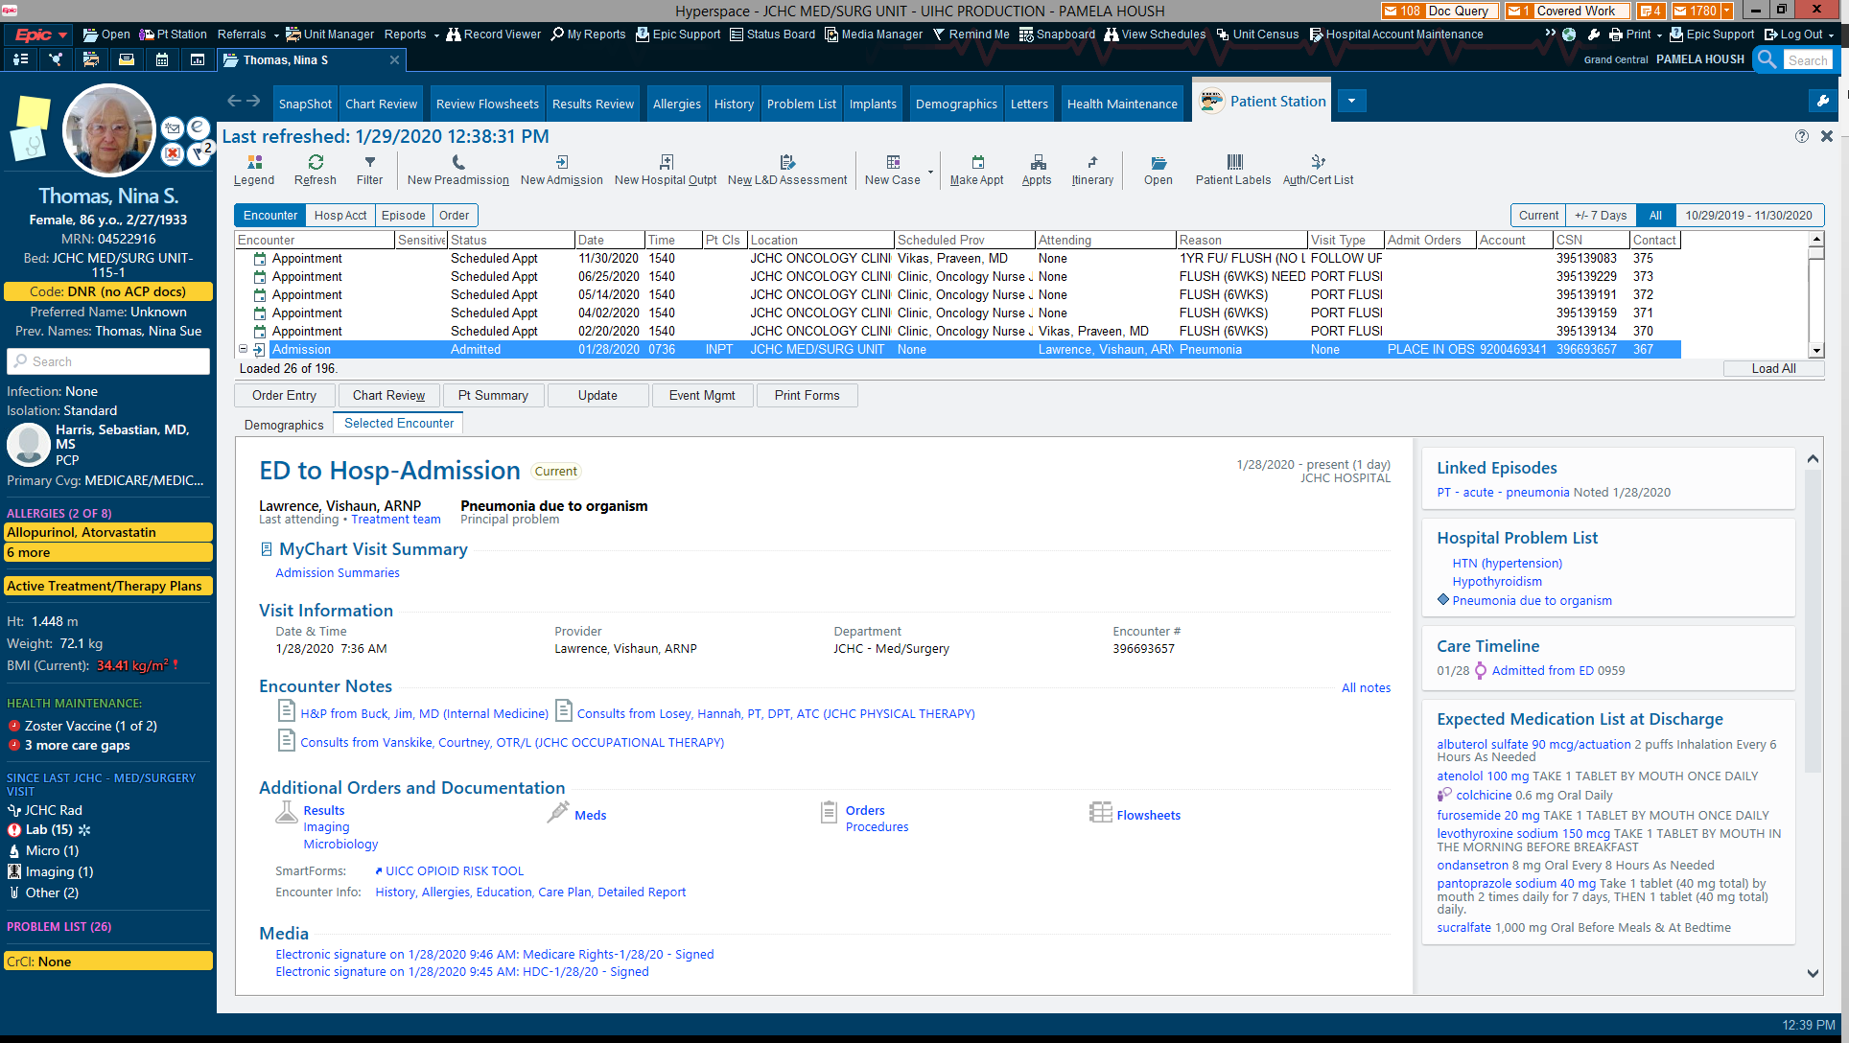

- Click the magnifying glass in form section.
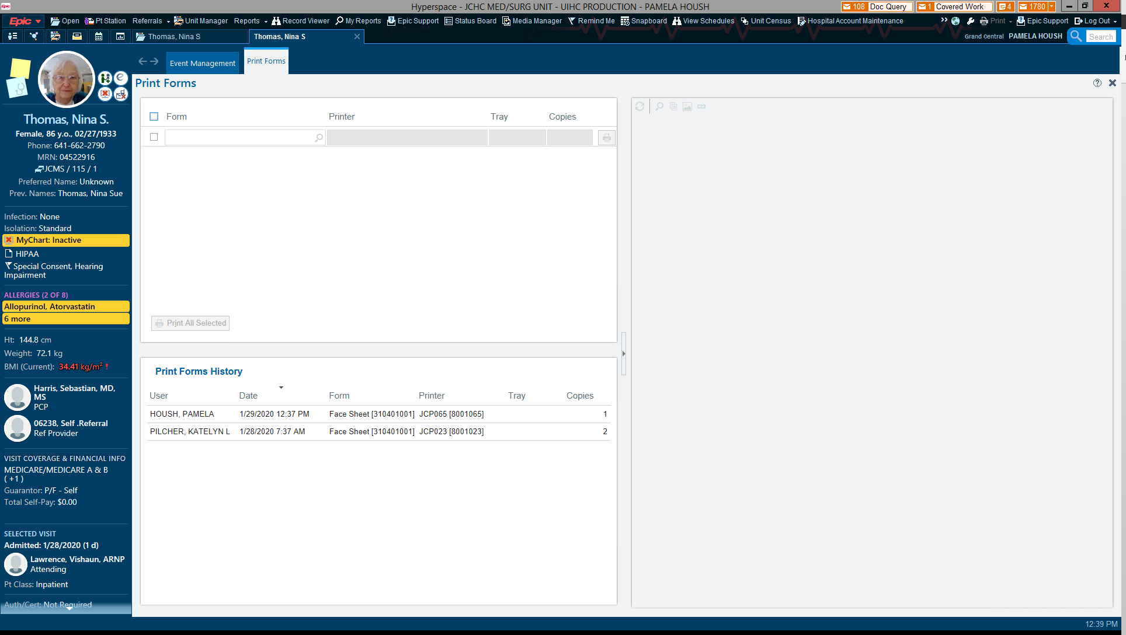

- Click the top selection “Face Sheet”(Note if you type face sheet in you get three selections the first one or the one typed like this “Face Sheet” is the one with our LOGO on it).
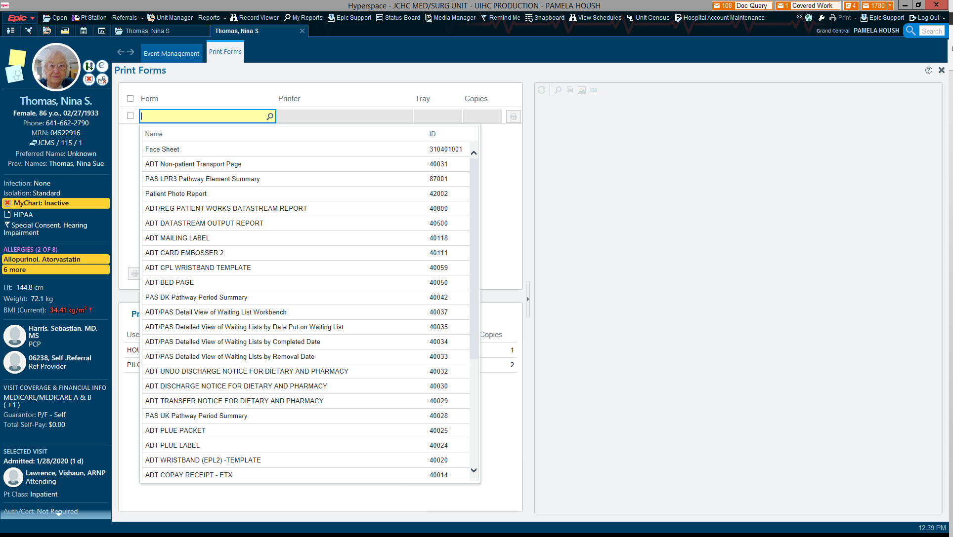

- Click print all selected.

