Ordering Therapy Plans
- Go to Encounter tab, under Epic Button (left hand corner). Enter a patient’s name and click the accept tab. ALWAYS VERIFY the correct patient.
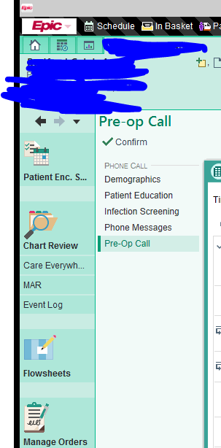
- Select New
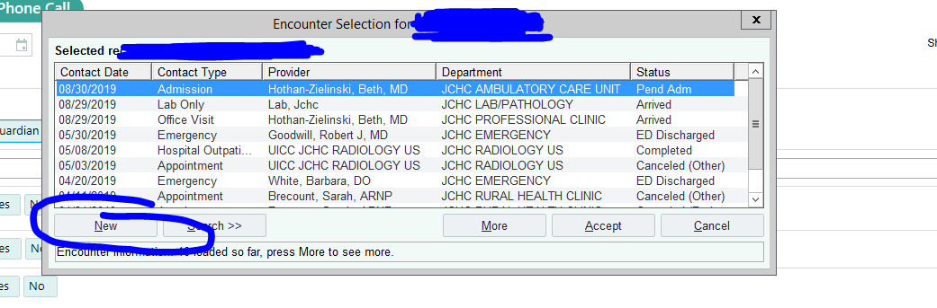
- Enter type as Orders/Note, Provider *whoever the prover is.. if external enter external provider.
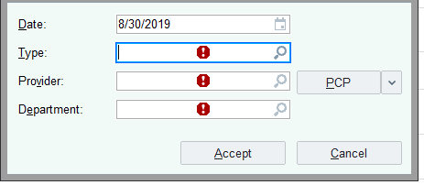
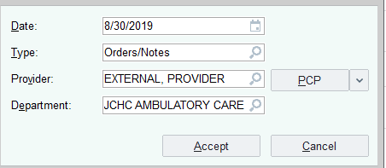 Should look like this!
- Find the therapy plan tab once the chart is open.
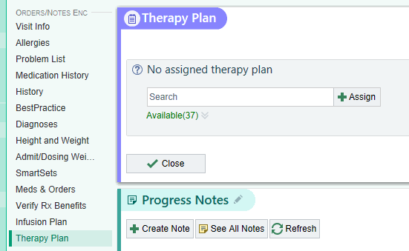
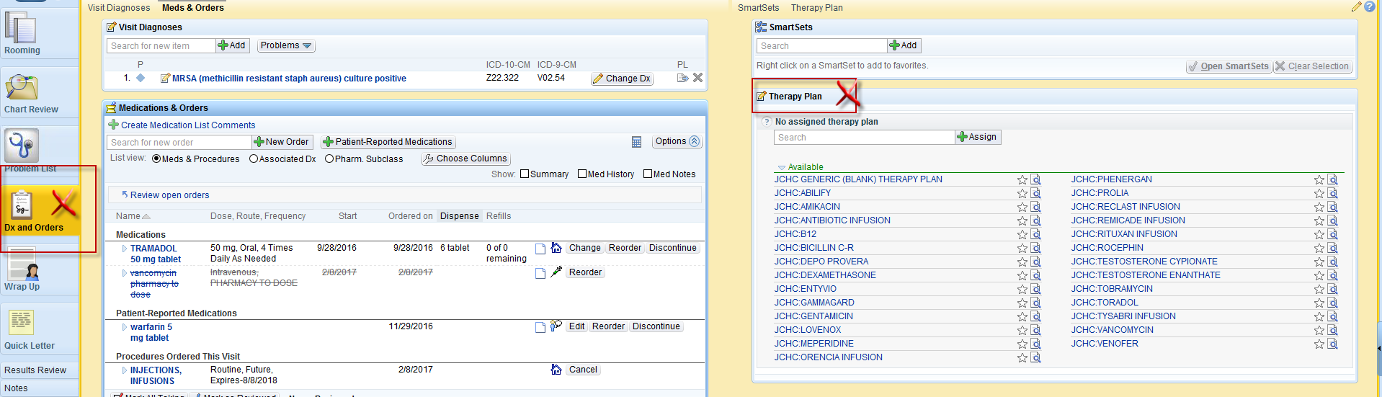
- If you find the plan you are looking for you can click to choose it. Otherwise you must create a generic plan and add the orders you want.
  - Once your therapy has been chosen, fill out start date, treatment dept (ACU). If the reason for the infusion is on the problem list you can chose it now. Otherwise you will associate a diagnosis prior to signing. You can also preview the plan prior to ordering.
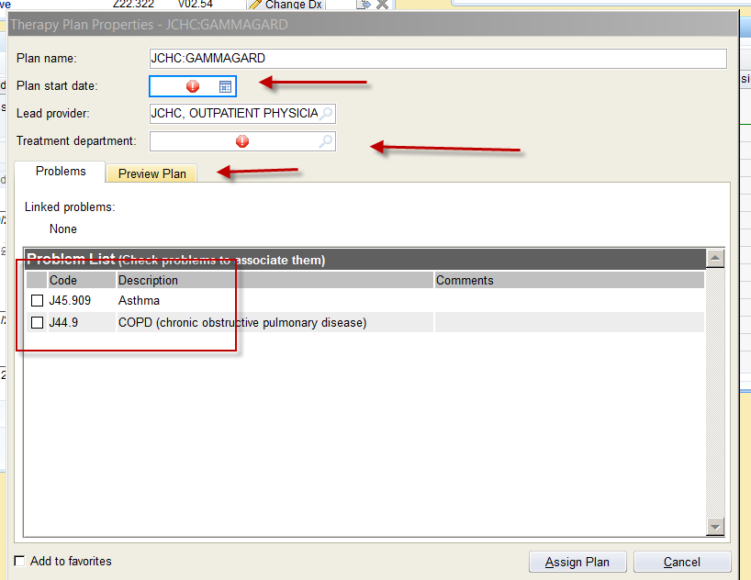
- Fill in medication order details, including frequency and how many doses or number of treaments patient is to receive.
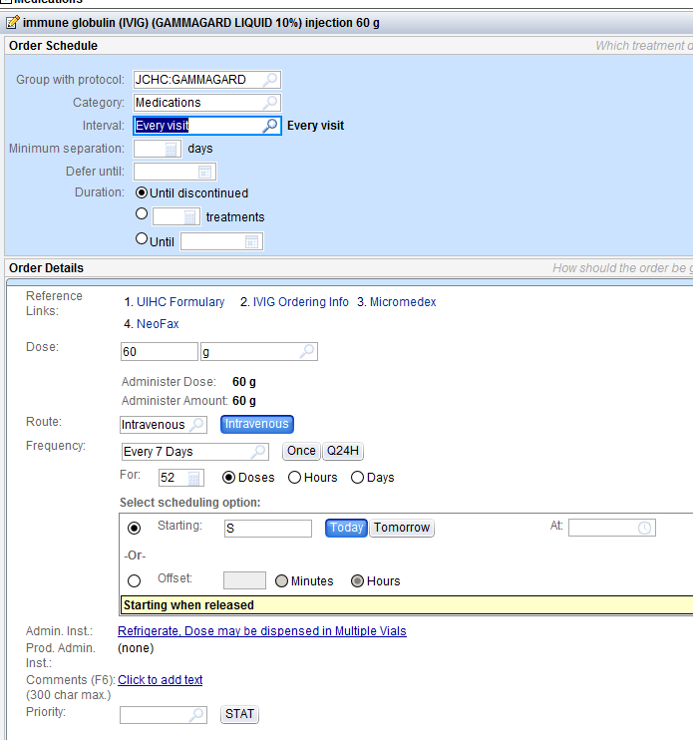

- You can check the box at the top to choose all orders, or individually check boxes you would like to order. Orders not signed will not have a green check. Click the X to the side of the order to remove it.
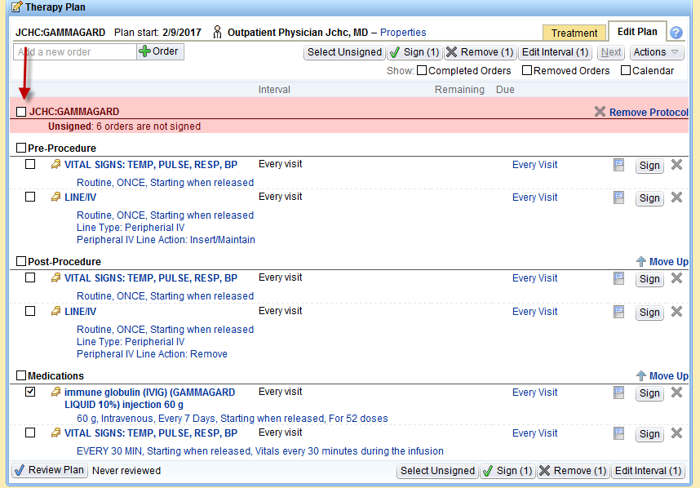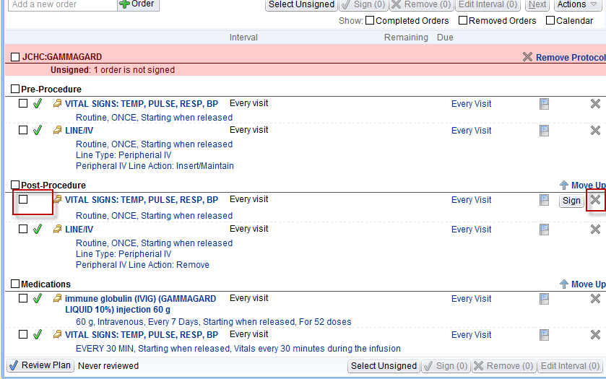

- For large therapy plans, providers can check what orders he/she would like to order, sign the orders.
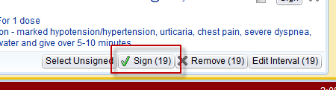

Provider is notified there are orders not signed.
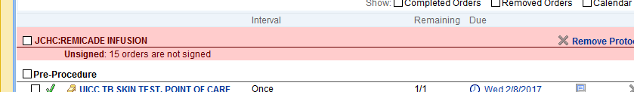
Click “select Unsigned”
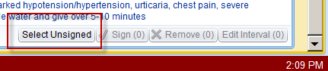’
Click “X Remove (#)”. All unsigned, undesired orders will be removed from therapy plan.
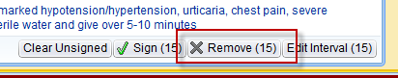

- After you have clicked “remove” a green banner appears at the top noting your plan is good to go!

- A patient may have more than one therapy plan at a time. You can merge two plans by clicking the “Actions” drop down. An example would be if a paient receives IVIG and also gets the depo injection.
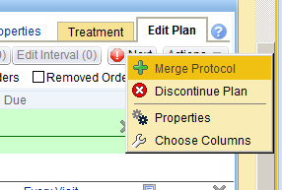
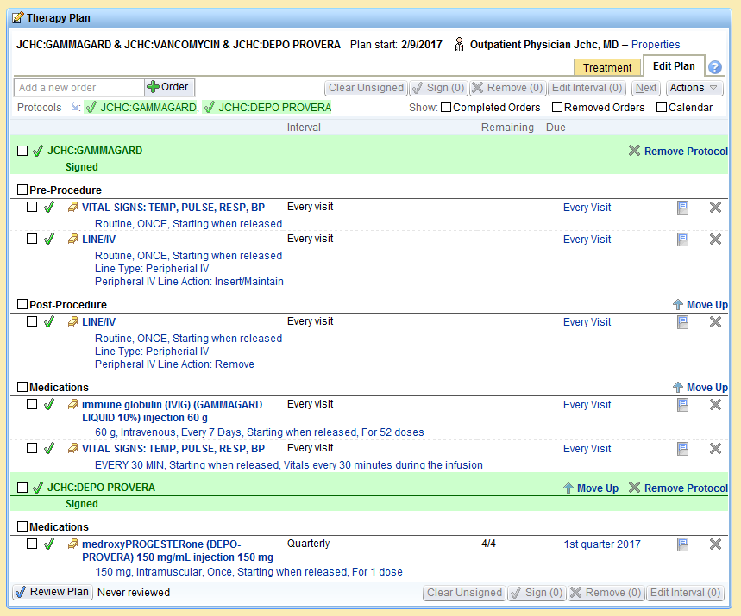

- Remember to include Injections, Infusions order (after visit order). This prompts ACU to schedule patient. Unfortunately, there is not a way to include this in the Therapy Plan so it needs to be done separately.
