Making an appointment for Patients
- Find patient under patient station tab.
- Find the Make appointment activity once they are pulled up.
- In the screen that comes up next you will free text appt notes ( Vanc Infusion, Orencia, Prolia etc.)
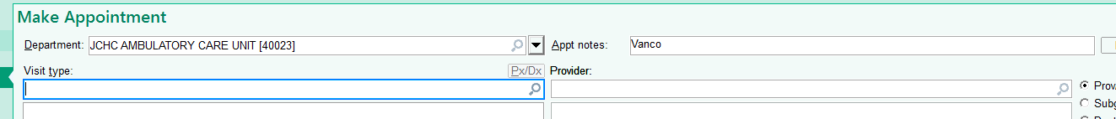
- Under Visit Type pick the correct choice, then click accept.
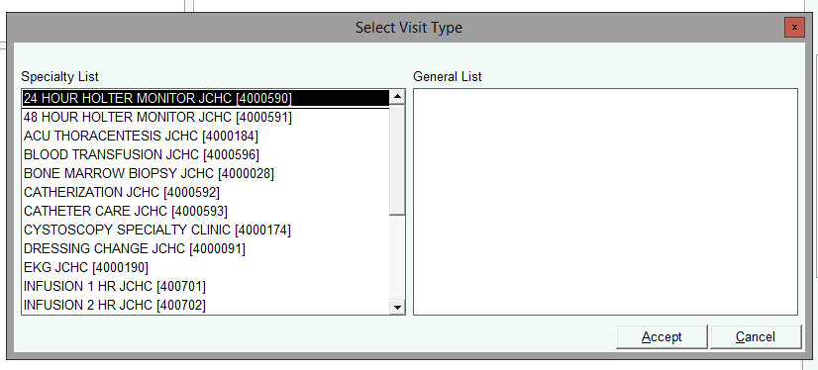
- Under Provider you can choose once room or multiple rooms.
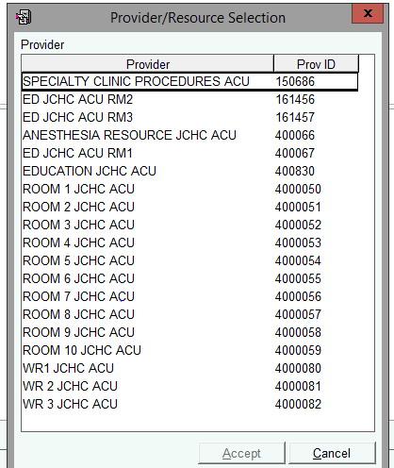

The screen should now look like this:
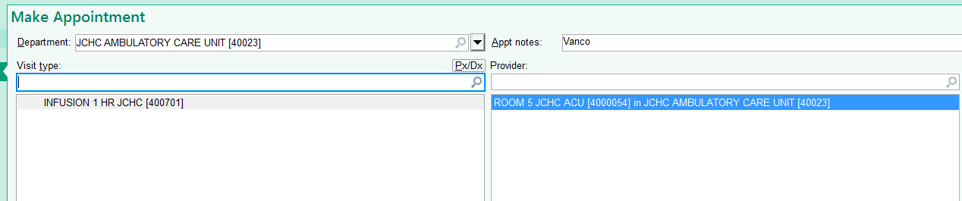
- Click accept
- First pick the date you want to appointment in the lower left hand corner (Calendar); Double click on the time you want to schedule the patient. Then double click that time. (if you have multiple rooms selected to schedule from it will show you more than one at a time for ease of scheduling.
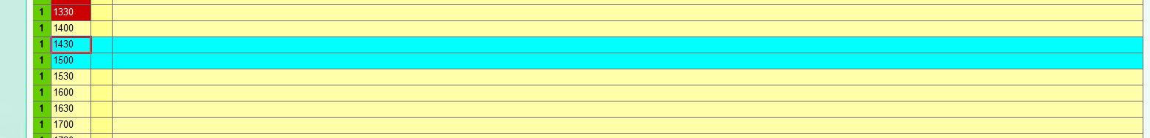
Click schedule. After you click schedule you will get a pop up. (usually you will select Outpatient)
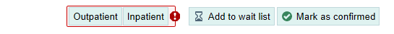
- Click accept, and then click finish. You will get a pop up to fill out a few more questions. Fill them out until you just have yellow warnings that can be bypassed.
- One you get an appointment scheduled you can see it on the patient’s appointment desk.
Recurring Appointments – Weekly/Monthly Appointments
- When recurring an appointment you will do the same steps as above (1 – 5) You will then click the recur button.
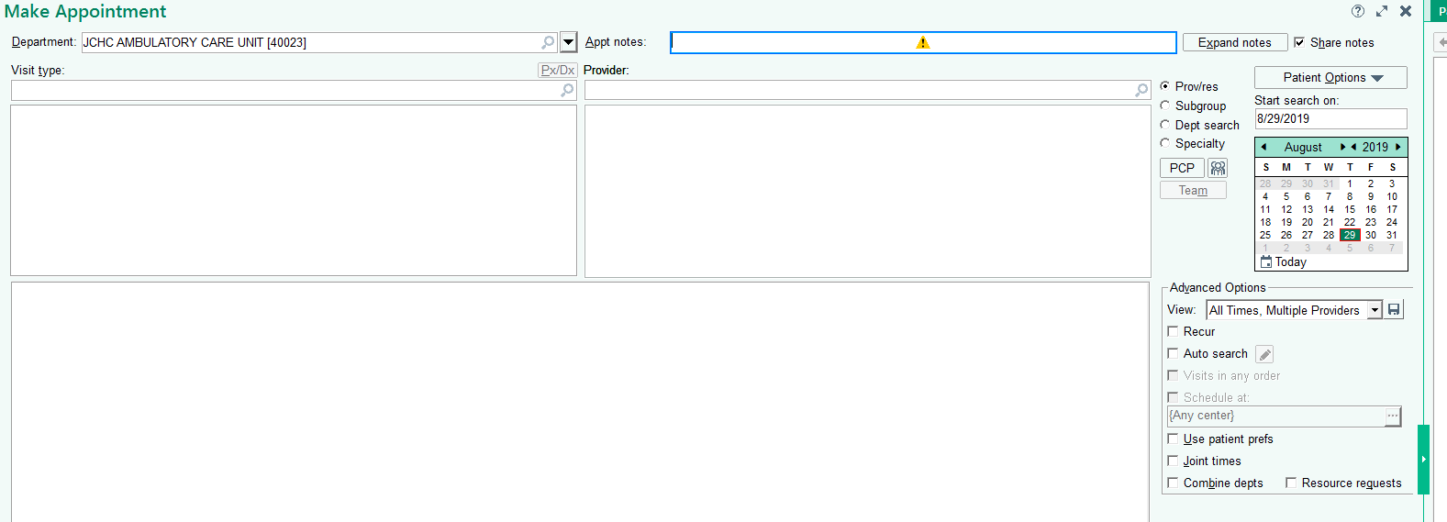
- Once you click search on this you will be prompted for a little more information.
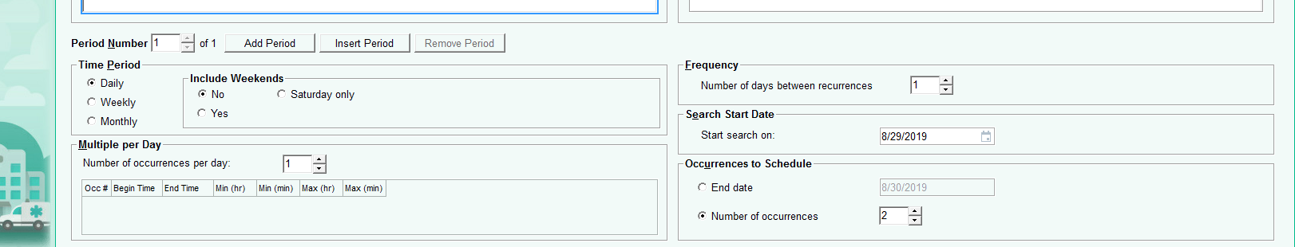
- After you are finished with this information you should see a screen that looks like below. Make sure the current date is at the top and all the other appt are scheduled appropriately. Then click schedule.
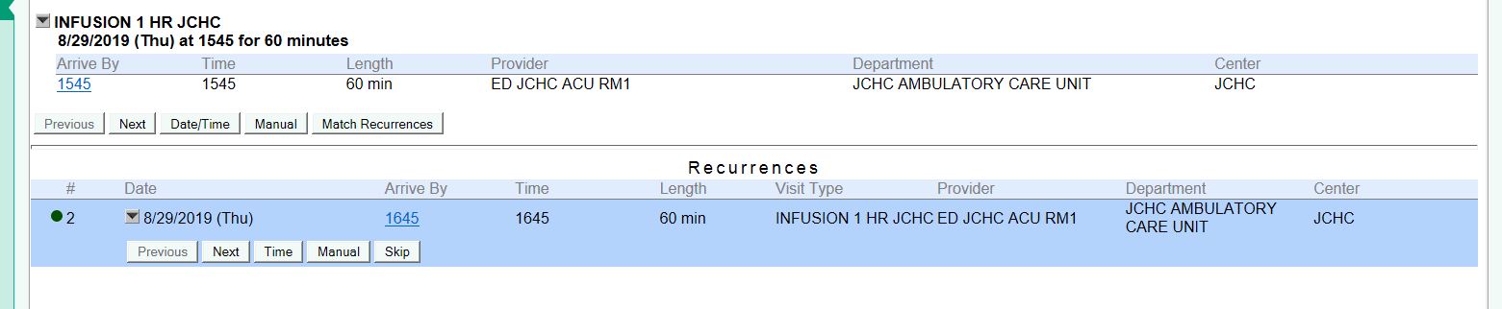
  - If a time needs adjusted you need to click the manual button.
  - You will see warnings if another patient is already scheduled in the room you are trying to schedule for (these will have to be manually scheduled.
  - Follow the prompts.
  - Once you are finished scheduling the screen should show all of the appointments on the appointment desk.
  - You will get the same warnings as before… Bypass them by answering the ones you have to and skipping yellows.

