Recurring an appointment from the snap board.
- If a patient has an infusion and is needing another one next week, or whenever you can right click their name off of the snap board.
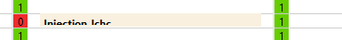
- After you right click, select Copy forward (left click)
- Place the date you want to schedule and click search.
- Check to make sure you are on the correct date. Double click the desired time. Then click schedule. 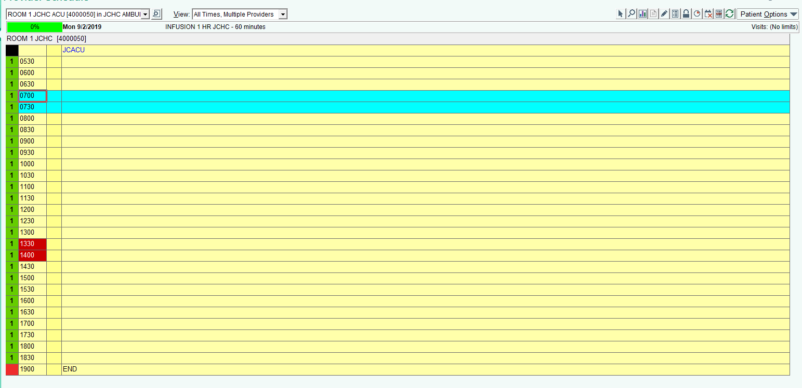
  - The only issue with scheduling this way is the system will only show you the room the appointment was made in previously. If it is full you will have to go back and start from the beginning.
- Click schedule. After you click schedule you will get a pop up. (usually you will select Outpatient)
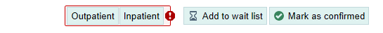
- Click accept, and then click finish. You will get a pop up to fill out a few more questions. Fill them out until you just have yellow warnings that can be bypassed.
- One you get an appointment scheduled you can see it on the patient’s appointment desk.

