Discharge Instructions for Surgeons
1. Discharge Navigator
2. Click Instructions 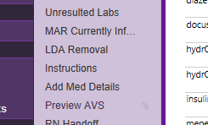
3. Type Nicholson (for Dr. Nicholson), Zielinksi (Dr. Zielinksi), Ivins (Dr. Ivins) in the box.
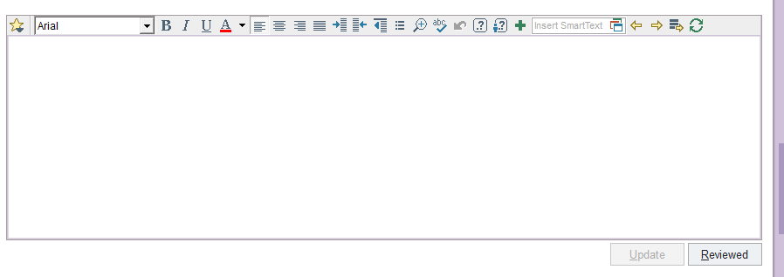
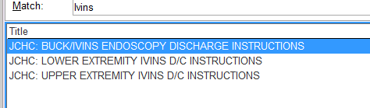
You can highlight these and right click to add them to your favorites. This will make it so you don’t have to search every time.
Once these are added, most of them have lists in them that need questions answered. If there are 3 *** replace these with text, f/u apt if you do the discharge instructions type your name.
The system will not let you print the AVS if there are lists in the instructions!!!!!

**Navigate through these by clicking F2 or hitting the right arrow at the top of instructions
