On the Central Station (Monitor at the nurse’s station) put the patient’s MRN in the patient ID field. This should automatically pull the patient’s name and dob to the monitor. PLEASE VERIFY the patient’s name Is correct.
In EPIC (before actually attaching your patient to the device) If you don’t do this your data will not pull.
- Go into the patient’s chart
- Click flowsheets
- Click Validate Data by Device
- Click - Associate Devices, then click add to associate what devices you would like for your patient
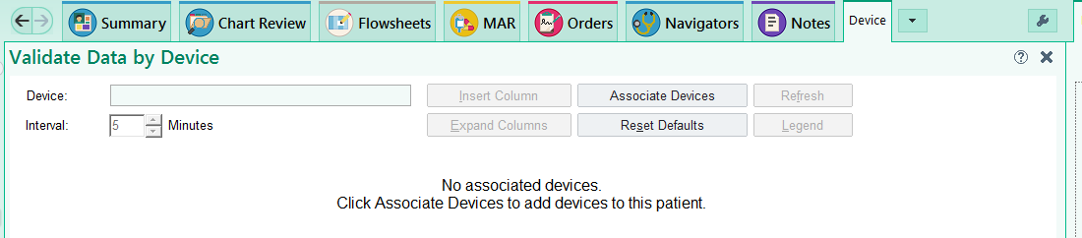
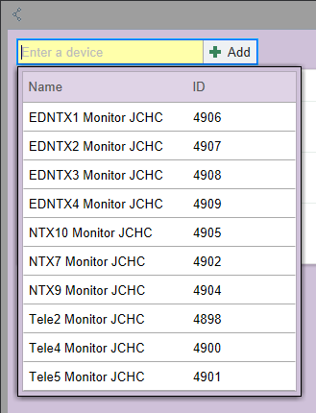
This is an example of Med Surg’s device.
DO NOT Change the interval on the patient to be anything more than 1 minute! This could cause you to lose a b/p or other timed event if the actual device doesn’t meet the interval set in the system there is a chance information could be lost!!!!!

- To pull in the vitals again go to Associate Device, you will select the columns you want to pull in. *after vitals start pulling in. This will probably take a few minutes to see.
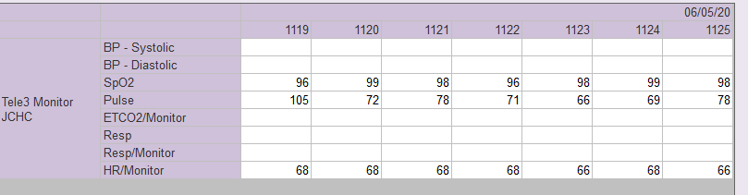
If you don’t want to select all, you can one by one pick the vitals you want to pull in by selecting the time above.
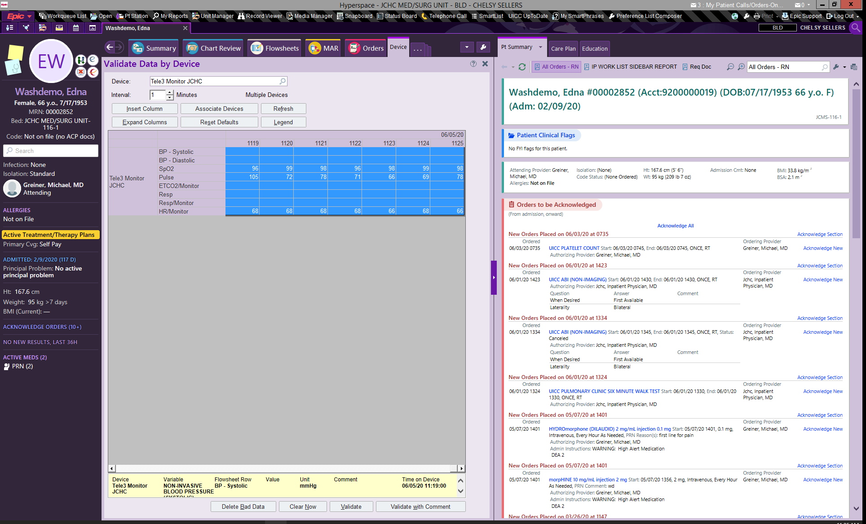
- Select Validate and you can pull this into the chart. If you do not validate vitals will be deleted in 72 hours!
  - You can delete bad data out…
  - You can add a comment if needed.
  - You can also still manually add Vitals to the flowsheet.
  - You can pick and choose which sets up vitals you would like to validate. Click the time above the vitals. YOU CAN ONLY DO ONE AT A TIME.
  - The actual tele-strips still need to be printed and scanned this is not interfaced at this time!
!!! When patients are discharged – Un-associate device in the system!!!
Validating after the fact. If you do not validate vitals they will disappear after 72 hours.
If you don’t validate your vitals while the patient is hooked up to the device and need to go back and do it afterward. You must go to vitals. Click the rows you want to validate. Right click the time (select File).
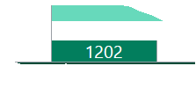
when you right click on the time an arrow shows up, click the arrow, and select file.

Note, when a patient is discharged you should disassociate the device, after validating a last set of vitals. Do this the same way as associating the device, just click the different buttons (you can also click the x)
- If you do not do this, and you hook the patient up before putting them into the central monitor, the old person’s vitals will pull in.

