When documenting post op ESI calls –
1. Click the boxes to document.
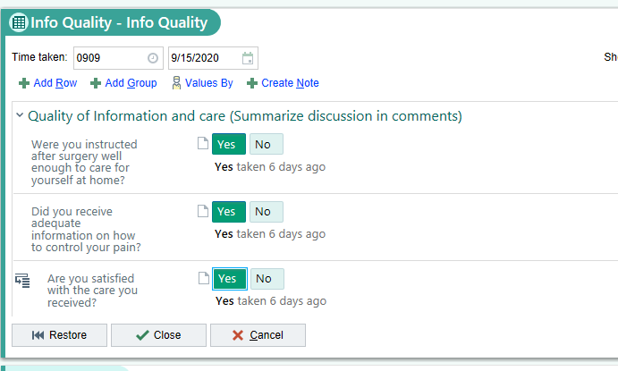
2. Select Create Note
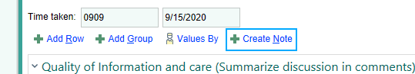
3. The note screen will pop up. In the left hand corner select insert data - 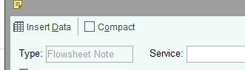
- This will put whatever you documented in your buttons into a note to be seen under the notes tab in chart review.

