`1. On the avatar, click assess on the wound that you have taken a picture of. I PAD How To –
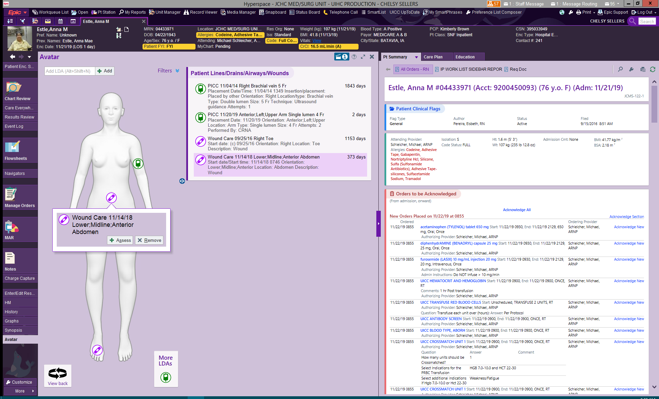
2. Click the Select Images button on the top of the screen
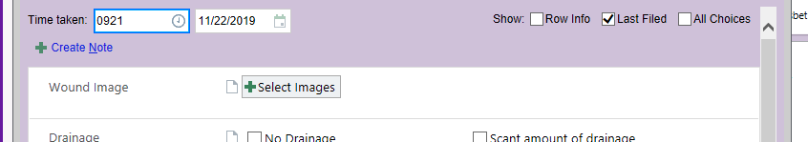
3. Select the image you wish to import to the LDA
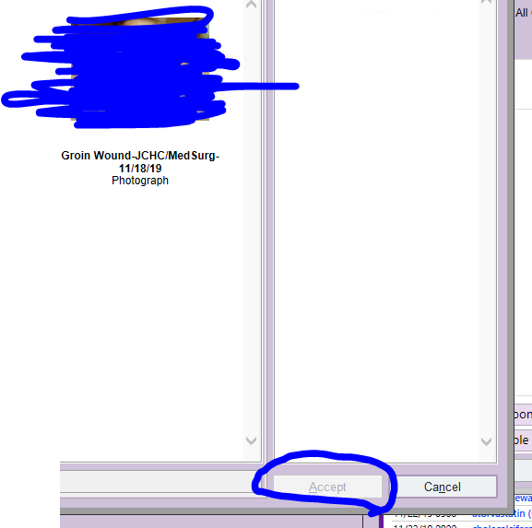
4. Click Summary view in the wound Care Healing Process Section to see a comparison of any other pictures attached to the LDA
