I PAD Instructions – Canto App for EPIC
- Swipe up from the bottom of the I-Pad screen
- IPAD LOGIN: (extension of your department) is 4327

- Click on Epic (Canto) icon 
- Type in Epic user ID and password

- If you are logged into OR, you must select the little folder Icon on the left hand side of your screen.
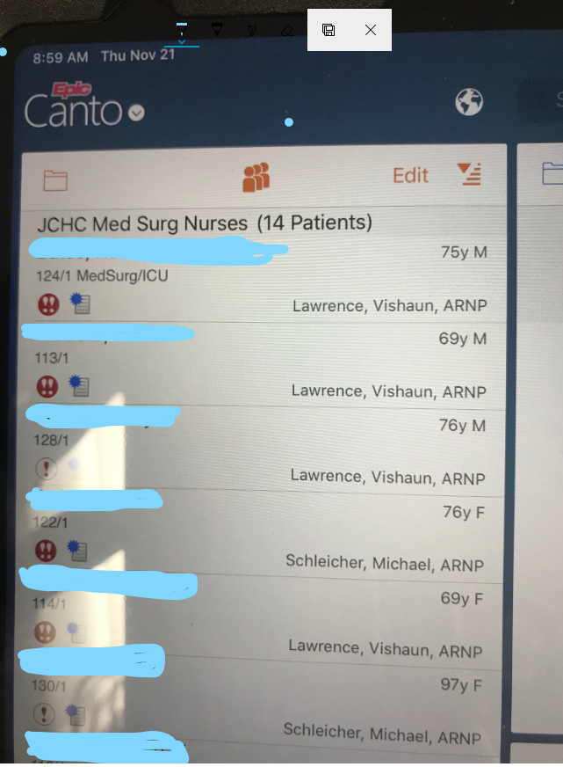

  - Click back list arrow (←List)
  - Select System List
  - Select JCHC Units
  - Select JCHC OR

- Once you find your patient tap their name to open their chart.

- Click on little camera up by patient’s picture. See picture below.

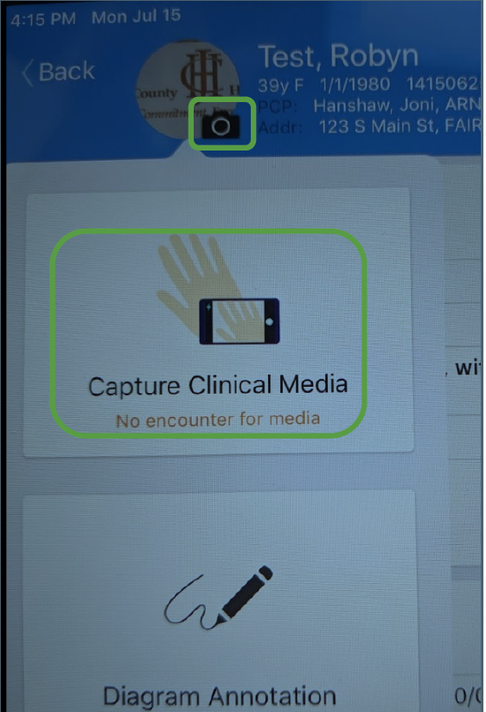

- Tap on ‘Capture Clinical Media’. See picture above.
- Take your picture
- Click “Use Photo”
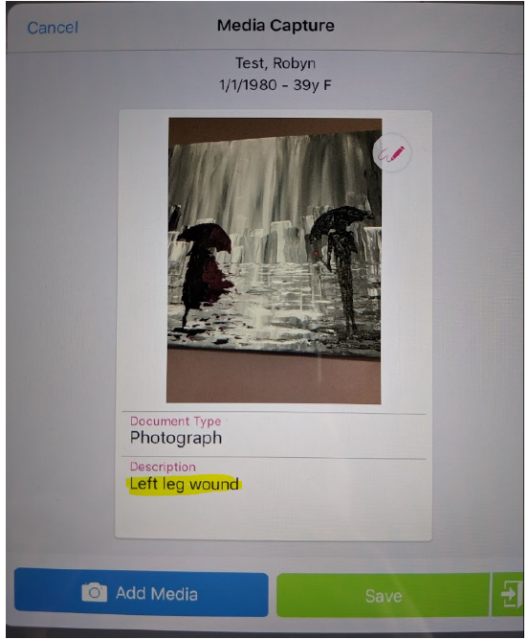
- Add a description *Laterality Location of the wound/incision - date of photo* Ex- Left lower leg - 02-02-2020. Use correct capitalization rules. NO ALL CAPS.
- Click Save.

For Multiple photos you must select the camera Icon again, and follow the above steps.

***If you take multiple photos and do not have time to put a description on all of them, please log onto a computer afterwards, and edit the photos so that you can title them.
I PAD How To –
To Log Out – Click on Canto Chart Icon in the top left corner. Drop down pops up – click Log out from the drop down menu.
Shut off – Hold power and top volume key down to shut IPad off.
Close App – Double tap the screen and swipe away open apps

