Tip sheet for using a Therapy Plan in JCHC Ambulatory Care Unit

- Select therapy under the Infusion/Outpatient Navigator
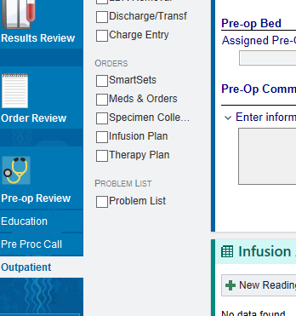

- After clicking on the therapy plan therapy tab you will see the medication ordered on the therapy plan.
  - Click begin treatment. ***As you can see from the screen shot this therapy plan is for Lovenox 80mg and they have 10 treatments out of ten left to be administered.
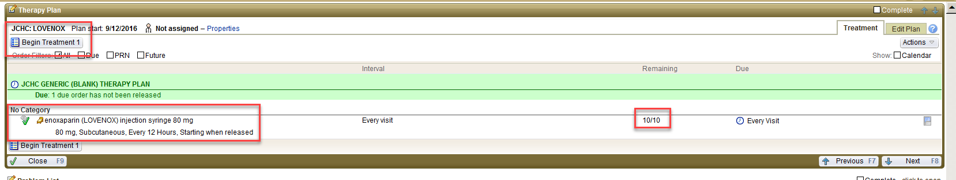
- 7. On the next screen you will see that the begin treatment button is grayed out and the release button is available. You will then need to release the orders (sometimes you may not need to release all orders to carry out patient care) PAY ATTENTION TO DATES.
- 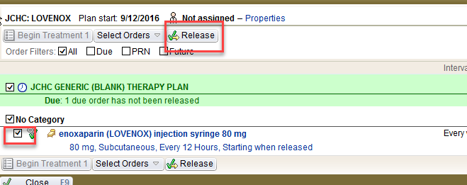
- After you release the order it will be available for documentation on the MAR.
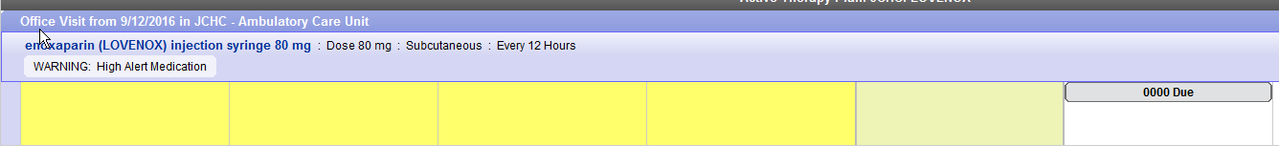
- **There is a outpatient assessment section on the outpatient navigator, this is where you will put your comments that used to go under intra-op sedation flowsheet. This comment will pull to the intra-op sedation flowsheet as well.

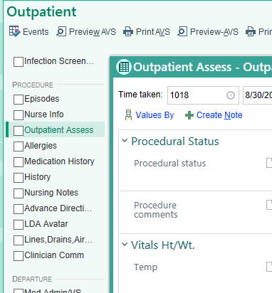***If you scroll to the bottom of the infusion assessment, there is a close button.
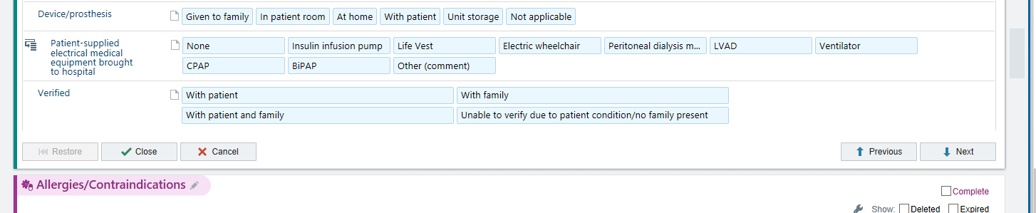
- Hit Events (top left)
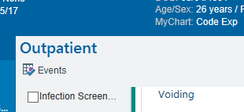
- Scroll down to post op and go to discharge and enter date and time.
