Outpatient Surgeries from ED to ACU (OR)
- The provider will put in the case request order (using the this encounter option)
- Once the order is signed, it will drop to ACU’s depot.
This has to be drug up for the surgery staff to proceed.

If ACU Scheduler is not here, please complete the following task. NOTE: Provider’s order must be in first!
1. Click your EPIC button in the Left hand corner. 
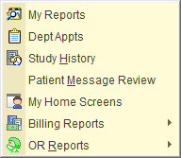
This step should only have to be done the first time. You can save this item to your “wrenched items” See separate hand out.

2. Hover over Reports, Hover over OR Reports, and select SNAP BOARD. Click JCHC ACU, Click Run
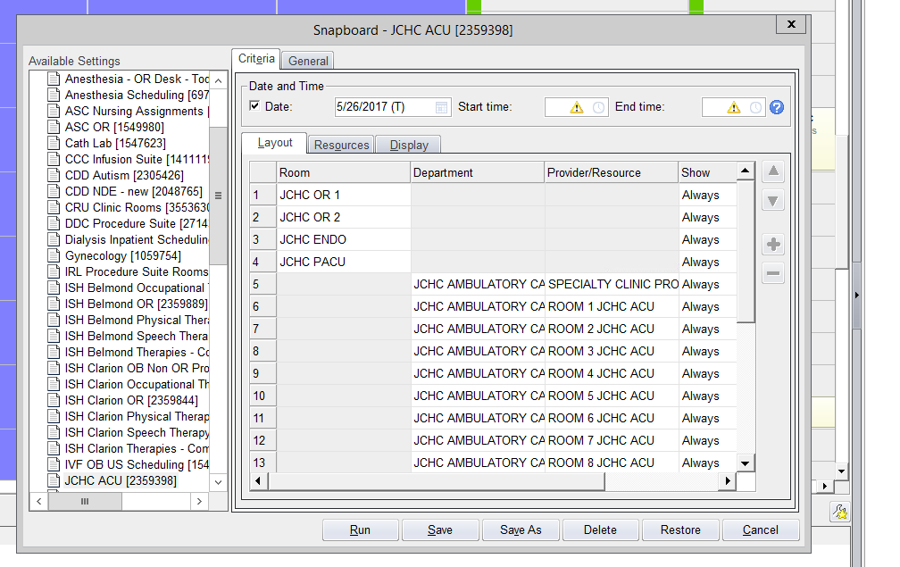
CLICK JCHC ACU

On the bottom of this screen right hand side, you will see a blank space with a drop down arrow.
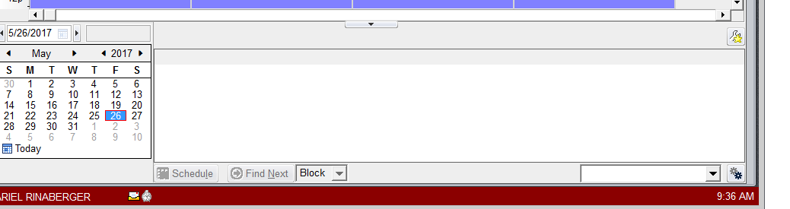**Above is where the orders will go **New orders go to the bottom of the list.
JCHC OR DEPOT
3. Click down arrow and Select JCHC OR depot. The order will drop to the bottom of the list 4. Drag the order to the specific time slot under OR 1 or OR 2, let go. 
5. Scheduling pop up will appear, click schedule. 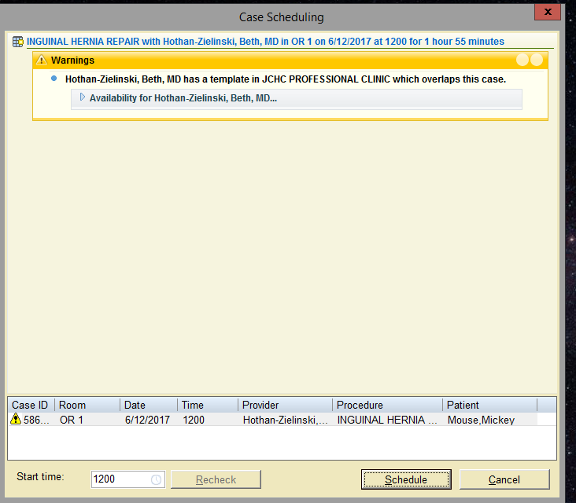
Schedule
6. After dragging from the depot the Ward Clerk/reg staff in ED should Transfer the patient to the ACU/OR room using the Observation button.
Hit this to TRANSFER

7. Fill in the necessary information: Unit, Room, Patient Class, Accommodation Code, Admitting Provider Effective date and time 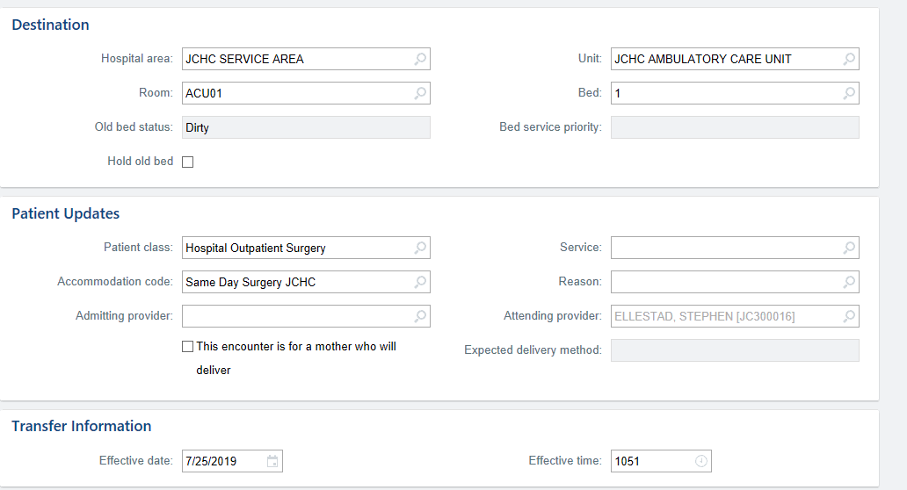
FILL OUT:
Unit, Room, Patient Class, Accommodation Code, Admitting Provider, Effective date and time
All patients having surgery will be transferred to ACU NOT OR
Select ACU room 1, 2 or 5.

- Patient Class : Hospital Outpatient Surgery
- Accommodation code should always Same day Surg JCHC for outpatient surgeries.
- Room should be ACU 1, 2, or 5
- You do not need to select a service.

8. Hit the transfer button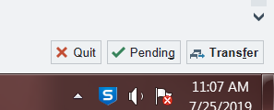.
9. Your final screen should look like this (below), saying Admitted to ACU

