Acute Surgeries d/c readmit to ACU (OR)
The provider will put in the case request order (using the future encounter option, SDA)
Once the order is signed, it will drop to ACU’s depot.
The patient should be discharged from ED at this time before anything else is done in the computer!
DO NOT TOUCH THE CASE UNTIL IT’S CONFIRMED WITH A PHONE CALL FROM ED to OR, THAT THE PATIENT IS DISCHARGED.
If the case is clicked on too soon, it will delete the pending admission and this process will not work. DO NOT CLICK or touch the case until ER calls OR to ensure the patient is fully discharged…

If ACU scheduler is not here follow these steps to get the case scheduled only AFTER THE PATIENT IS DISCHARGED FROM ED.
The provider must have their orders in before these steps can be completed.
1. Click your EPIC button in the Left hand corner. 
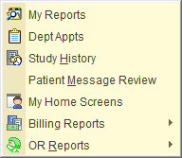
This step should only have to be done the first time. You can save this item to your “wrenched items” See separate hand out.

2. Hover over Reports, Hover over OR Reports, and select SNAP BOARD. Click JCHC ACU, Click Run
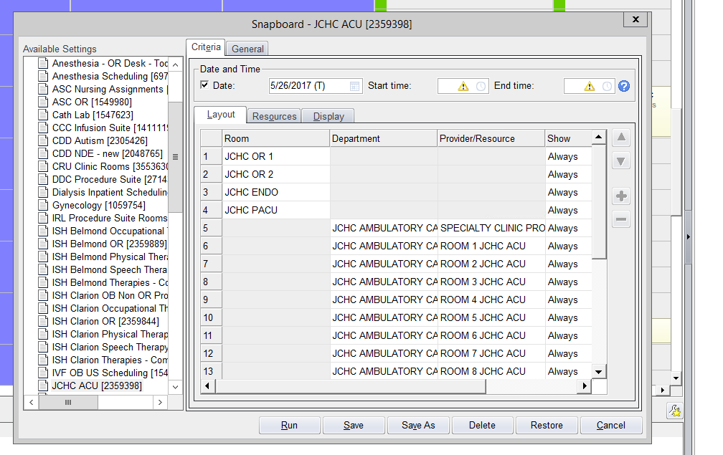
CLICK JCHC ACU

On the bottom of this screen right hand side, you will see a blank space with a drop down arrow.
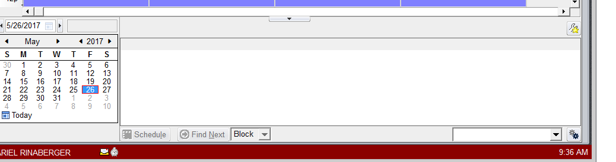**Above is where the orders will go **New orders go to the bottom of the list.
JCHC OR DEPOT
3. Click down arrow and Select JCHC OR depot. The order will drop to the bottom of the list 4. Drag the order to the specific time slot under OR 1 or OR 2, let go. 
5. Scheduling pop up will appear, click schedule. 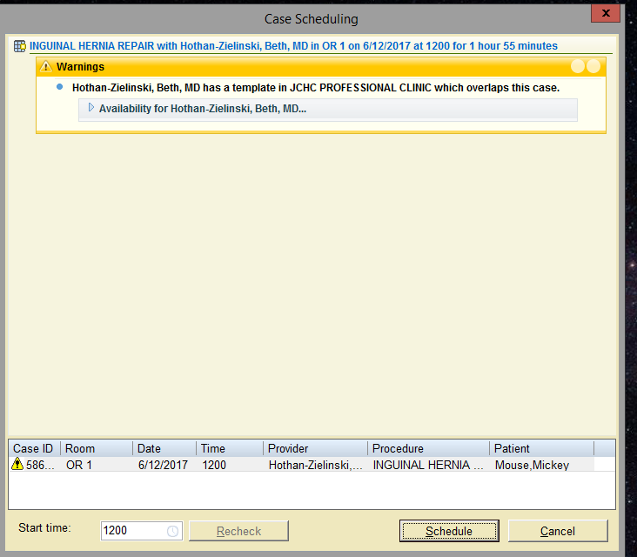
Schedule
6. After dragging from the depot the Ward Clerk/reg staff in ED should go to patient station and find the pend Pre-admin. Verify it’s in there.
8. Go to Patient Station and select the pending pre admit. Right click and select update.
9. Automatically select Pending and then 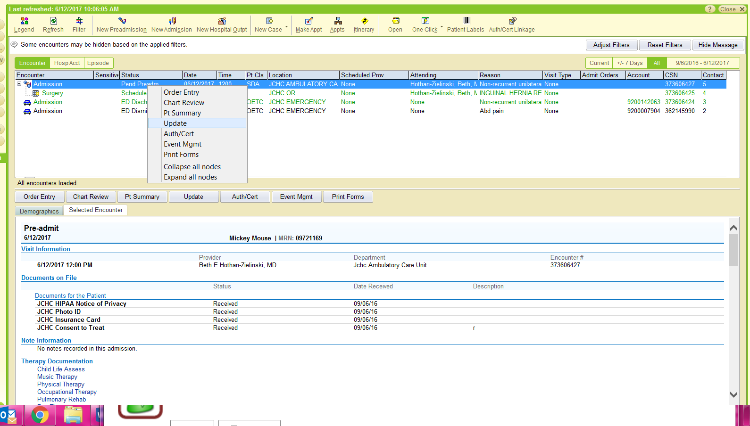
Select Update, and then hit PENDING in the right hand corner.
10. Repeat. Right clicking and selecting update. This time select Admit. The system will show you what to fill out.
- Accommodation should be the first screen.
All patients having surgery will be admitted to ACU NOT OR (This should default in)
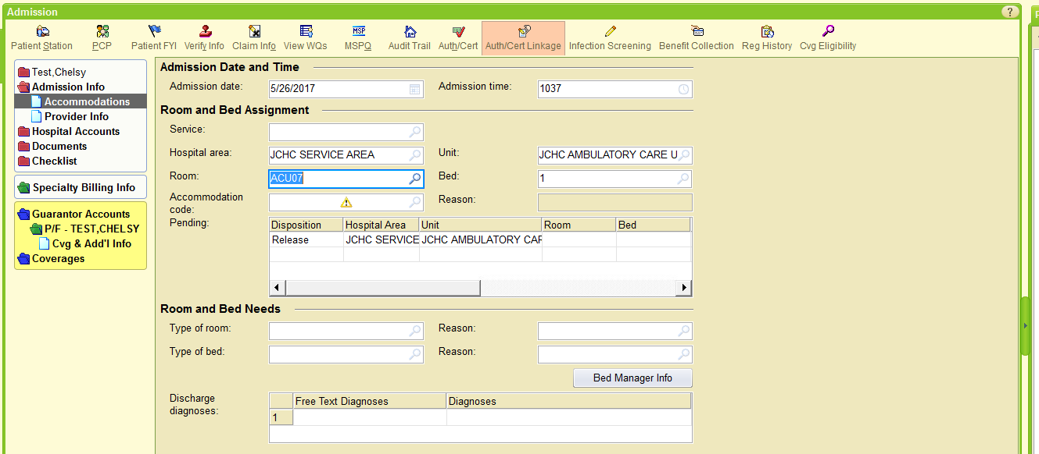
Select ACU room 1, 2 or 5.

- Accommodation code should always Be Same Day Surg JCHC for ACUTE SURGERIES
- Room should be ACU 1, 2, or 5
- You do not need to select a service.

11. Create a new hospital account for the patient by selecting create new account.
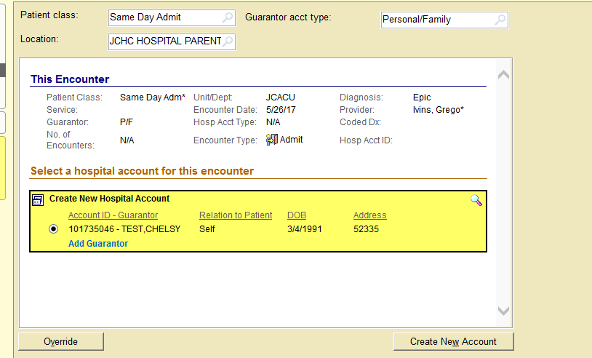Cr
CREATE NEW
12. Bypass the warning about the patient being admitted in the last 72 hours, after hitting admit.
13. Your final screen should look like this (below), saying Admitted to ACU
14. Now OR staff including anesthesia can go in and chart what they need to chart.

