~*~ Admitted/Discharge patients workflow when surgery request is placed ~*~
Acute- Surgery will pull patient from MS using their normal workflow, MS pulls back to the floor from Surgery
- Case request gets put in as current admission, Inpatient.
SNF- Patient current level Skilled- Discharge Readmitted to acute number. Doesn’t need pending admit if case request is already in (this will already be created if they have the case request in before patient goes acute)
Patient current level skilled when placing the order.
- Case request goes in as future encounter, Same Day Admit if being put in when patient is still skilled when ordering case.
- Under patient station the Ward Clerk will find the pending admission for surgery and update it to be admitted Acute (THEY SHOULD NOT CREATE THEIR OWN PENDING ADMISSION). This will only be there if order was placed on skilled #.
- The patient should be moved to acute as early as possible for easier documentation. From skilled to acute.
  - All documentation for surgery including the consent should go on the new (acute) number.
- After patient is acute, surgery will pull acute # to their department, using their normal workflow
Already discharged from skilled admitted to acute when order is placed.
- If patient on acute number when the order is being placed, put in as current admission, Inpatient
- Surgery will pull patient to their department from MS using their normal workflow, MS will pull patient back when surgery done.
Observation- Floor provider will put in discharge order, should mark in comments going to OP surgery. **DO NOT DISCHARGE THIS PATIENT** Surgery will pull patient from MS to surgery using their normal workflow, patient to be discharged after surgery. Accommodation codes need to change when patient changes departments,
- Case request goes in as current admission, inpatient.
- Patient to be pulled in the computer from MS, and admitted to ACU to go home after surgery.
  - Patient class will change to Hospital Outpatient Surgery, accommodation code should change to Outpatient Surgery JCHC. SEE EXAMPLE.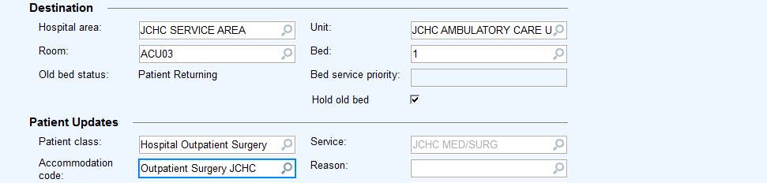.
When recovering on the floor Same day Surg to observation.
On unit manager find patient name and right click.
Select Event Management and then select insert update.
- Patient class will change to Observation, accommodation chosen should be Observation Same Day Surgery JCHC **This charges differently than just observation acc. Code.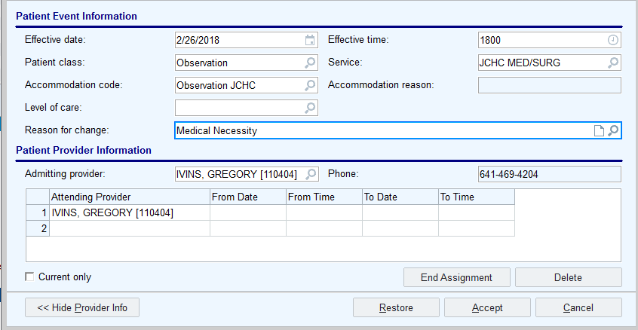
This will help track down phase 2 times, and should auto create a charge. Order should be placed at the time of change.

