JCHC Med Rec Process November 2019
- Verify each med on the list: route, dose, frequency.
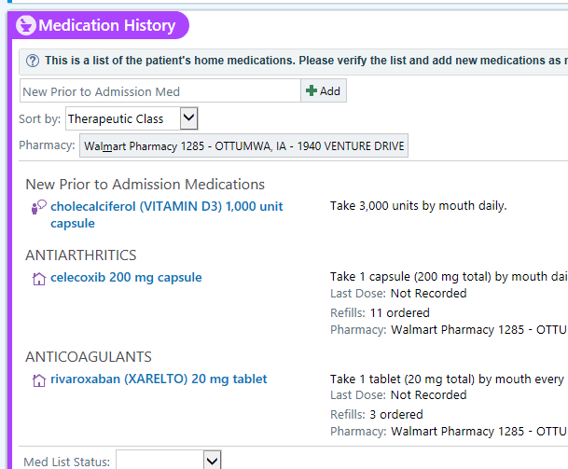
- Mark as ‘taking’ if appropriate.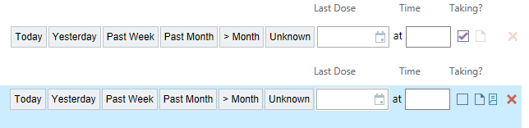

- Update dose/frequency as needed.
  - Click on the name of the med to expand it, and adjust the sig appropriately. Use the buttons/fields instead of free text whenever possible.

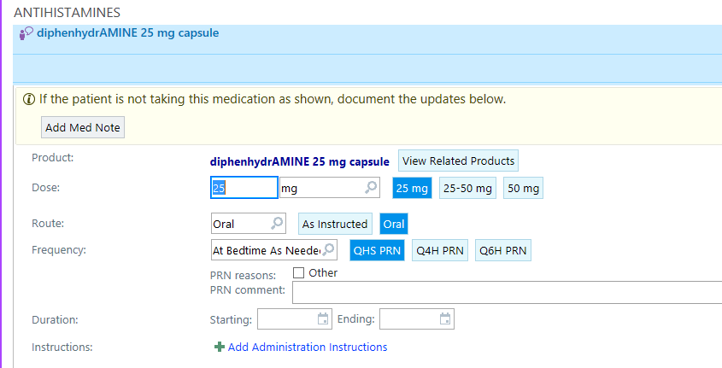
Ex: Patient reported meds:

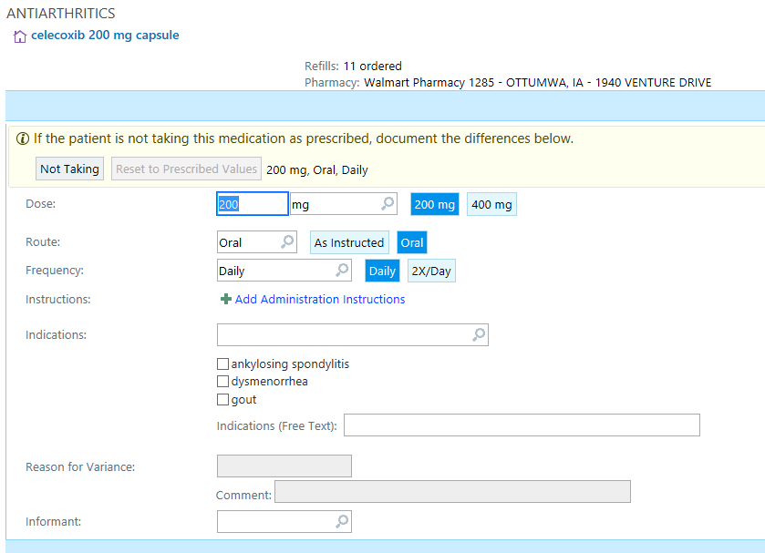

Ex: Prescribed meds:

- ‘Hard delete’ (Red X) antibiotics/short term meds the patient is done with.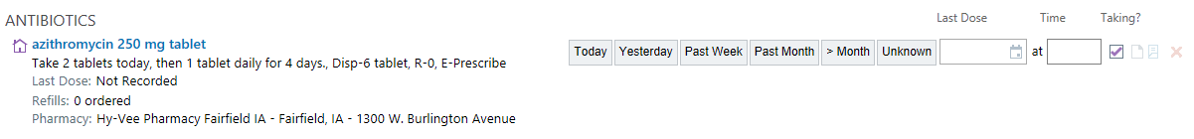

- Mark as ‘Not Taking’ if patient is not currently taking a chronic med-the provider will need to address this.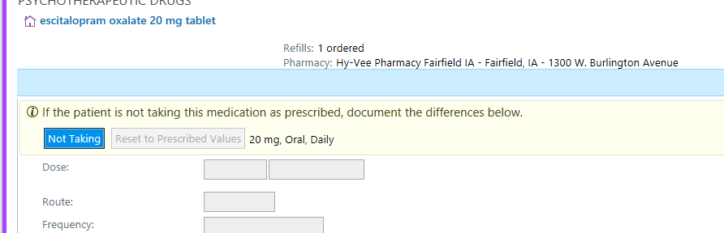

Nurse View of Changes on med list: 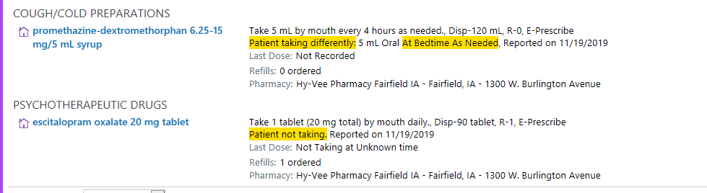
Provider View of Changes on med list marked by nurse:
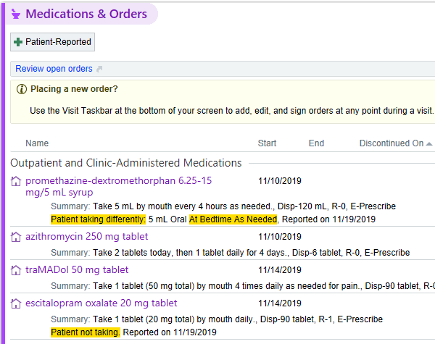
- Update Med List Status: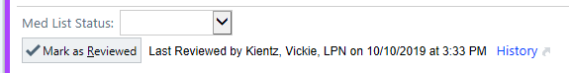
    - Completed = Each med on the list has been gone through one by one with patient/family, verified, and accurately updated. Short term meds have been deleted.
    - In progress = Meds have been started and attempted to update but unable to complete at this time. This should be communicated to the next shift, floor hand-off, and/or provider.
    - Waiting = Meds may have been started or attempted- may be waiting on list from pharmacy or family. This should be communicated to the next shift, floor hand-off, and/or provider.
    - Unable to Assess = Patient/family unable to give information. This should be communicated to the next shift, floor hand-off, and/or provider.

