Sign Electronic Consents –
- While in a patient’s chart go to Chart Review, Procedure Logs tab find the case request for the surgery the patient is having. Look for the section that says Panel, if there is more than one you will need to copy both. Also note what laterally it is, if there is one. Copy the description of the procedure under panel by highlighting and clicking ctrl C.
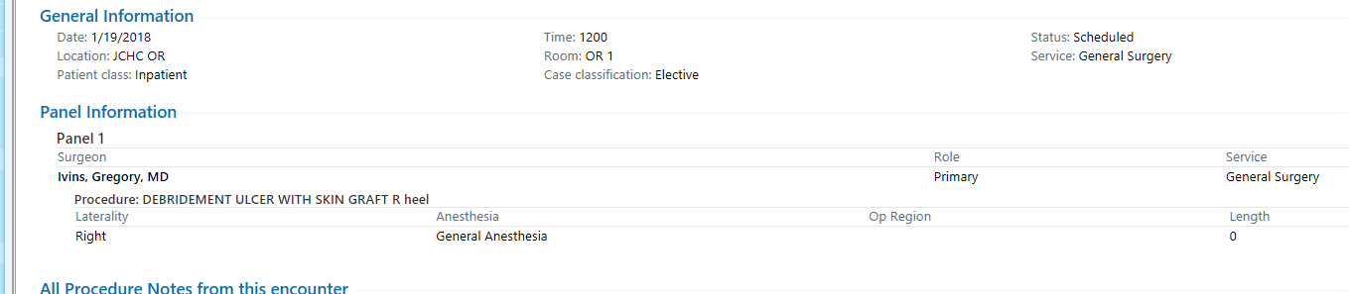
If this scenario didn’t include R hand at the end. You should go back and type of the Right hand because he did select Right for the laterality.
This consent should read the procedure as DEBRIDMENT OF ULCER WITH SKIN GRAFT OF THE RIGHT HAND.
- Consent button placement for each DEPT
ACU – Under your pre-post navigator/outpatient navigator you will find a new consents section (towards bottom of the screen)
ER- Under the Dispo tab you will find a consent section for e-sign consents/discharges
Med Surg - go to either your Admission/Discharge Navigator and find the consents section
Rural Health Clinic – Under your rooming tab, and the wrap up section you will find a consent button.

- Click add or search for the name of the consent you are needing. 
  - If doing a discharge signature look up JCHC Discharge instruction Acknowledgement
  - Note surgical consents all start with JCHC Consent Surgical (dr. Ivins and Dr. Zielinski have a specialized consent for their “normal” procedures.
  - There is a separate consent for scopes JCHC Consent Endoscopy (for all providers)
  - For those “abnormal” procedures use JCHC Consent Surgical.

- Electronic consent will be pulled up, and should look similar to this.
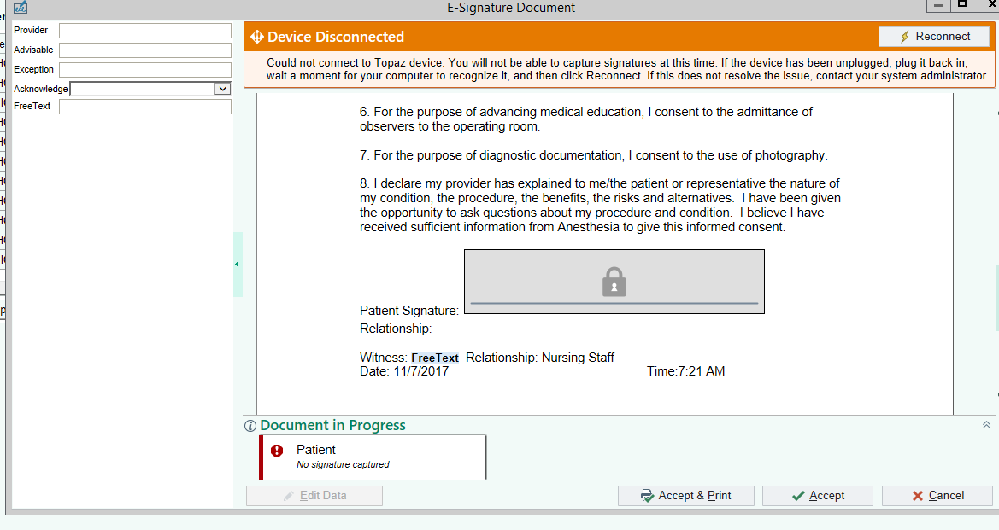
- You must fill out the buttons on the left-hand side.
- Paste or CTRL V, to paste what you had copied in the procedure line. If the description didn’t include a laterality, you need to include one.
- Type Nurse’s name in the “free text” area on the left. Tap on the Patient Signature area and allow the patient to sign.
- You MUST click “accept” at the bottom of the page in order to save the information.
- Look under Chart Review, Media tab to ensure your consent looks correct for surgery or the discharge.

