Before Surgery
- On the procedure tab, click H and P interval Note. 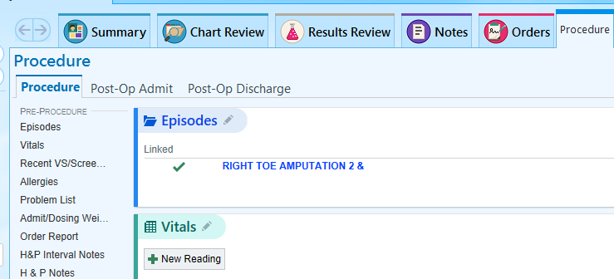
- Find the scanned image of the H and P that was done in the click
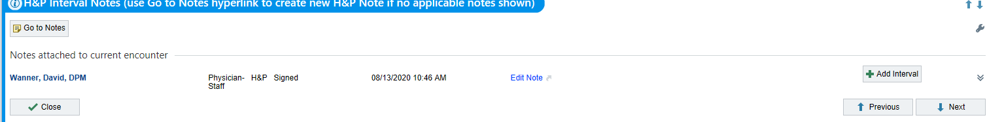
Click Add interval button.
- Type .handp and hit enter (this will pull in the interval)

After Surgery
- Click the orders tab
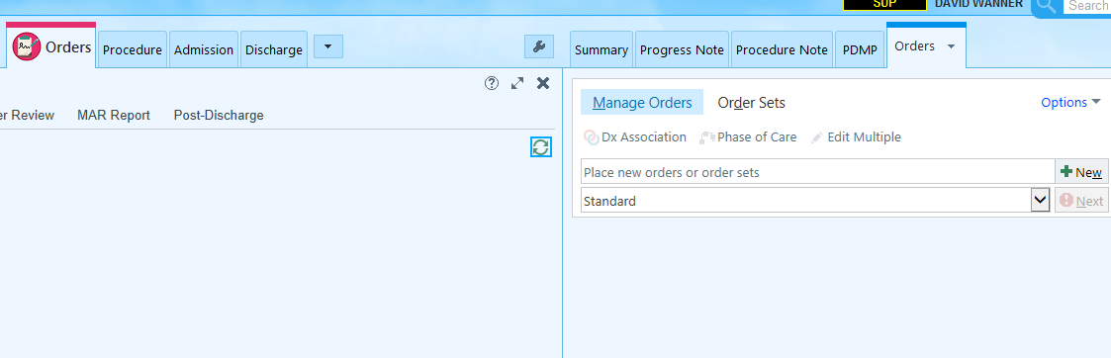
- Select Ordersets, then JCHC OR-Post OP OP

If you need to add any additional orders type them in, and then when done hit sign.
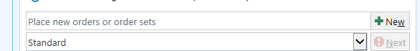(Top)
 (bottom)
- Always double check the inbakset and sign any verbal/protocol orders pending


