How to enter charges in EPIC – Amanda Flynn
- First go to Outpatient tab and find Charge Entry.
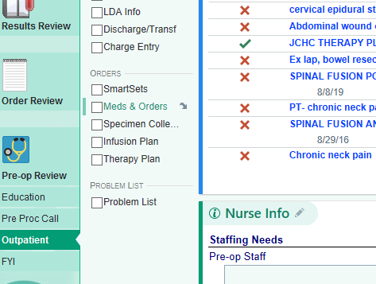
- Next make sure Ambulatory Care is the department listed
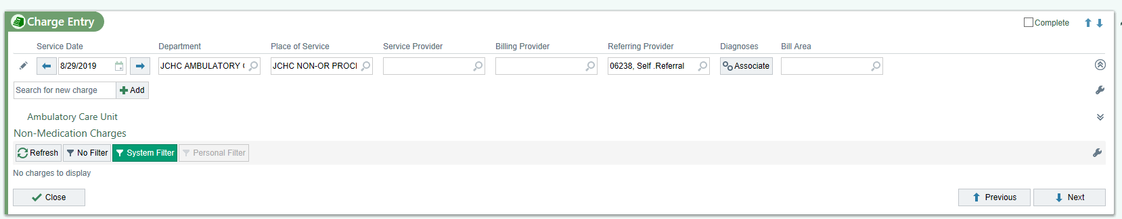
- Choose the appropriate charge and check the box/boxes, then click accept charges to complete the charge capture.
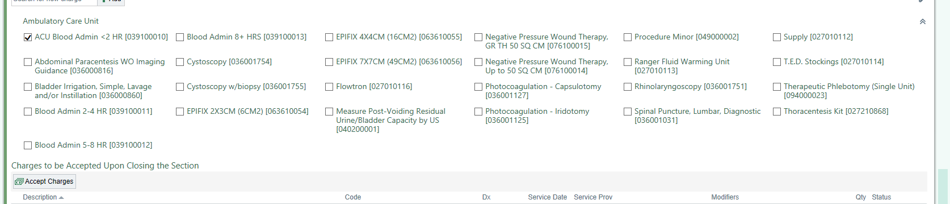
- To verify you have completed the charge, you can go to chart review, then encounter, then choose the encounter for that day. Off to the right, scroll down to the bottom of the visit encounter document. At the bottom there is a section called “charges for this encounter” The charges you entered should be able to be seen there.
