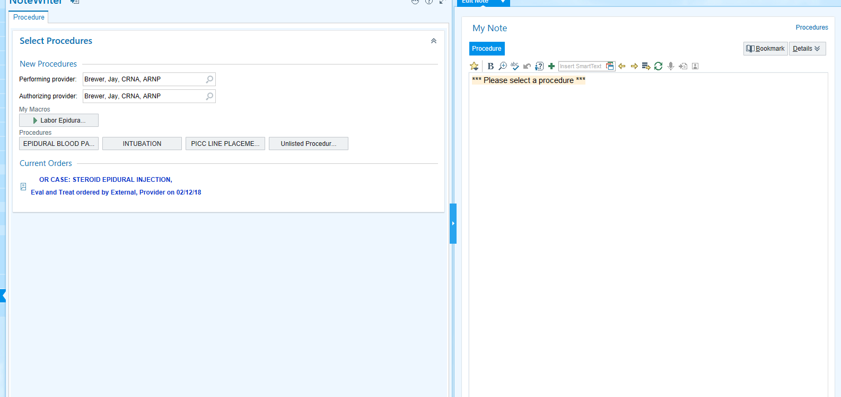
On the right hand side the order must be selected that says OR CASE: (for HIM) we can change the name though after it’s selected.
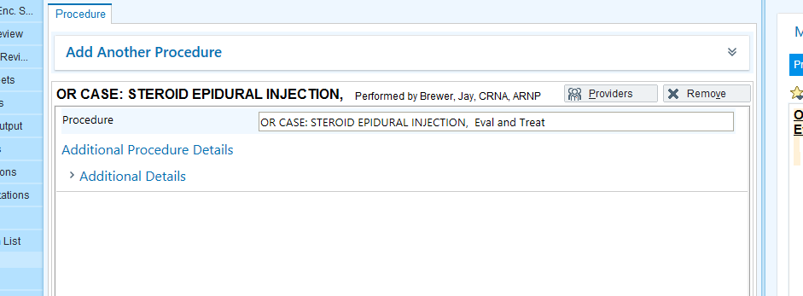
Can change the name here.

On the right hand side, under where it’s orange you will type your smart phrase. .jaybrewer (enter) will pull in the long one. Otherwise you can use the one we made the other day. Click the right arrow at the top of the screen to move through the list to be able to sign your note. Double click on your selection in the list. 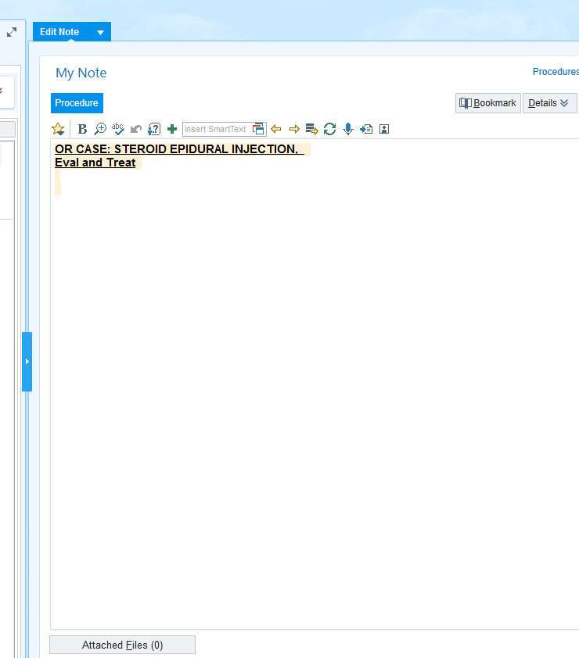 If you don’t do your note in this section the links will not pull information (medications/history for your H and P portion of this note).
If you like this smartphrase, I can make it as an option when we get the pop up like VBHC has, so you wont have to remember another smart phrase.

