How to set up patient list

Log in to JCHC Anesthesia
Click on the “Patient Lists” tab at top of screen
Under Available Lists open the JCHC Units
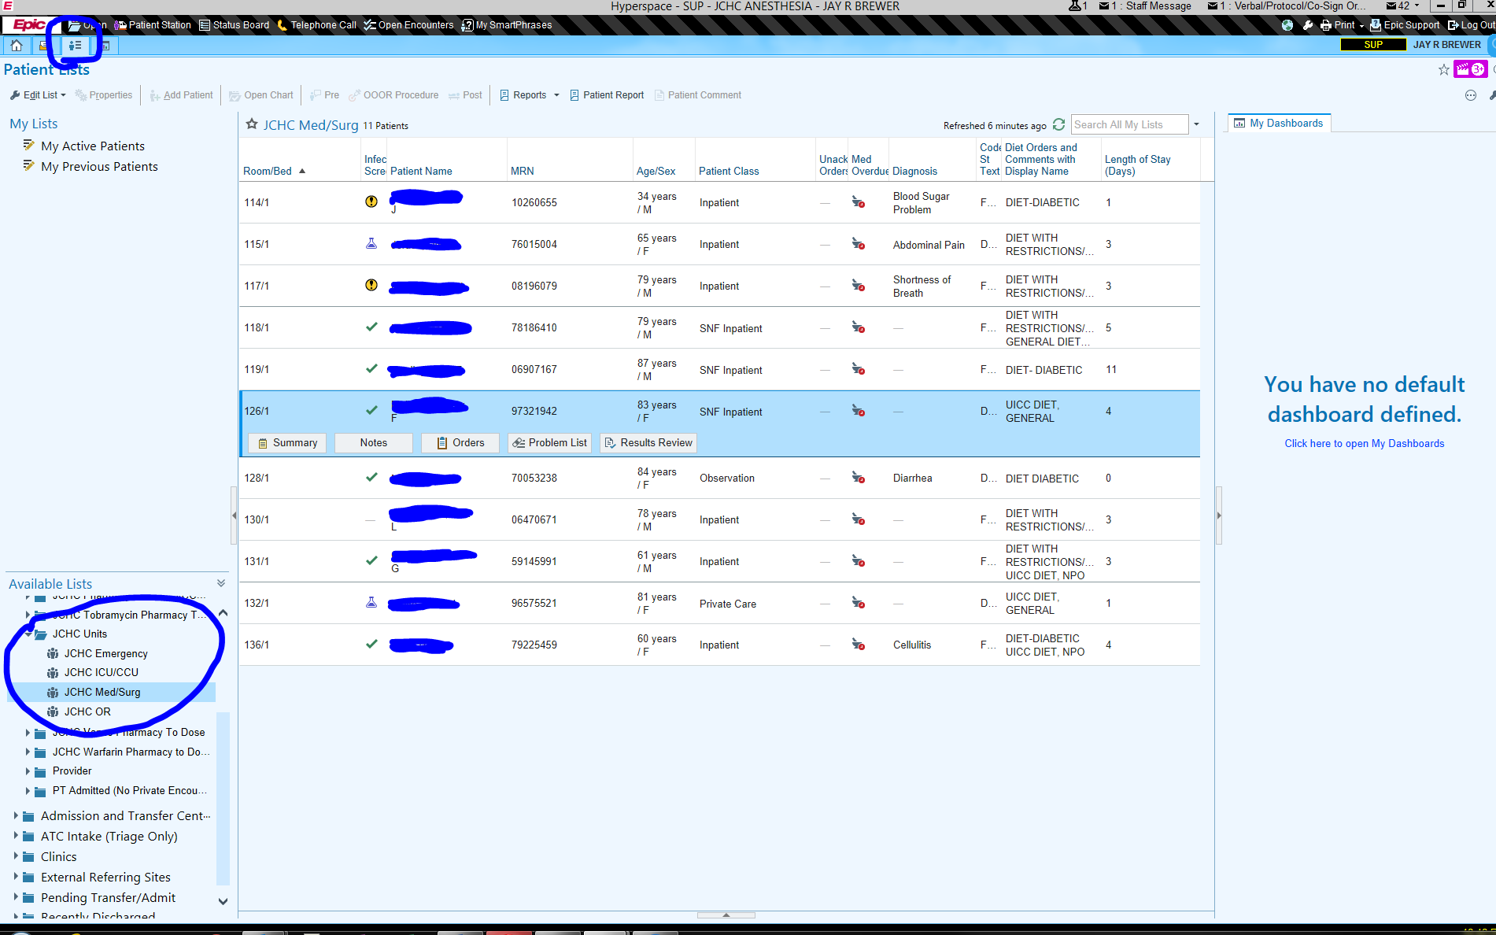

Click and drag JCHC Med/Surg to “My Active Patients” in the My Lists section
Do the same with JCHC Emergency

