Out of OR procedure (Intubation)

Log in as JCHC Anesthesia
Click on the Patient List tab at the top of the screen
Under “My List” click on the department the patient is located in (JCHC Emergency or JCHC Med/Surg)
Single Click on patient name
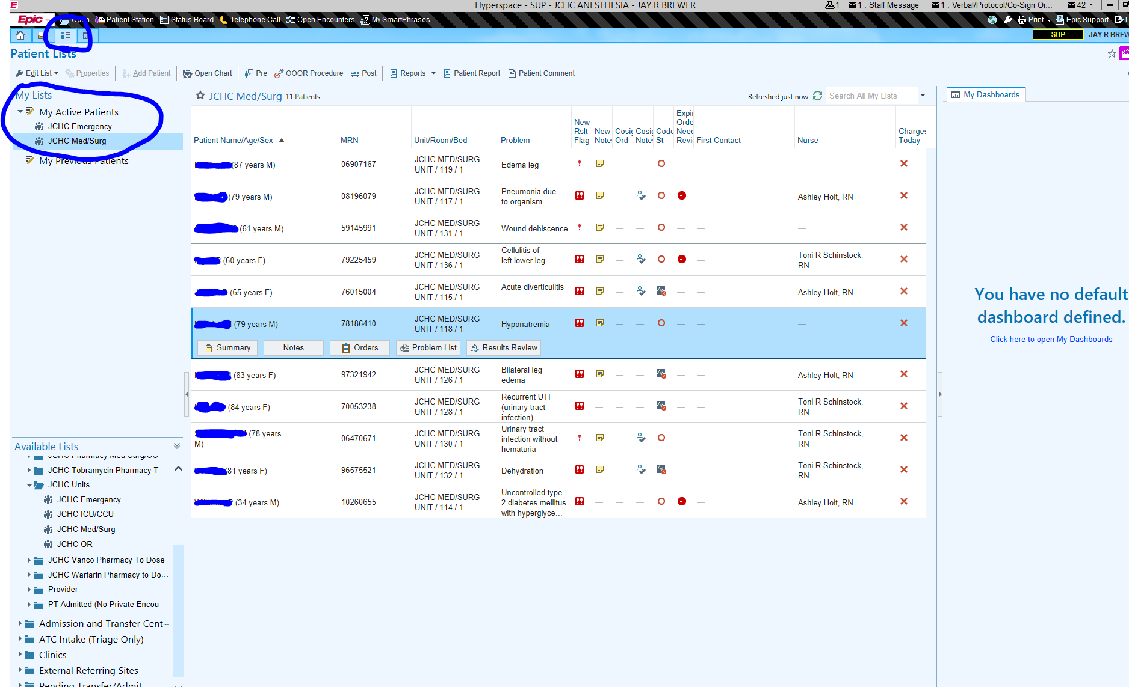

Once the patient is highlighted the button for OOOR Procedure will become bold. Click on OOOR Procedure.
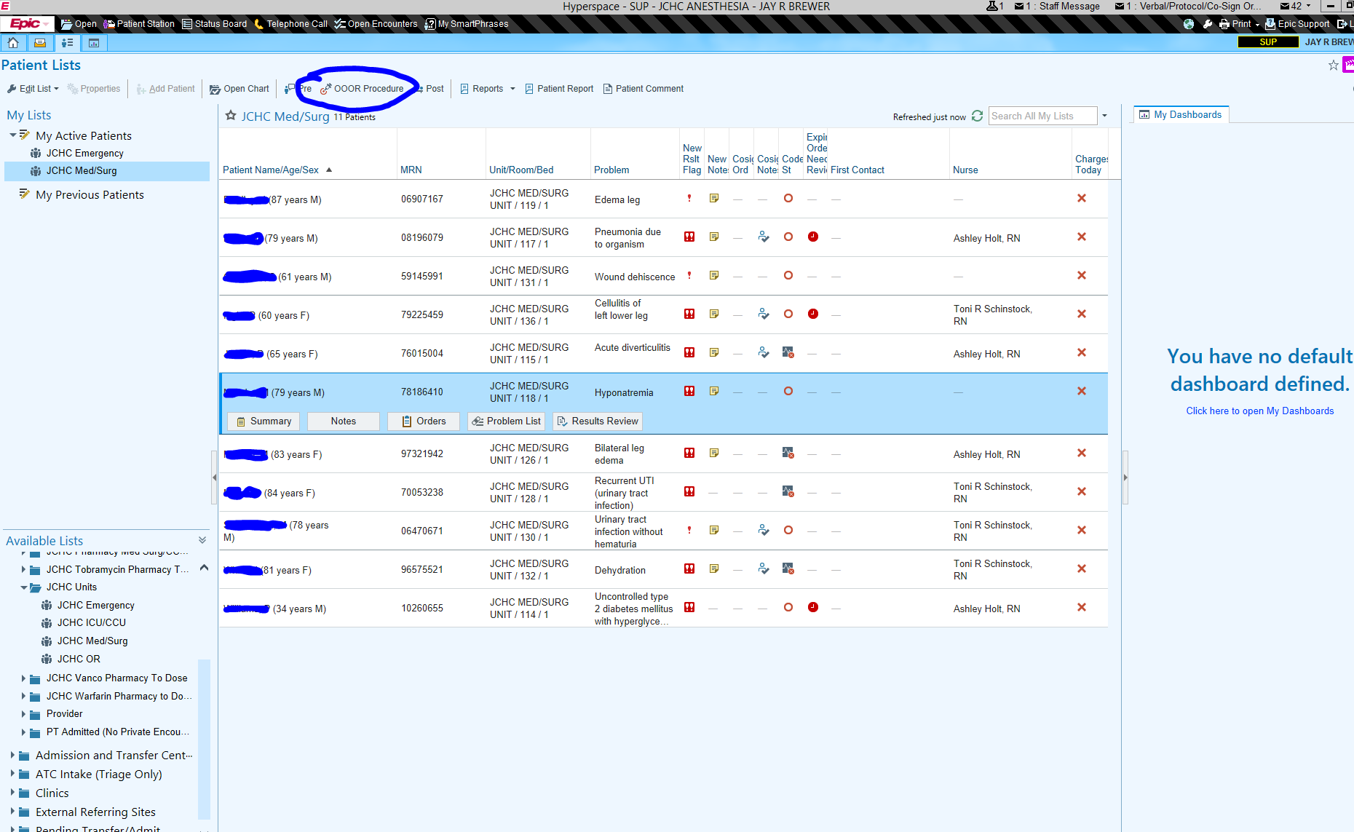

This pop box will appear – choose Intubation
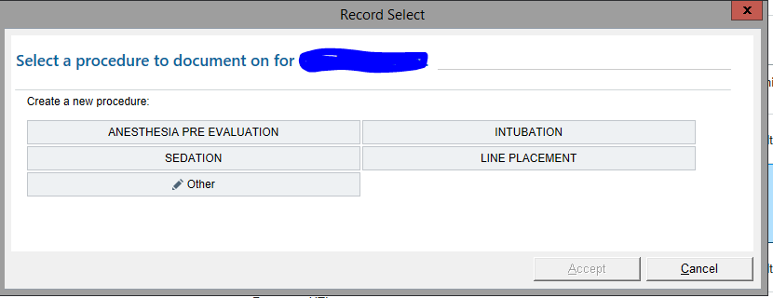

Click Anesthesia start near the bottom left of the screen.
Then Click Procedure on the left mid-screen.
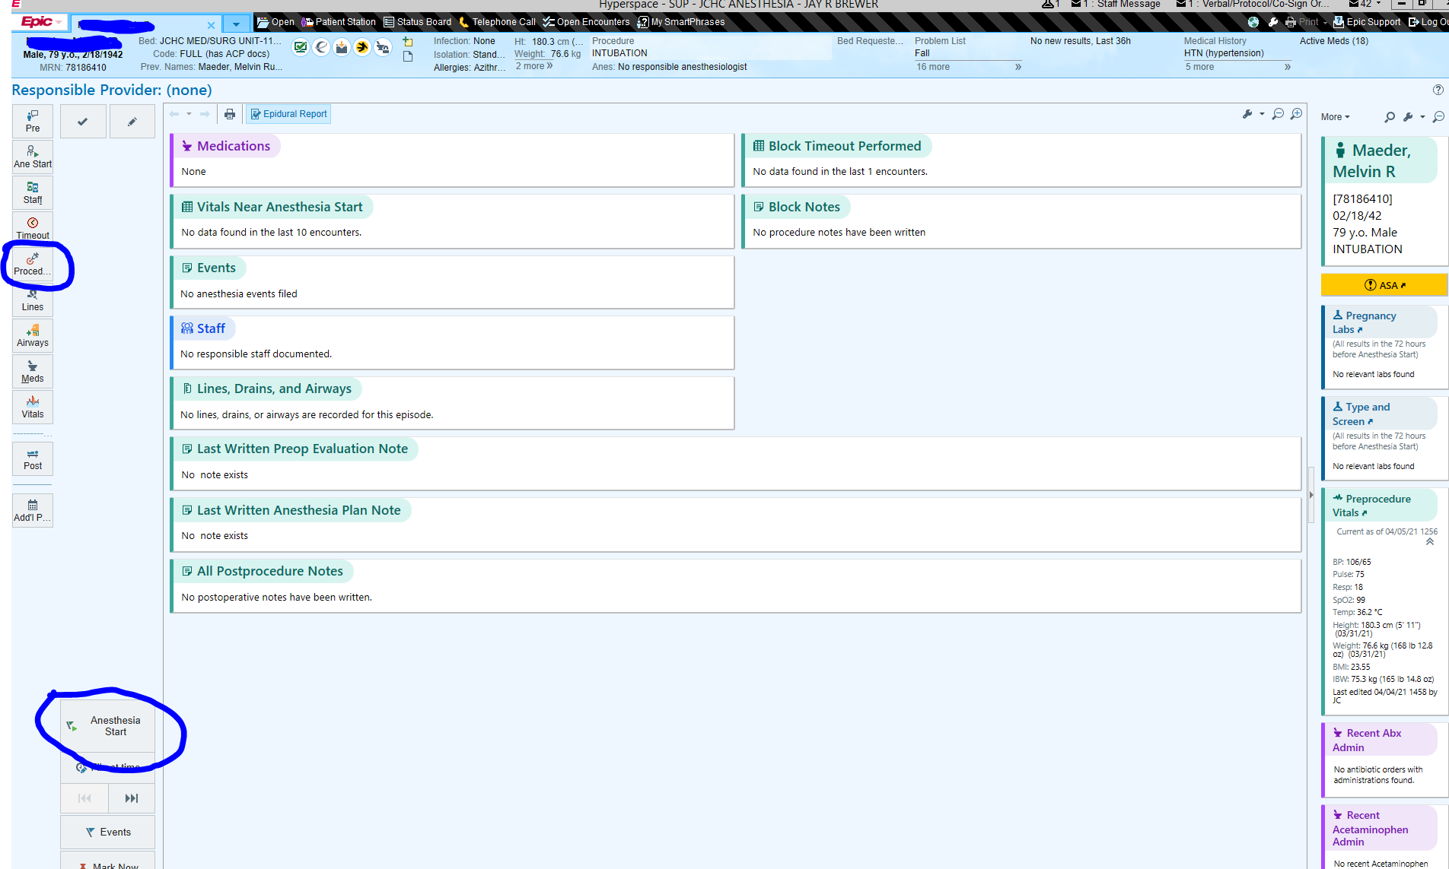

You can now choose Intubation
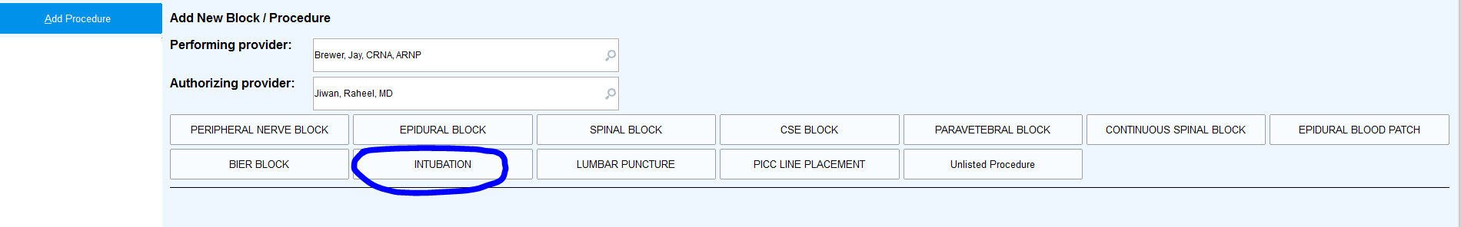
In this section you can use click boxes to document Propofol, Succinylcholine, ET tube placement, etc.
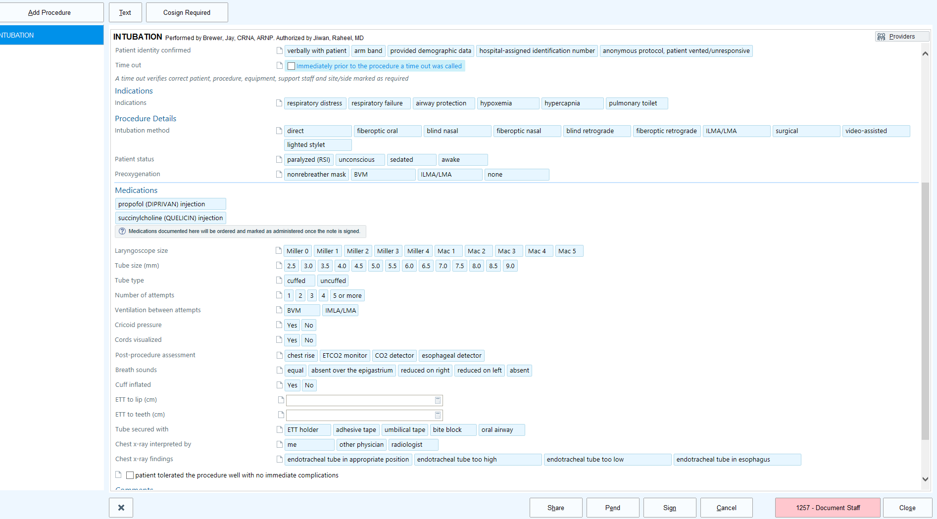
Click on the Document Staff button at the bottom right of the screen and enter your name. This will open a box allowing you to enter the anesthesia start and stop times..

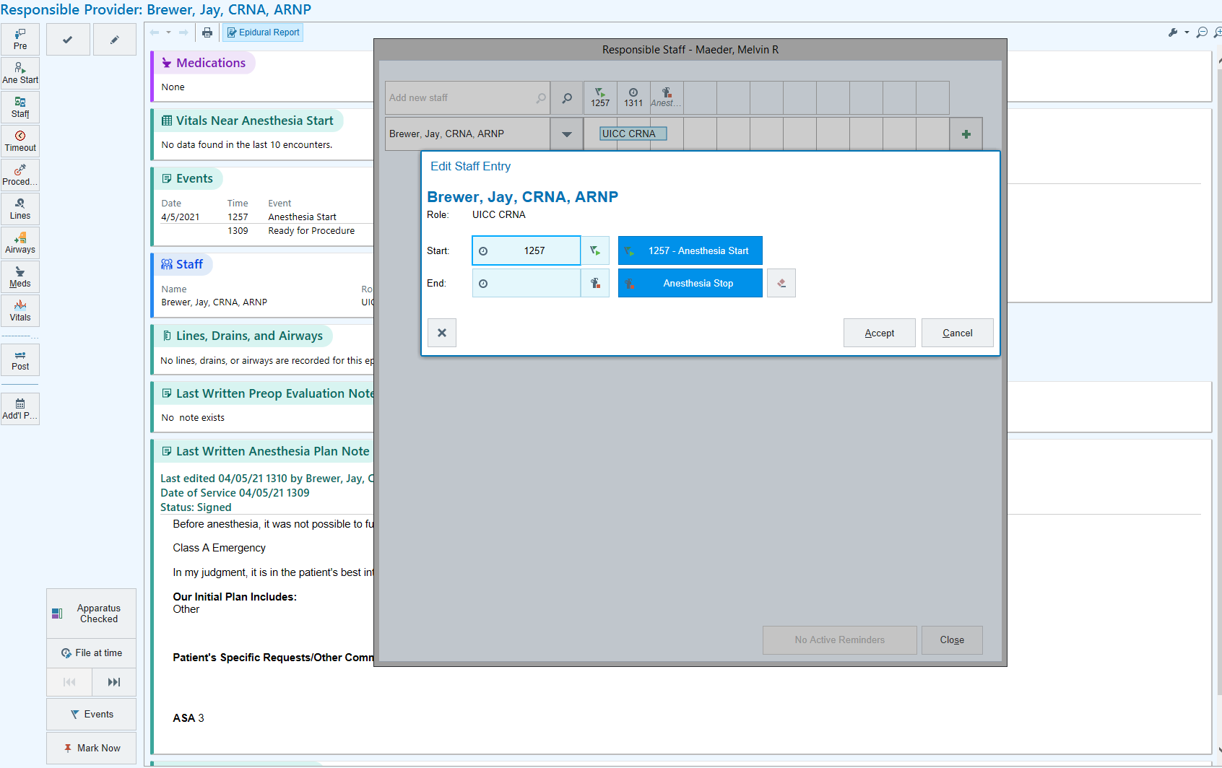

Click on Sign when complete.
Back on the main screen you can now choose Meds and a Medication Administration pop up will appear to allow you to document other medications used during intubation.

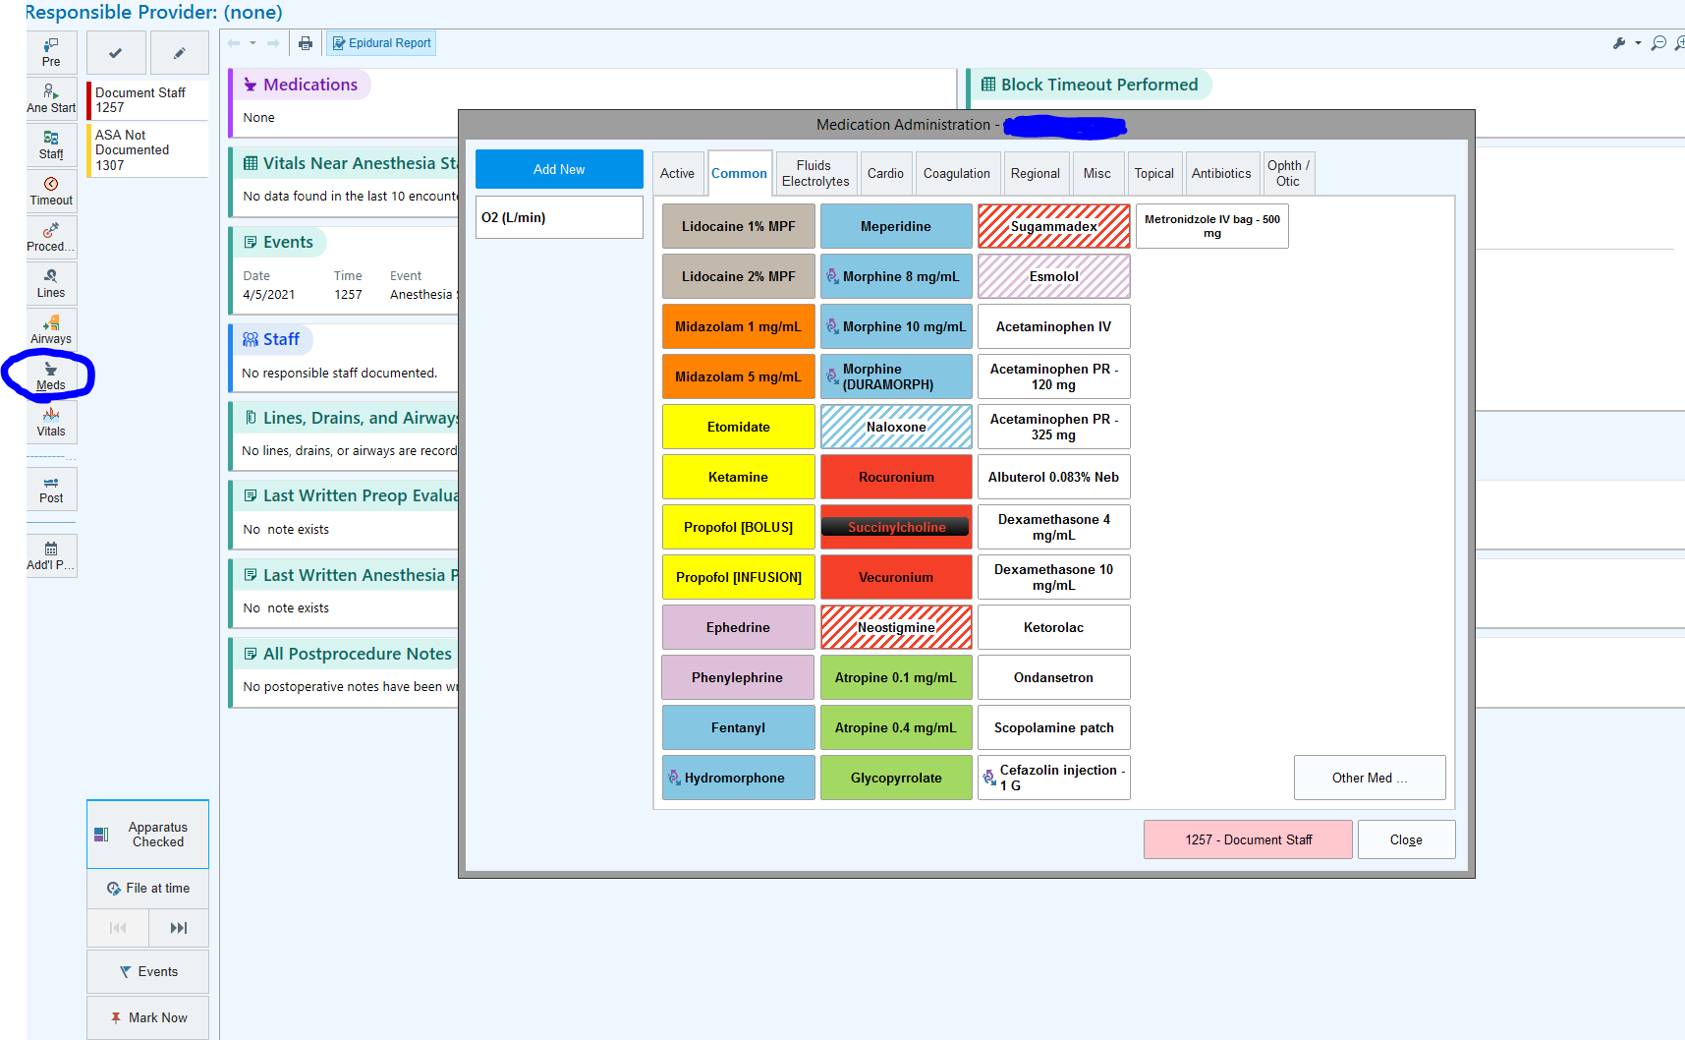
Click on ASA Not Documented to go to the Preanesthesia checklist to enter this information.
