Anesthesia |  | Device Select
In your Intraop Navigator Toolkit, click “Device” | 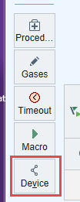
The Device Management box will appear | 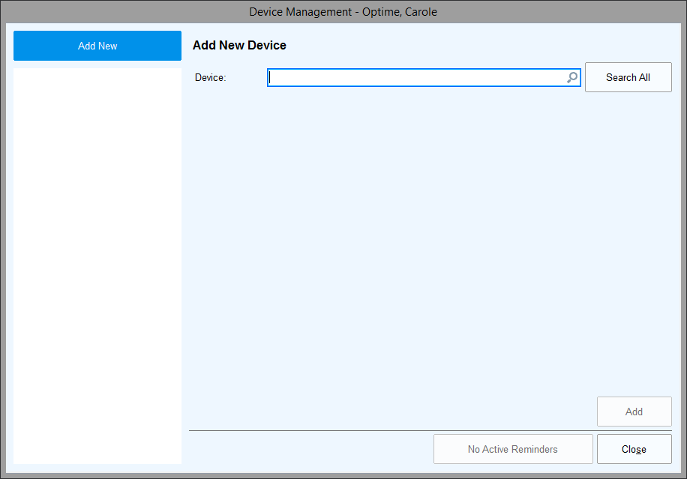
In the Device search field, select or type your device name.  Type; “OR” or “PR” to limit your search  Note: You have 2 monitor devices to select from. Look at your monitor to determine if you have the S/5 or the B450. You will only need to associate one monitor. | 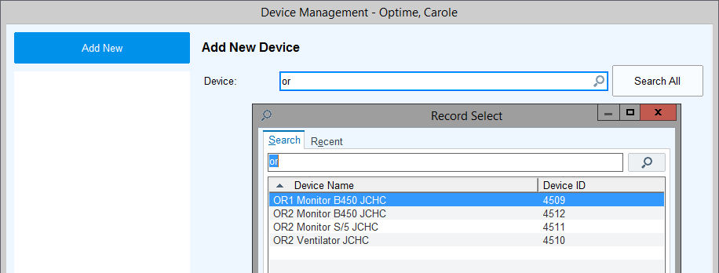
For each device you want to associate to your patient, click “Add” at the bottom of the screen | 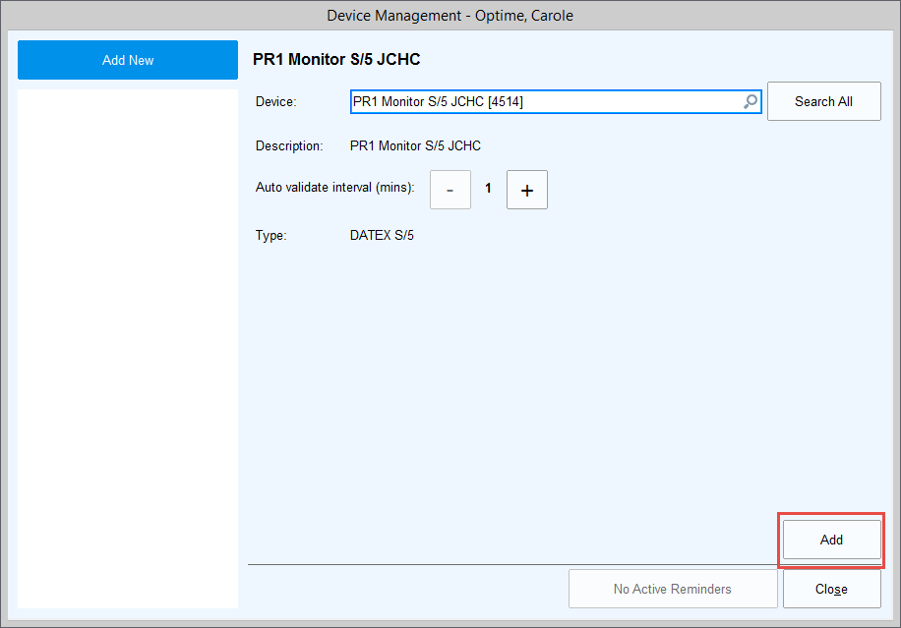
Your devices will be attached and the box will look like this- | 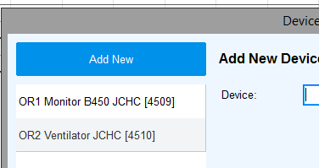
Close the window and your devices are attached | 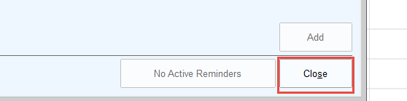
Additional Information
You will need to use the Start Data Collection and Stop Data Collection events for the rules in the background to begin the data capture, end the data capture and automatically disconnect your device at the end of the case.
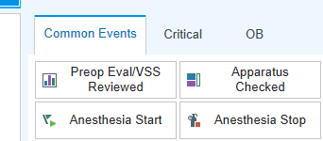
These events have been added to your Macros if you choose to use these.
If you see a “Red Screen”, like shown below, it means that data is not being transmitted into Epic. You will need to begin your troubleshooting process with your IT department to check the Neuron connectivity, etc.
