Anesthesia Performing Provider Documentation |  | To be used when Anesthesia provider is acting as the procedure’s performing provider  Log in to ANE Procedure department
- Access the Statusboard | 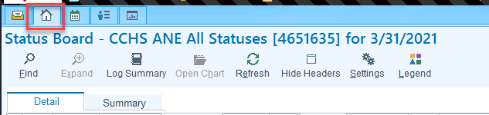
- Double click on the desired patient | 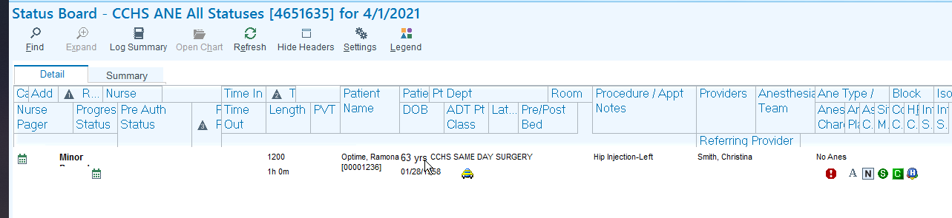
- In the Procedure Navigator write your procedure note by accessing the Procedure Note section. | 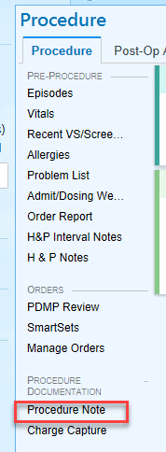
- Select the procedure’s order by clicking once on the hyperlink with the order | 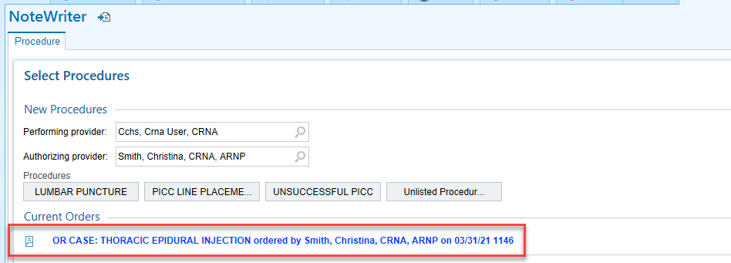
- Enter charges as appropriate | 