1. On the Preprocedural Navigator click “consents” option.
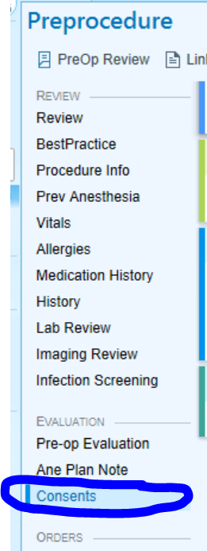
2. Select the Speed Button for Anesthesia Consent Form


3. Select the type of anesthesia needed for the procedure.
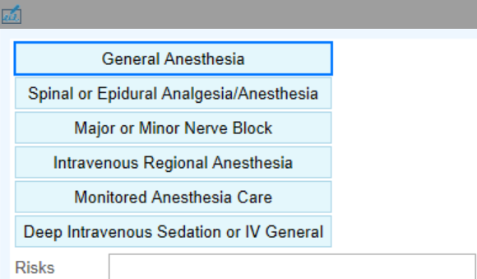
4. Free Text any additional Risks in the Risks box. 

5. Select the correct relationship to the patient for the person signing the consent
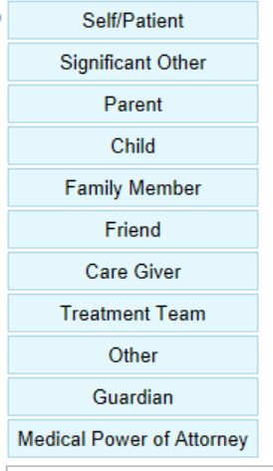

6. IF an Interpreter Phone is used, type the ID # in the Interpreter ID# in the box.


7. Have the patient sign the box for patient, the witness in the witness box, and you sign the Provider section. If interpreter used in person, they will sign as well. clicking next/accept after each one.
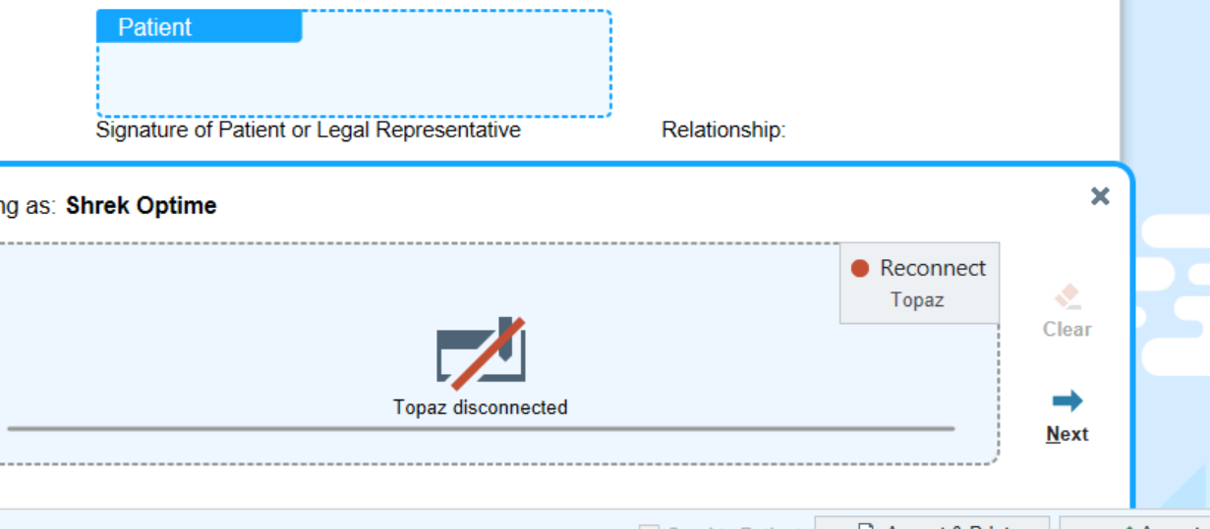

10. After all signatures obtained, click accept.
11. The consent should look like this and say e-signed. 

12. If you want to see what the consent look likes you can look under chart review – media tab.

