After giving blood to put in a stopped time please go to the blood admin rate flowsheet, click on the syringe.
Then put in the action to stopped/completed.
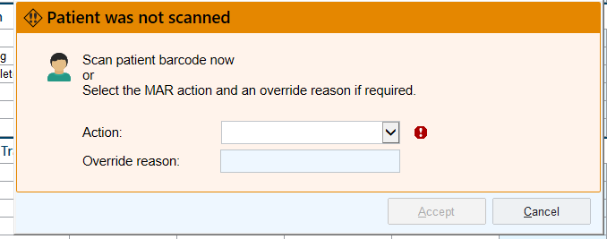
Stopped
Select the PIV to link the blood to.
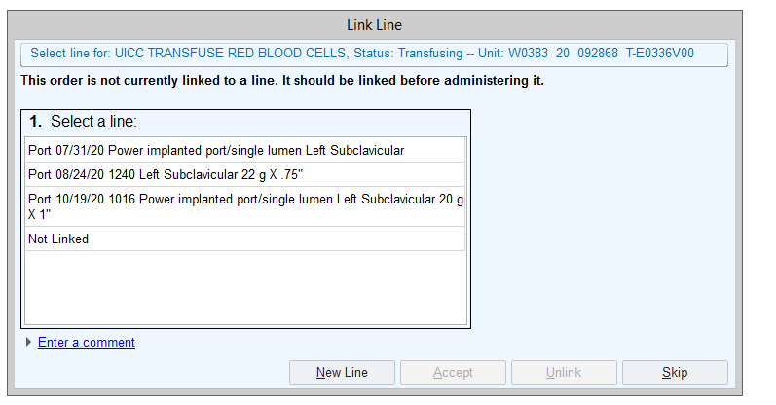

On this please fill out the blood admin volume – This will show how much blood was given.
