Uncompleting Blood Documentation
If blood is accidentally completed, or the wrong unit is completed. Go to the blood admin flowsheet, and uncheck Hide Comp’d.
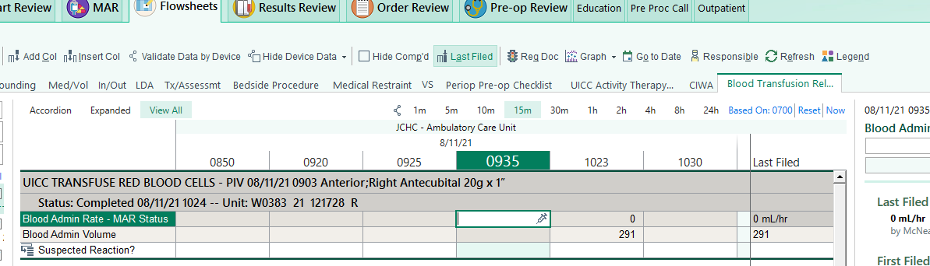
The flowsheets will open and you can click the syringe on the Blood Admin Rate- Mar Status
There will be a warning pop up, and ask you to reactivate the unit of blood, click yes.
You can set the status to infusing, and accept.
Delete out the old information until the blood is completed for real.

F:\EPIC\Department Tipsheets\ACU - OR EPIC Tip sheets\Blood Transfusion Updated 8/11/21 CJS

