Anesthesia |  | Blood
In your Intraop Navigator Toolkit, click “Blood” | 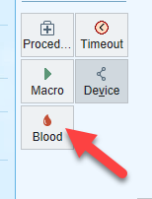
Choose the blood product you will be giving

Scan the patient band or select and override reason | 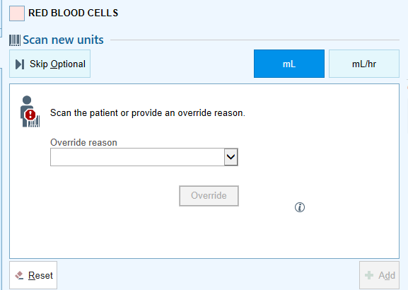
Scan all four barcodes on the bag- unit number, product code, unit blood type and expiration date  (During testing a warning may appear that the unit has been documented on another patient- dismiss that warning) | 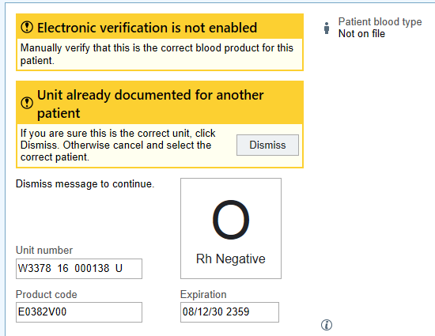
Click Add to add the blood to the workflow | 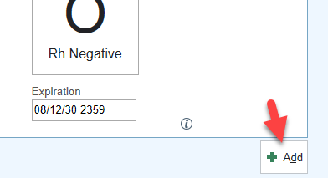
The start time will auto fill in as the time that scanning took place. This can be edited if needed. | 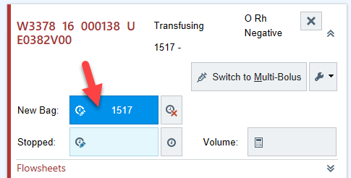
Expand the Flowsheets to document a set of vitals- This must be filled out for reporting purposes!! | 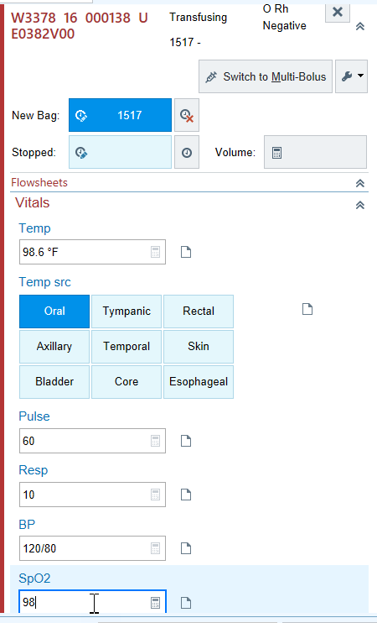
Document the stop time when the blood has finished infusing. If you have volume defaulted the 250 mL will populate as the stop was documented. If the volume is not defaulted for your site, enter the volume at this time. | 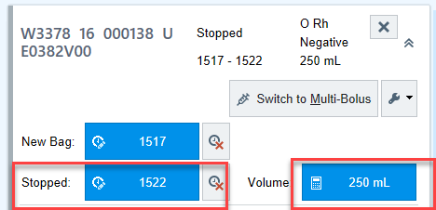
If the volume administered is a volume other than the 250 mL that defaults the volume can be edited by clicking on the volume and changing the amount | 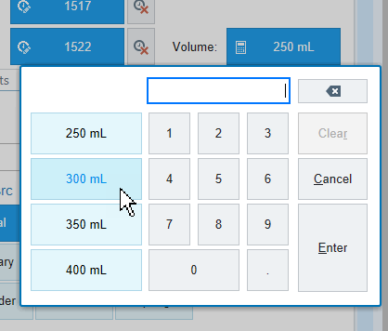
It is also possible to document multi-bolus. Hit the “Switch to Multi-Bolus” button and document the bolus start and stop times and volumes of each bolus. | 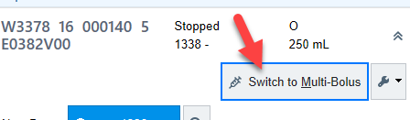  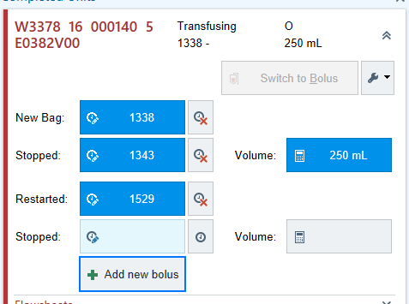
Once the blood window is closed the CRNA must enter their password.  Click Accept and Sign.  A second person must then enter their credentials for a dual sign off at this point. | 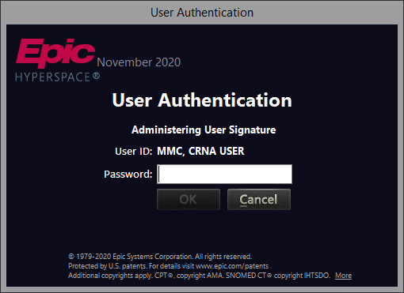
The blood administration will show on the Intraprocedure grid | 