Renewing Therapy Plans that are due to be expired.

- Under the Therapy Plan Section click Actions.
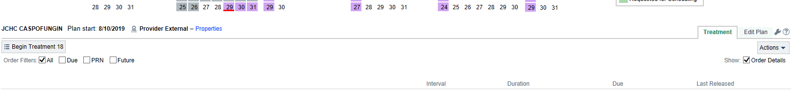
Click HERE
- Click Send Plan.
- Make sure the correct provider is the one getting the message.
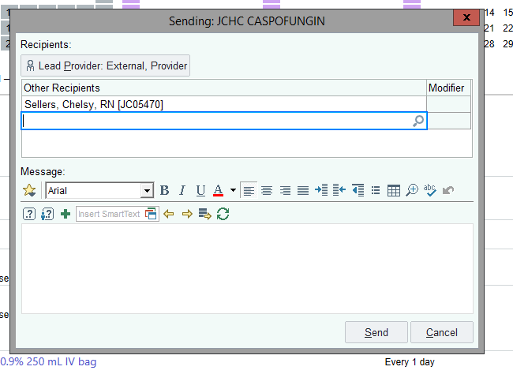

- The provider will then get a message in their inbasket that looks like this: 

- Provider then has to click “Open Plan” in inbasket. They then scroll to the bottom of the plan anc lcick” review plan” and EPIC will prompt them for a password.
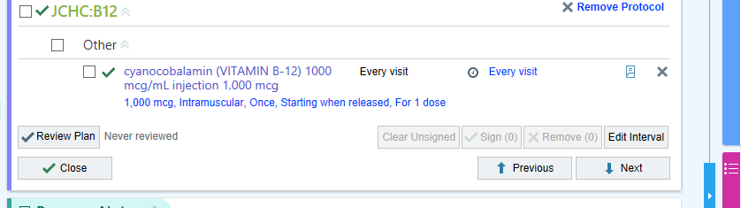

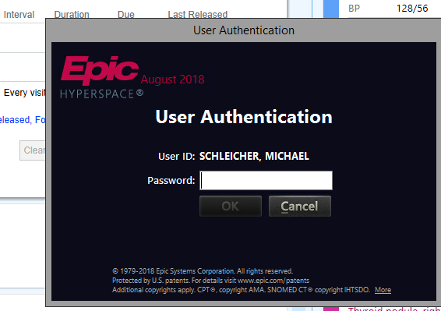

- *** If there are no orders in the plan the provider will see this message when they go to sign.
