Transferring Patients
Patient’s must be transferred between departments to or from surgery IF THEY ARE ON THE SAME LEVEL OF CARE.
- On your status board highlight your patient
- Click the TRANSFER BUTTON
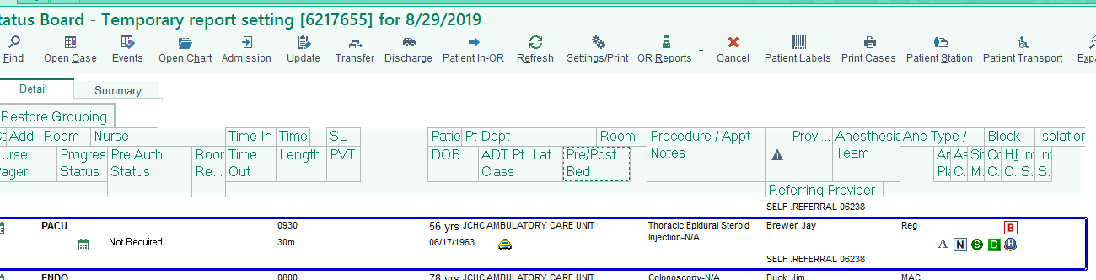
- Fill out fields as appropriate ( Use accommodation code from patient’s current information)
  - Make sure to hold Old bed for patients that will be returning to their previous bed.
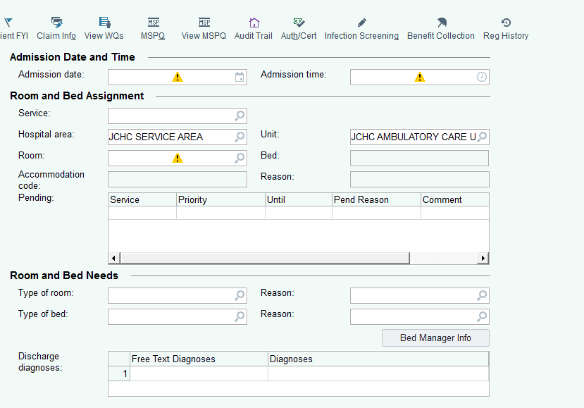
*** IF A PATIENT IS GOING ACUTE TO THE FLOOR AFTER SURGERY THEY MUST BE DISCHARGED AND THEN READMITTED.

