Medication Reconciliation Process
Nurse:
- Room Patient (all departments)
- Medication Reconciliation should be performed each time a patient has a visit, hospital stay, and or procedure where they will see a provider.
  - All medications should be reviewed thoroughly.
    - Include Route, dose, frequency
    - Do not just ask if there have been any changes to medications.
    - Any discrepancies noted by the nurse should be documented by changing the sig on the medication use button or fields whenever possible. The documentation will highlight in yellow automatically for providers to see the patient is taking differently then ordered on their screens. 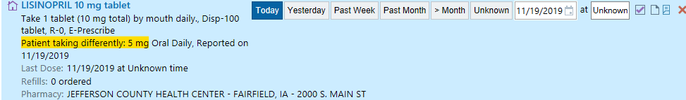
    - If a patient is simply not taking a medication prescribed to them, the nurse should note this under the sig. as not taking. Provider will follow up on the items highlighted in yellow. 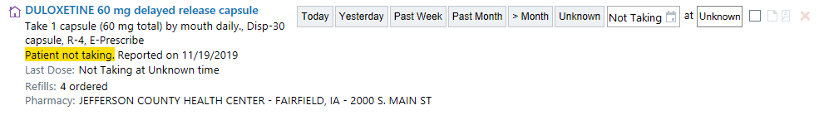
    - Nurse will call patient’s pharmacy for clarification if there is a dosage discrepancy, i.e., huge difference between 20mg and 40mg.
    - If a patient is taking a short-term medication and is finished, it’s ok for the nurse to hard delete (click the red X) the medication, i.e., Antibiotics or short-term steroids
This is somewhat new for some nurses and providers: Please take note of the above.
- If a patient is taking supplements, the nurse will make a note and communicate with providers appropriately. Only noting the supplements the patient is taking on a regular basis.
- If a patient does not know which supplements are being taken, put in as an “other” medication.
  - See Media Tab for scanned list.
  - IF the patient does not know every supplement they are taking and all supplements can’t be entered/scanned into the patient’s chart, DO NOT MARK AS COMPLETED at the end of this process.
- Patient’s pharmacy will be checked at each visit to make sure the correct pharmacy is selected as primary.
  - Scripting “What pharmacy would you like to use for any prescriptions you receive today/this visit?”
    - This may differ by department since Med Surg and ED should only be a 1x fill vs mail order refills in the clinic.
- (NEW STEP)
  - The Med List Status should be marked with the appropriate description of actions taken. This will help other departments the patient may travel through know if the med rec has been reviewed completely.
Med List Status Options:
    - Completed = Meds have been completely gone through one by one with patient/family verified and accurately updated
    - In progress = Meds have been started and attempted to update but unable to complete at this time. This should be communicated to the next shift, floor hand-off, and/or provider.
    - Waiting = Meds may have been started or attempted may be waiting on list from pharmacy or family. This should be communicated to the next shift, floor hand-off, and/or provider.
    - Unable to Assess = Patient unable to give information, no family, etc. This should be communicated to the next shift, floor hand-off, and/or provider.

***Even if a med rec has been completed on a patient, it should be reviewed with the patient when transferred to another department (ED/OR/IP) or (Clinics to IP).

  - Inpatient ONLY-
Home meds should be the patient’s most up-to-date med list.
If discharged from another facility, what new meds were they discharged on? These meds need to be added to list for take home!!!
Once Med rec. has been performed by admitting provider. The charge nurse will:
        - If needed - will enter 2 orders for same medication taken more than once daily with different doses.
        - Make sure provider converts same medication orders back to a single order upon discharge. (to ensure patient doesn’t get 2 prescriptions causing 2 co-pays)
        - If pharmacy calls with discrepancies a telephone encounter MUST entered.
        - WE SHOULD ALWAYS HAVE A MED REC unless TRANSFERRED to another facility acutely.

Providers
- Once the nurse is done with the intake of the patient, the provider is to also reconcile any discrepancies in the med list. *Yellow highlighted items*
    - If a patient is not taking a prescribed medication as directed, or taking a medication differently than prescribed, it is up to the provider to:
      - Make the permanent change to the patient’s med list by deleting the medication
      - Educating the patient on why it was prescribed and needed if they feel they need it.
NOTE: If the nurse hard deletes a medication, there is no documentation indicating to the provider, the patient was on the medication.
      - Providers will add a duration to short term medication prescriptions.
NOTE: Putting a quantity on medications does not automatically drop it from the med list when it is completed.
    - The provider will know the medication list has been fully reviewed when marked as completed is documented status.
    - If the med list is just marked as reviewed and in progress for med list status, the provider will know there is an incomplete item. Nurses are instructed to communicate this to the next shift, floor hand-off, and/or provider.
      - If there is a discrepancy or 2 meds on the list with 2 different dosages, the nurse is directed to call patient’s pharmacy to verify. HUGE difference between 20mg and 40mg.
      - Supplements
        - Nurses will try to put all routinely taken supplements on the patient’s med list, if the patient knows what they are. They may be in under “other” medication.
    - Med Status reasons for incomplete:
      - Nurse may mark Unknown med list at the time of rooming
      - Should be trying to get the full med list in the meantime.
      - Not all meds where reviewed due to patient’s condition.
- INPATIENT PROVIDERS ONLY
  - During order reconciliation phase (2) Review PTA Meds
- Providers should now closely look at the 2nd tab (Review PTA MEDS)
        - This is where the nurse’s notes will go for review of taking/not taking/taking differently than prescribed.
        - The “Mark as Reviewed” button should be hit by the provider after thorough review of the med list, even after a nurse has reviewed it.
- Med List Status Check: If a med list is not marked as completed while doing admission/discharge reconciliation, he/she will report to the charge nurse and/or pharmacy to complete the reconciliation to ensure patient is being discharged on the most current medication list.
    - The provider also sees the nursing comments on their Reconcile PTA meds tab (4) upon admission and discharge.
    - Providers have the final decision as to how a medication is prescribed upon discharge.
- Providers make sure you convert same meds back to a single order upon discharge. (to ensure patient doesn’t get 2 prescriptions causing 2 co-pays)

