Giving a TB test
- Patient should have a form from an employer or school
- Make sure patient will be available to have it read within the correct time
- Draw up 0.1 ml of tubersol in a TB syringe
- Verify with another nurse
- Go to meds and orders
- Order a TB panel (may have to click on facility lists to see the right order)
- 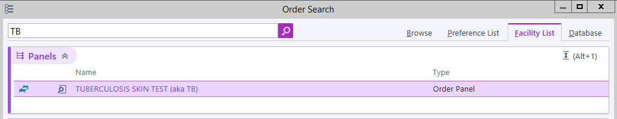
- Associate with Screening for tuberculosis
- Sign verbal order
- Print patient labels
- Scan labels then vial
- Document which side it was given, who it was verified with, NDC, LOT and EXP date
- Make sure the needle is bevel up and insert just under the skin on the forearm
- Make sure it bubbles up
- If it does not, you will have to repeat on other arm
- Fill out form
- Instruct patient to come back to have it read between 48 and 72 hours later. No earlier and no later.
- Scan in form EVERY TIME and give back original copy (or specifically document where the original form is
- Go to nursing note
- Use .cntb
- Make sure there is a cosign
Reading a TB test
- Verify that patient is in the time frame to come back (48-72 hours)
- Can redo TB that day if late
- Look at the site and make sure there is not a reaction (See poster in large nurse lab)
- If there is a reaction, have a doctor look at it
- Fill out form accordingly, scan in form and give them original copy
- If they need to have a second TB test they may come back in a week
- Release order under order review
- Go to enter/edit results
- Enter TB results
- Document on the Outpatient flowsheet.

