How to move pictures to the correct patient is accidently entered on the incorrect patient.
- Select Media Manager from tool bar if you do not have Media Manager on your tool bar go to next step

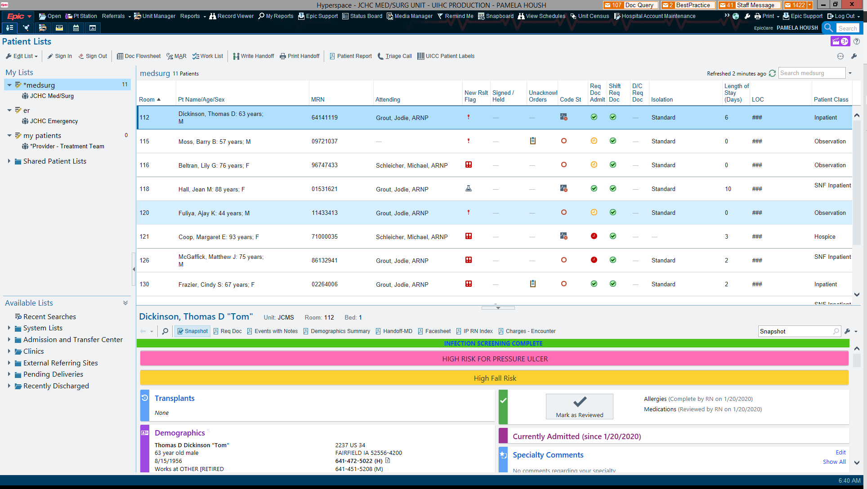

- On tool bar search Type Media Manager when jump to media manager comes up click on it.
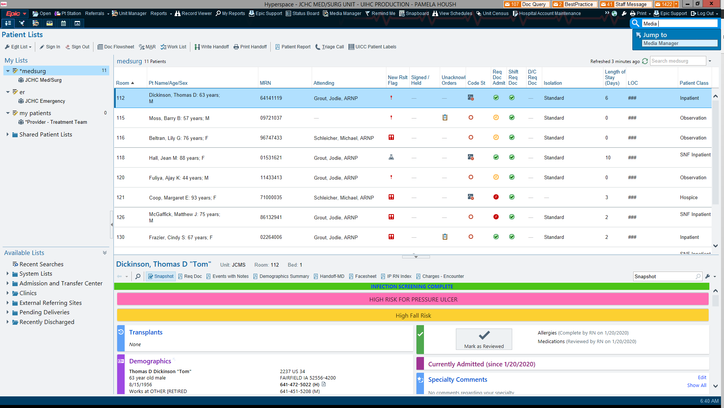

- Patient Lookup will come up. Type the name of the incorrect patient. (The patient the picture were accidently put on) and enter or accept.

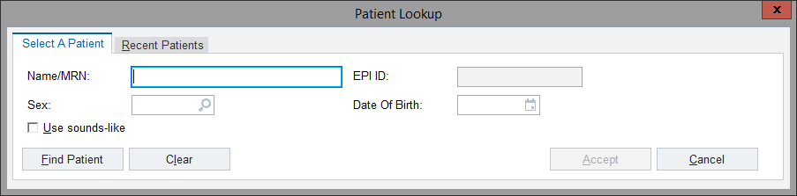

- Highlight the photo that needs moved and click edit.
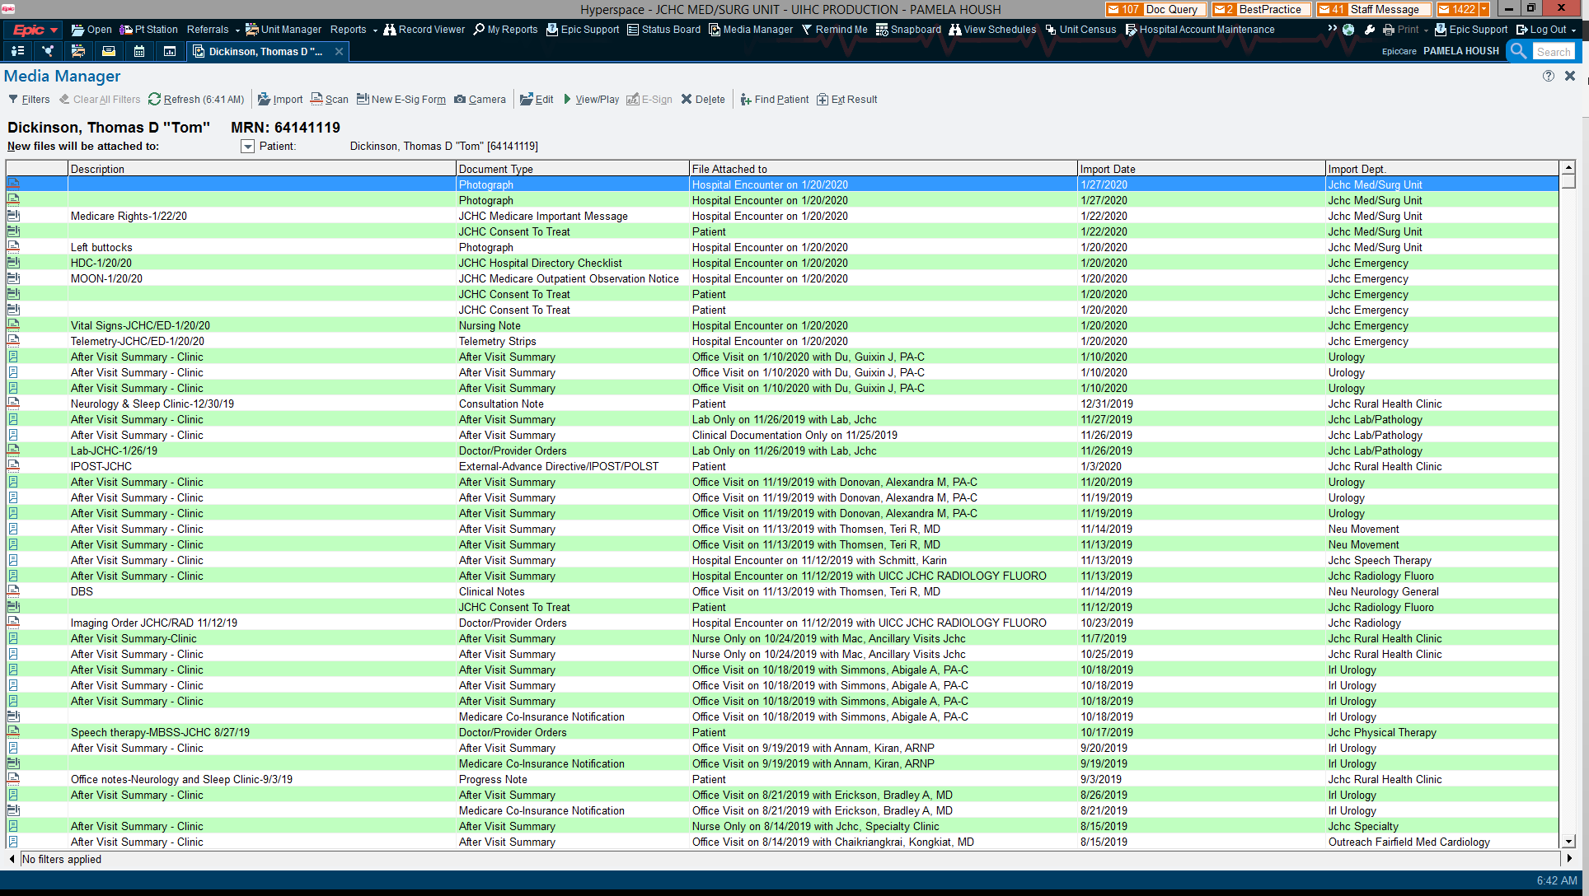

- In center where is says patient Type patient’s MRN you want to move the photo to. (the correct patient)
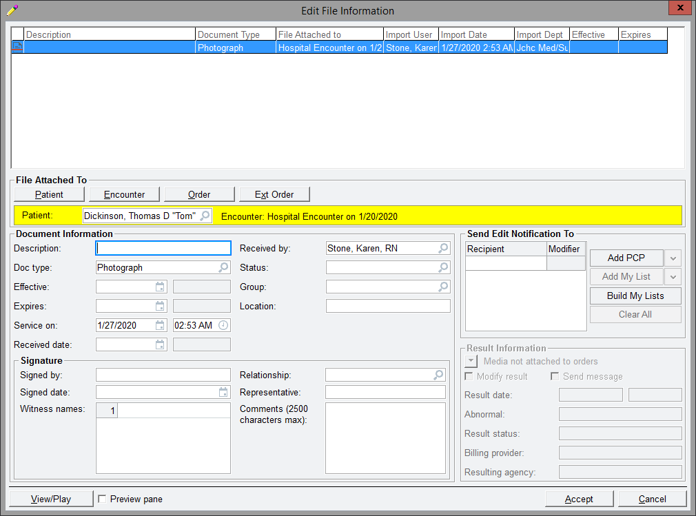

- Change patient will come up select the correct patient again.
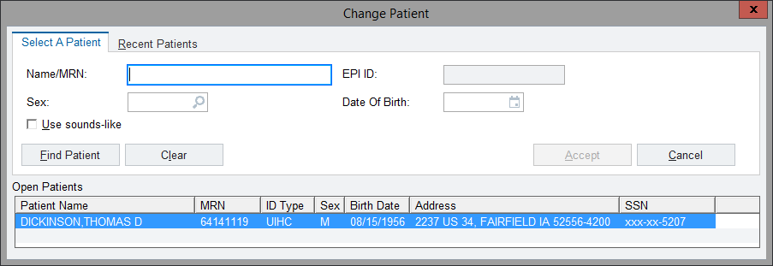

- Enter or select the correct patient
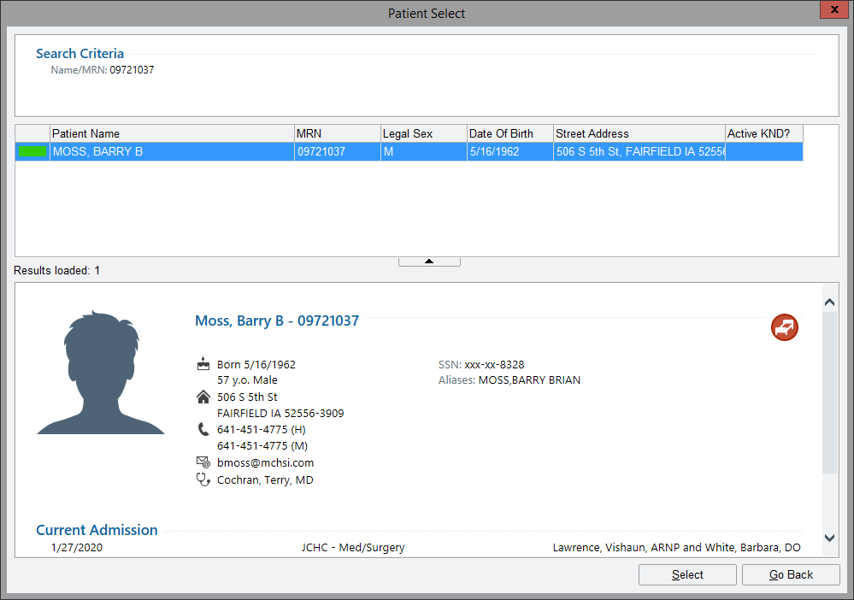

- You will get this warning select yes.

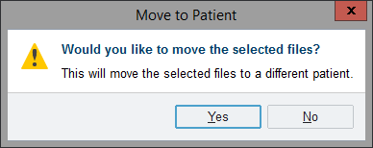

- Confirm this is now the correct patient and click encounter.
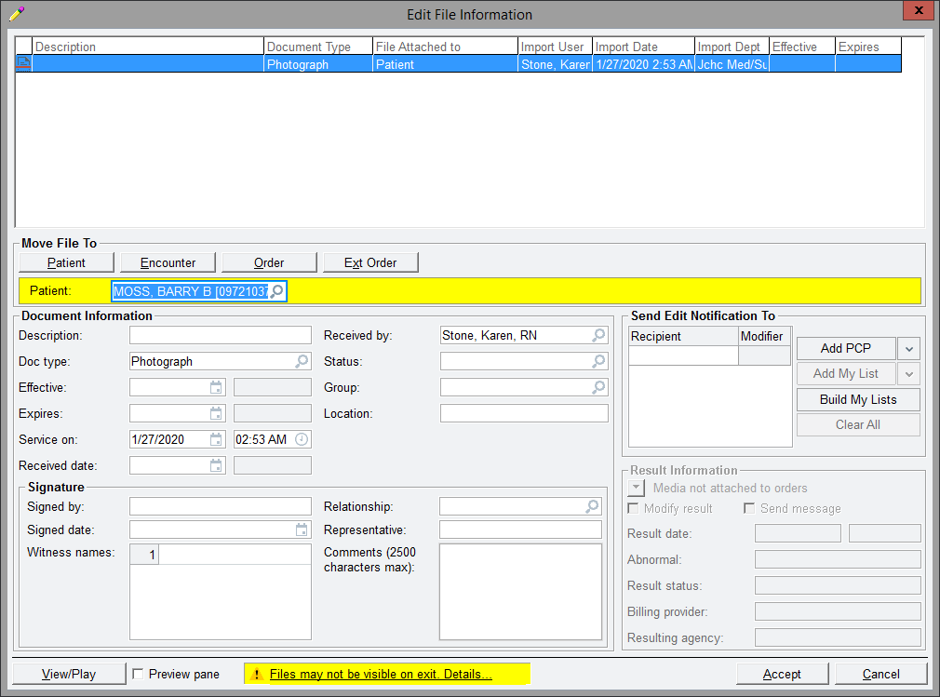

- Select the encounter the photos were to be on.

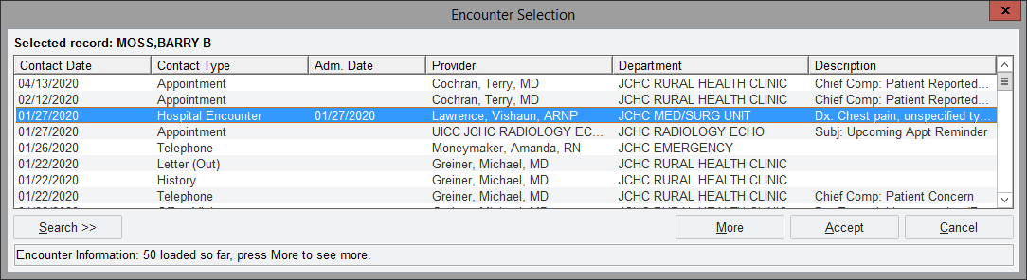
- You will get this warning select OK
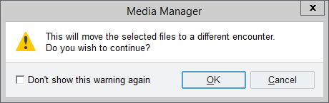

- Confirm on required information is correct and filled out according to scanning guidelines. Then click Accept.

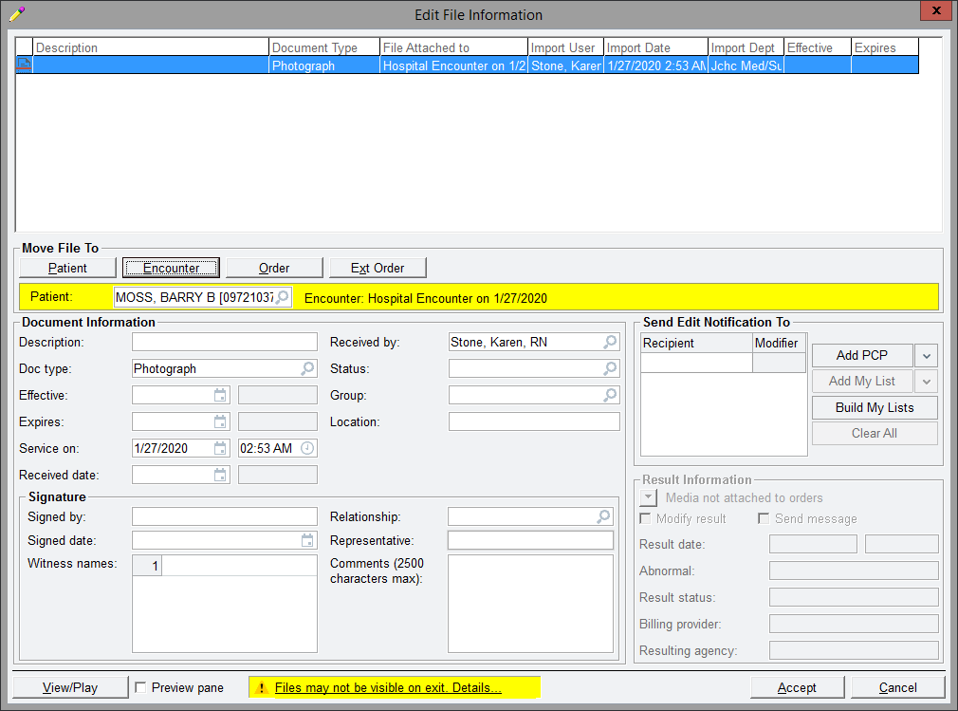

- Confirm photo was removed from incorrect patient.
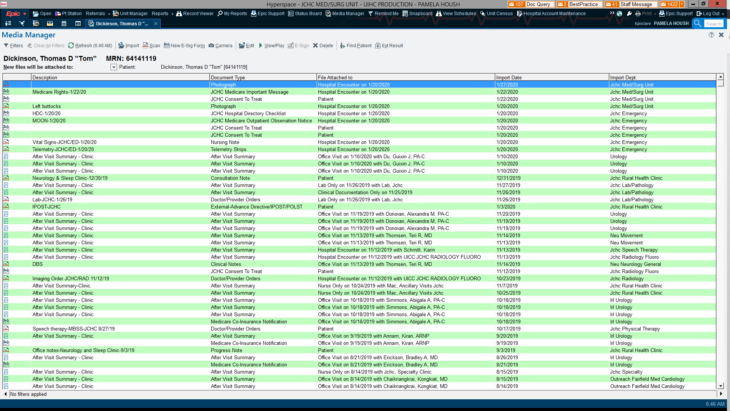

- Confirm photo is on correct patient. Either from Media Manager or chart review.

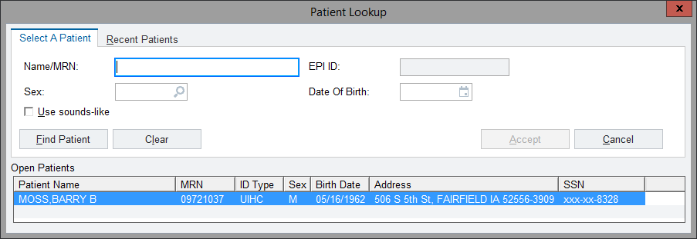

- Done!!!!
