Document Bladder Scan results in Enter/Edit Results:
You will not need to release the order.
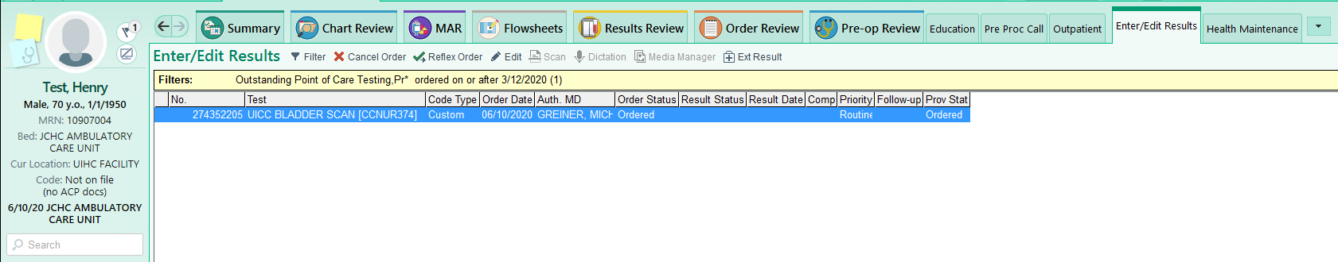

The comment you type in will show up for the provider. Entering the results here will automatically route them to the ordering provider’s In Basket (clinic/ACU & med/surg). ER results will show on the event log.
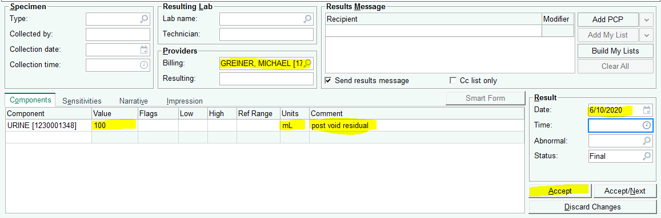
Leave ‘send results message’ checked.
Result to ordering provider (clinic & Med/Surg):
