Pre-op Review
- When doing pre-op review this part of the chart can be finished without talking to the patient.
- All questions need to be answered and that there have been appropriate labs, EKG, and images completed.
- Here is where we determine if there is an H and P on the chart.
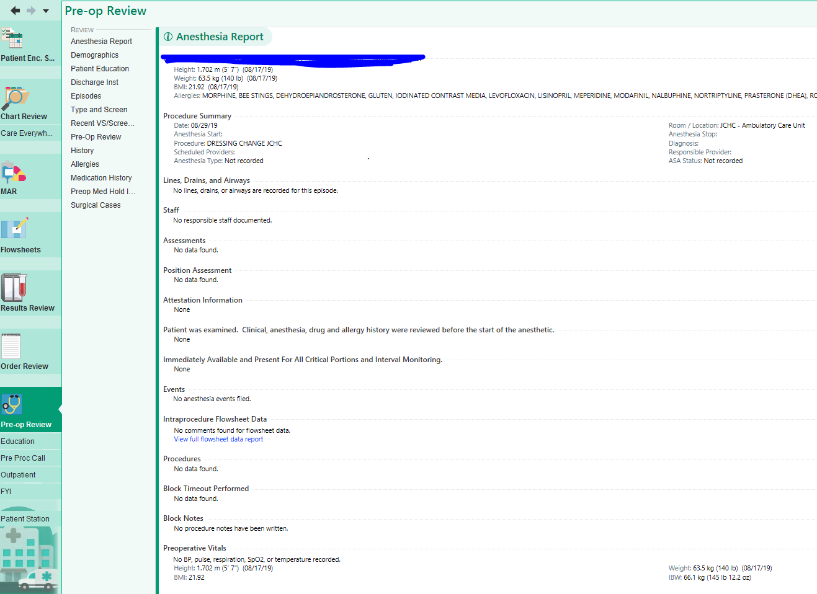
Finding History and Physicals, labs, images, EKGs
- In this tab you can find H and P’s under (notes or med tab (external providers). External doctors still fax in H and P’s which get scanned to the chart. At this point there must be an original H and P on the chart, or we need to call the provider to get one.
Chart Review - Notes
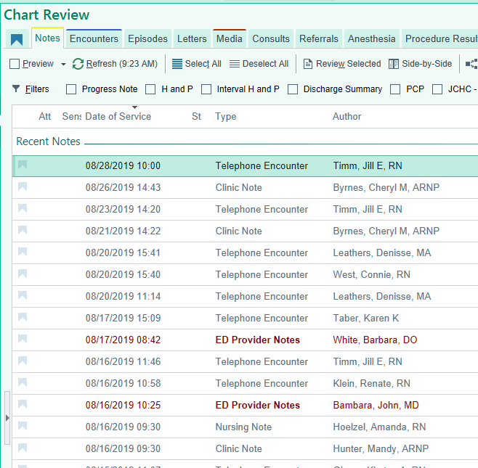

Chart Review- Media
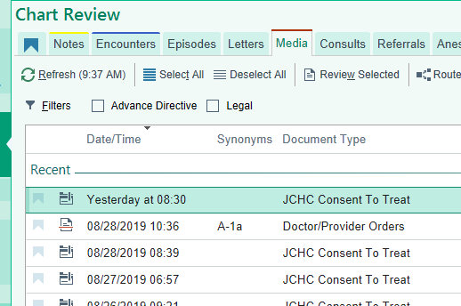
Pre-Op Call
- If a patient doesn’t answer or is busy when you call. Fill in what you can on the phone call. The rest of the information must be filled out the day of surgery.
- anesthesia questions must be filled out on pre op phone call.
- The patient needs to be off of any medications that may increase bleeding should be addressed with the pre-op phone call as well as those listed in pre op instructions.
- This is also where you can confirm the case.
  - Click the green check mark with confirm next to it will show the chart is ready and the patient has been talked to.
  - Do not confirm a case unless everything on the chart is done. H and P, orders, consent signed, and you have spoken to the patient.
