Optime | Statusboard Icons
There are many icons on the Statusboards. This is a legend for all those icons.
Status Icon  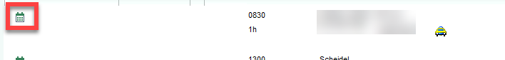  Or  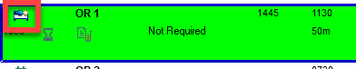  Or  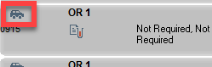 | This icon has multiple. The icon will show the status of the patient at the present time. For example if an appointment the icon may show a calendar for scheduled or a check mark for complete.  A case will show the patient’s progress as marked throughout the case. Examples include scheduled, in OR, or discharged. (There are many)  Hover over the icon for its meaning.
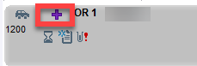 | Indicates that the case is an add on
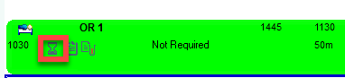 | There are signed and held orders that need to be released. (Please note that if there are signed and held orders for a future encounter this icon will appear)
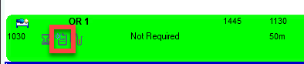 | There are orders that need to be acknowledged, once the orders are acknowledged the icon will disappear.
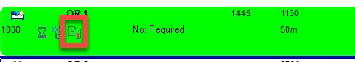 | There are results that have not been viewed by the user yet. None of the results are abnormal. To clear the icon click the Time Mark button in Results Review.  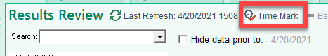
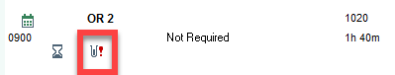 | There are results that have not been viewed by the user yet. There is at least one abnormal result. To clear the icon click the Time Mark button in Results Review.
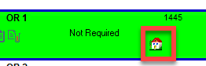 | Room Ready event has been marked
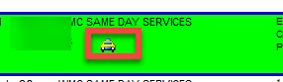  Or    Or  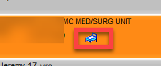 | This icon has multiple. The icon will show the patient’s Patient Class as scheduled. For example, a car icon indicates Hospital Outpatient Surgery.  Hover over the icon for it’s meaning.
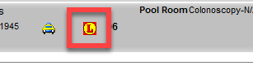 | The patient has a latex allergy
 | Indicates that Anesthesia has not written their preop note yet. The icon will clear when the note is signed.
 | Indicates the Nursing Checklist is not yet complete. The icon will clear when nursing marks the checklist as complete in their preop navigator.
 | Indicates that the surgical site has not been marked yet. The icon clears when the surgical site information is documented in preop/intraop.
 | Indicates that the consent has not yet been signed. The icon will clear when nursing marks the consent has been signed in preop.
 | Indicates that the H&P is not written or up to date. The icon will clear if the H&P is recent or an interval was written by the surgeon.
 | Indicates that the patient is scheduled for a block procedure.
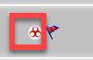 | Indicates the Infection Screen status of the patient. There are many icons indicating testing was completed, patient is recently recovered or that the patient has an active infection.  Hover to view what the icon is indicating.
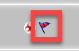 | This indicates that the patient has an active infection. Hover to discover the infection.
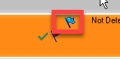 | This indicates that the patient is in isolation. Hover to discover the type.
ONLY WMC  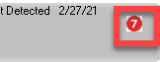 | Indicates the patients COVD risk score. The score is based on many items documented throughout the patient’s chart.
ONLY ISH/MMC   | Indicates that the patient has an order for intraop C Arm.
ONLY ISH  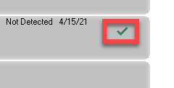 | Indicates that the patient has a COVID Vaccine documented in Health Maintenance.

