Documentation of Patient’s O2 status (upgrade change)

In the Gas button on your toolbar there is now a line to document whether the patient is on Room Air or Supplemental oxygen

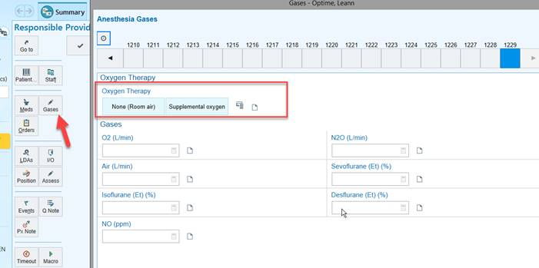

If supplemental oxygen is chosen there will be choices that appear showing what delivery method the supplemental O2 is delivered by

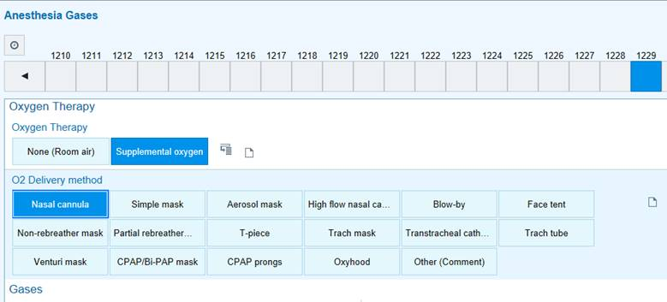

If these rows are documented on they will show in the Anesthesia Record Report in the Assessment area

