Anesthesia Creating an OOOR Procedure Record |  | The OOOR Procedure record creation process is to be followed when an Anesthesia provider is performing a procedure outside of the OR. Examples include: Intubation, PIV placement or Sedation in the ER or Med/Surg Units  Log into ANESTHESIA Log in!
Log into the Anesthesia OR Department and access the Patient Lists activity | 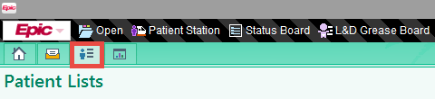
Access the System Lists option in the Available Lists section of the Patient List activity.  From the System Lists select the folder labeled XXX Units.  From the XXX Units folder select the Unit in which your patient is located. | 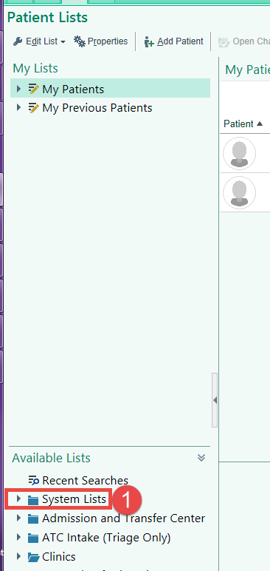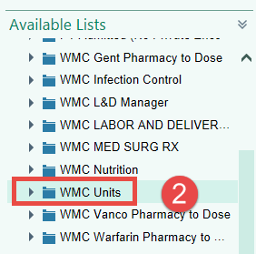  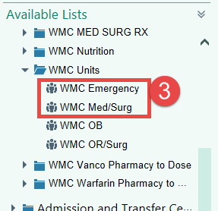
It is possible to favorite the unit lists to reduce clicks in the future. Right click on the unit you wish to save as a favorite and choose Save as Favorite.  The unit will now appear in the My Lists section of Patient Lists | 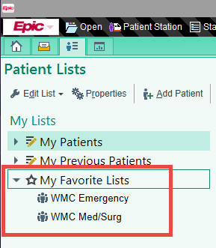
Once the unit is selected, the list of patients will appear at the top of your Patient Lists activity.  Click once on the patient that you are going to perform a procedure on. Once the patient is selected, the toolbar has options for charting on your patient.  Evaluation: Is to be chosen if the Anesthesia provider is simply going to evaluate the patient and not perform the procedure at this time. The Pre Eval and Anesthesia Plan Note can be written at this time *  Pre: The Preprocedure Navigator will be available in this activity  OOOR Procedure: The Procedure portion of the record will be available in this activity.  Post: The Post Procedure Navigator will be available in this activity | 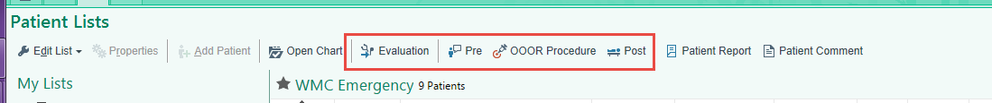
When accessing the Pre, OOOR Procedure or Post activities from Patient Lists, the Anesthesia provider will be provided with a box containing Anesthesia Record options.  Choose the option that best suits the procedure being performed, or free text in the “other” box if the options available do not meet the needs. | 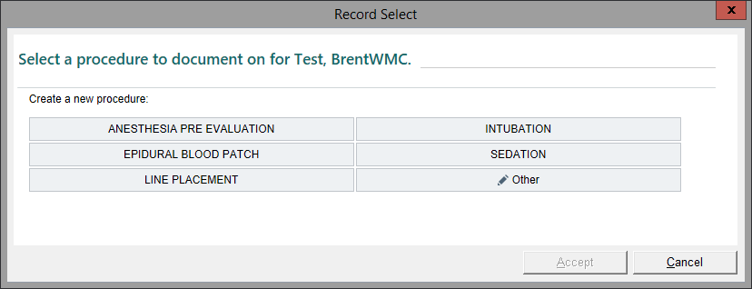
Once a record is created, the provider will not have the option to create another record of the exact same type.  For example, if an Intubation record is created on a patient and the Anesthesia provider accesses the chart again- the provider does not have the ability to create another Intubation type record. They will only have the ability to enter the Intubation record already created. This change should cut down on the number of duplicate records a patient has. | 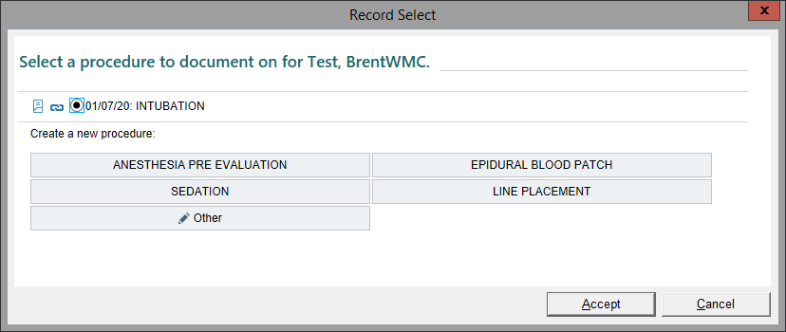

* Please note that the Anesthesia Pre Evaluation and Anesthesia Plan can be written ahead of time in the Evaluation workflow, but these notes will not automatically carry forward to the patient’s procedure record. The note will need to be copied from the Evaluation record into the procedure record. (Please see copy note tip sheet).

