PICC LINE DOCUEMNTATION
1. Log into JCHC ANE Procedure Context
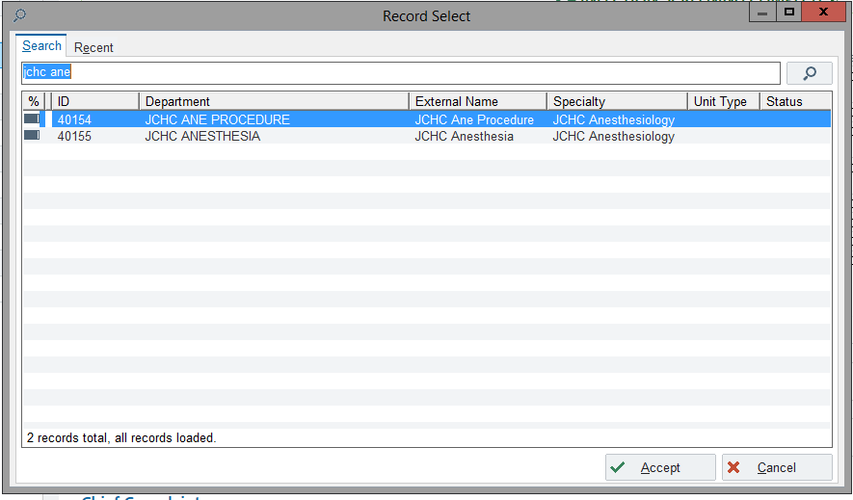
2. Under the Epic dropdown in the left hand corner select Status Board.
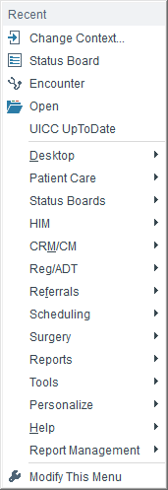

3. Double click into your patient and select the procedure tab. Then Select Procedure Note.
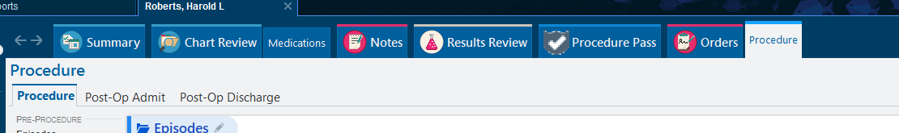
4. Select the ANE Blank Procedure Note
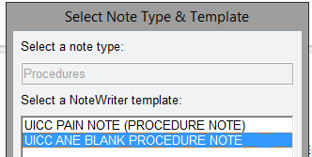
5. Select the PICC Line Button to pull in the smart form. (boxes)
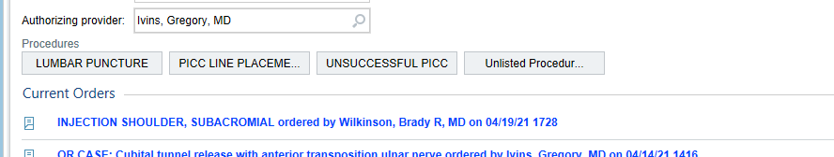
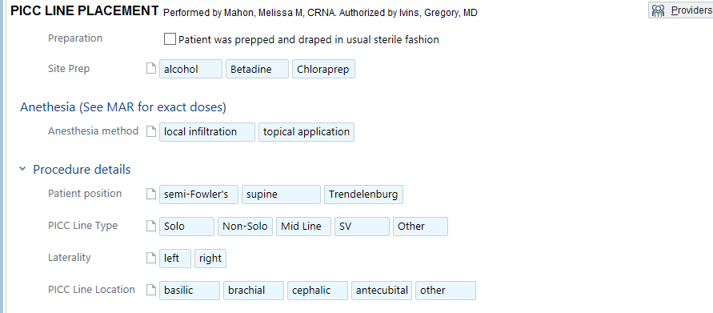
6. Fill out the form to populate your note. Add additional information under the NOTE tab or remove the ***.
7. Sign when completed.
8.Add charges in Charge Capture
