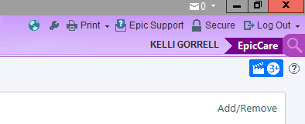
Click on magnifying glass and type in Preference List Composer
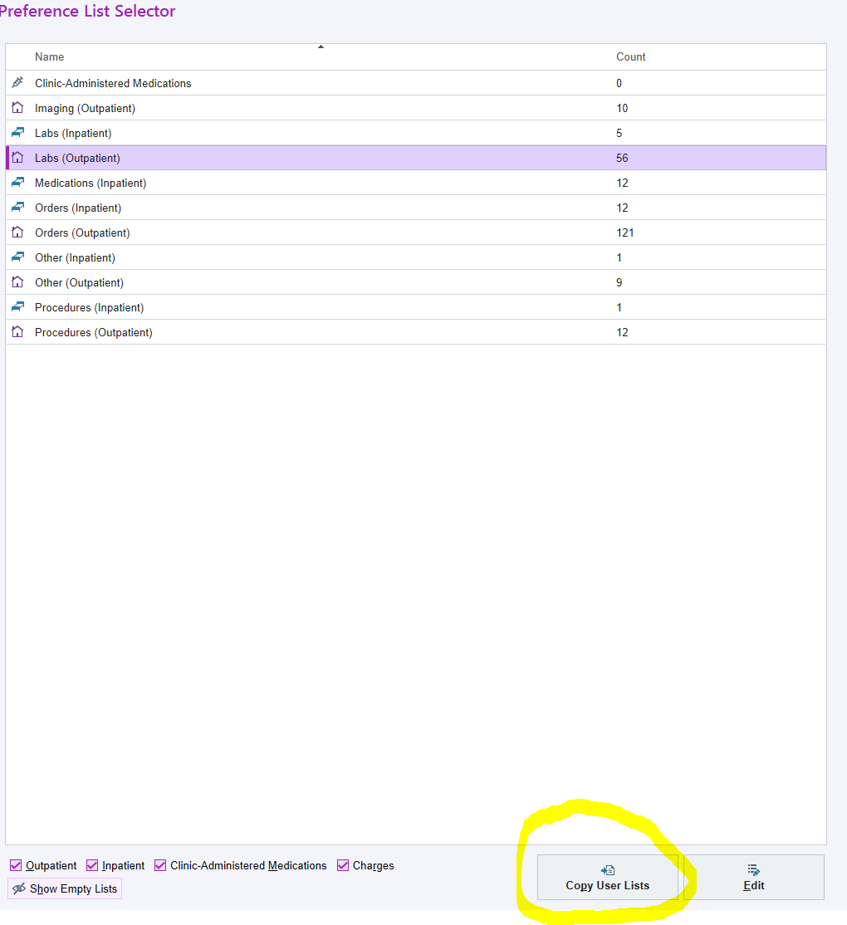
Click on Copy User Lists. In the pop up Type in Jennfer Hawkins and then scroll down to “orders (outpatient) and select it and choose Copy.
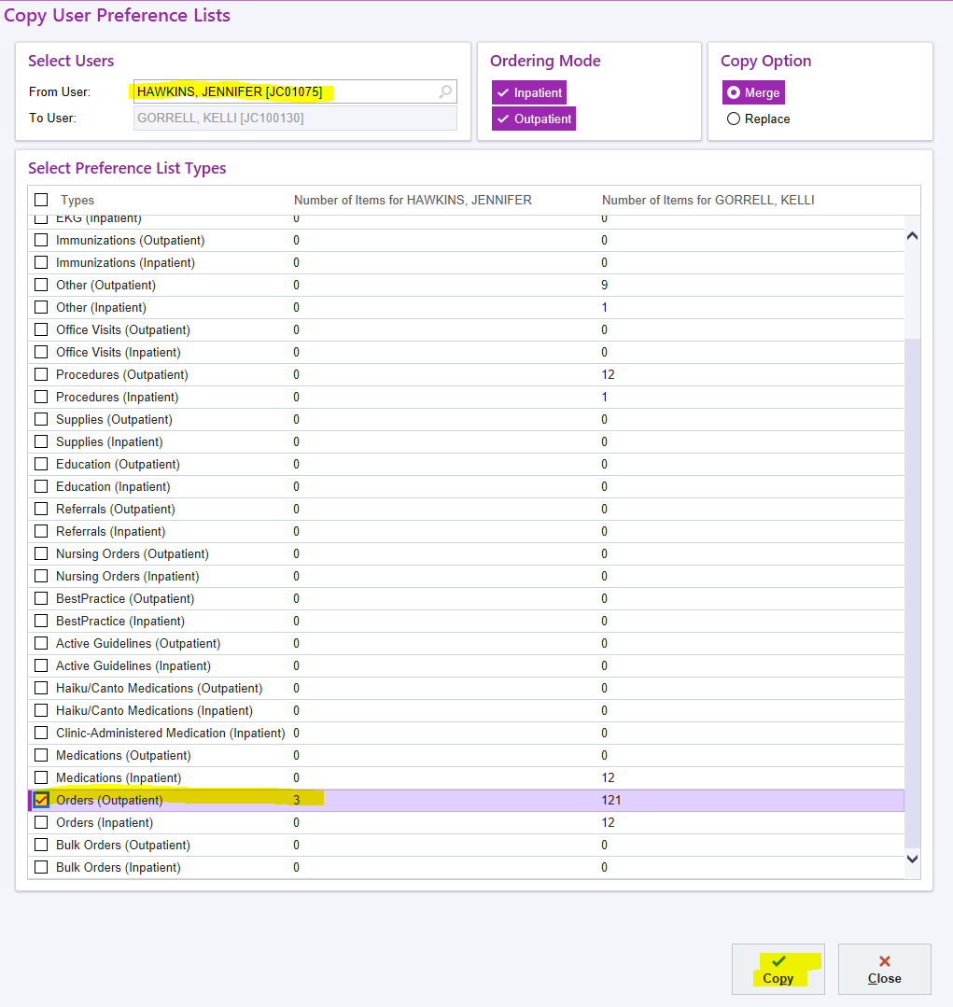
Wait until the bar at the bottom of the screen states Copy Completed and then click Close.
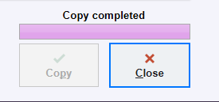

In your orders these will now appear under after visit orders in your My Favorites section. You should only need the two labeled HRA Wellness and HRA MALE GREATRE THAN 40.
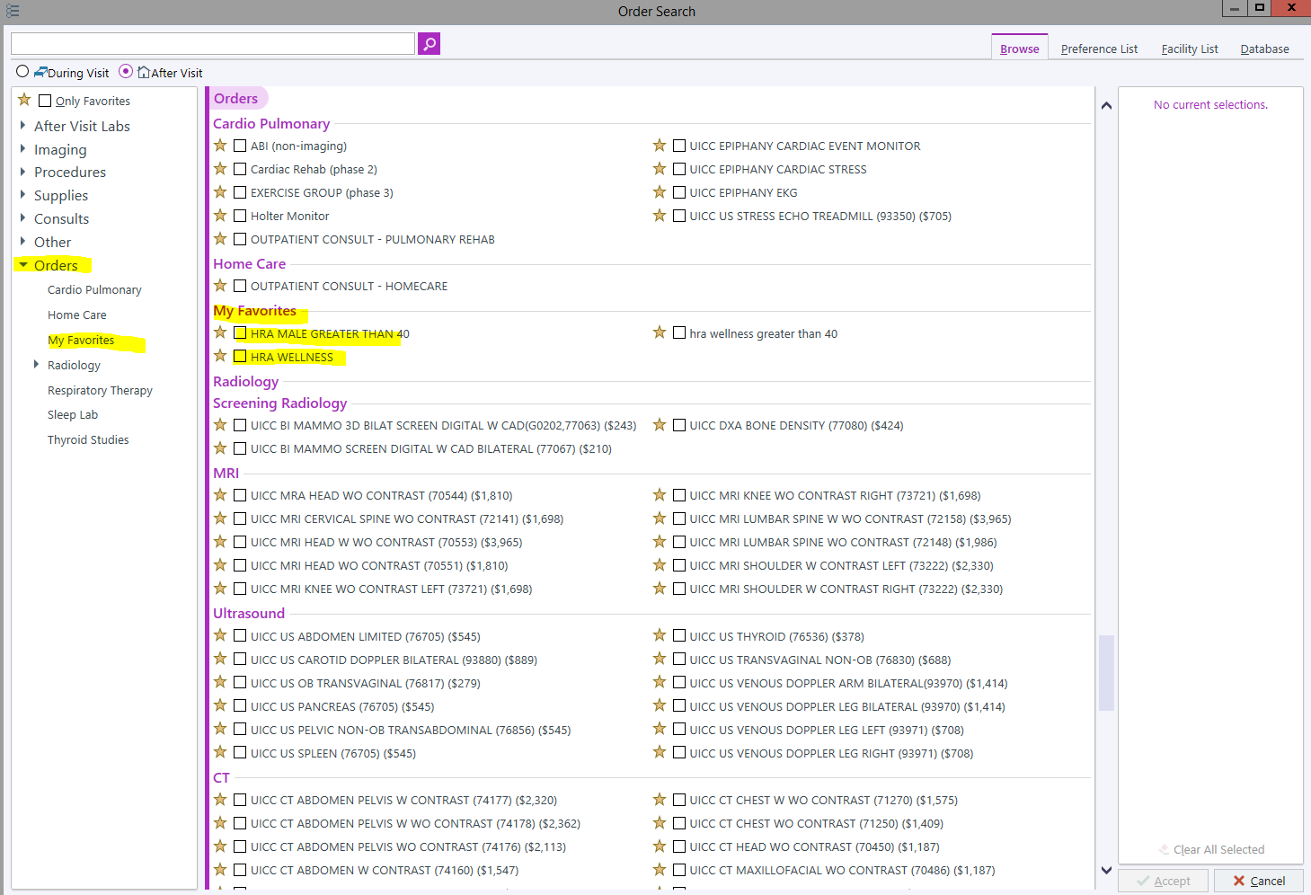

If you would like, you can remove the third entry (hra wellness greater than 40) by right clicking on it and choosing Remove Preference List Entry.

