Affected Departments: JCHC Ambulatory Care

Purpose(s) / Objective(s):
To help workflows with downtime procedures
Note: -If JCHC has internet availability- can still access Netscaler- follow Netscaler instructions
Double click on Epic Netscaler icon on desktop
Log in using your regular Epic login information
-If JCHC has no internet availability then follow this downtime procedure

Procedure(s)/Documentation:
- Orders
- Established ACU patients (non-surgical)
- Print off patient information needed using the back-up computer located behind the nurse’s station on MedSurg.
- Therapy plans
- Schedules
- MAR reports
- New ACU patients- non-scheduled (non-surgical)
- Patients should carry paper orders from clinic to admissions and then to ACU.
- Paper orders brought over with patient must be entered into EPIC once it is live.
- Paper order will be scanned into EPIC media tab using scan Matrix by Peri-Op scheduler.
- Surgical Patients
- Scheduled surgical patient (arrived before downtime)
  - Print off patient information needed using the back-up computer located behind the nurse’s station on MedSurg.
- If orders already released then print – Case request, orders released up to that point, MAR
ii. If orders have not been released see b.
  - Use printed surgeon order sets, located in downtime forms binder. *Note: The order sets will follow patient to OR and PACU so they can access their phase of care.
- Unscheduled surgical patient
- Patient should carry paper case request and order set from clinic to ACU
(see original in ACU downtime binder, clinics have copies as well).
- Paper orders brought over with patient must be entered into EPIC once it is live.
- Paper order will be scanned into EPIC media tab using scan Matrix by Peri-Op scheduler.
- Signed and Held Orders
- Will not be able to access signed and held orders
- Will need to obtain a paper order or a verbal order by phone.
- Once Epic is back up these orders will need entered back into the EHR by the RN providing cares in order to document on the MAR.
- Procedures
- All downtime forms can be found in the Red Downtime Forms binder.
- Keep paper log of event times on In/Out sheet for all patients.
- Documentation of medications given
- All administrations, rate changes, and stop times on will be documented on manual MAR worksheets.
- Person who didn’t give the medication- use MAR action: “Downtime Administration,” Override Reason “Clinician reported given by another.” Then type “Per *** see paper MAR”. Using that person’s initials.
- Person who administered the medication- use MAR action: “Downtime Administration,” Override reason system downtime.
- Obtaining medications from Omnicell:

Add a Temporary Patient in Omnicell
If a patient has not yet been added to the hospital ADT system due to downtime or another reason, their name will not be displayed in Omnicell for manual dispensing. You can dispense items to this patient by adding a temporary patient as described here.
- First sign into Omnicell.
- Press patient care if not already there.

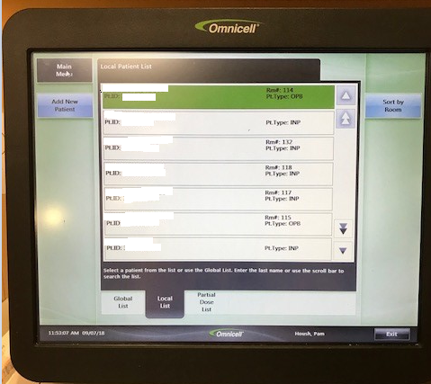

- Press Add New Patient.

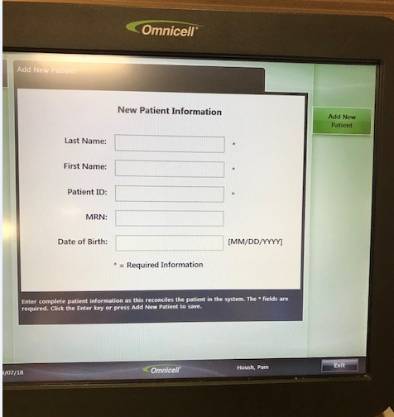

- On the Add Patient screen, enter available information.
Last name, first name, and temp(orary) patient ID entries are required, as indicated by the caution symbols on these fields. Press the caution symbols to display additional information.

- When required entries are complete, press Add New Patient to arrive at the screen where meds can be retrieved. The stocked meds tab will need to be used.
- Documentation of nursing/therapies
- Documentation on paper: ACU Order and Intervention Flow Sheet and/or Nurse’s Notes
- When system is active again, all allergy and I&O data, and any other critical data need to be back-entered into the system by the RN that provided the patient care.
- Non critical data may remain on paper, which is to be scanned into EPIC. The original paper copies to be put in HIM wire basket to be scanned in by them.
- If patient requires infusion/injection teaching, this information can be printed from Up To Date to be given to patient. This needs documented on nurse’s notes.
- H&P – Since we will be unable to do an interval H&P the surgeon will have to fill out a paper H&P form prior to the surgery or procedure. Form can be found in red downtime binder or in the file cabinet under the ACU RN desk.
- Consents
- Blood consents
- Use paper form in down time binder have patient sign.
- Place original paper copy in HIM wire basket to be scanned in by them.
- Surgical consent
- Fill out Consent to operation, anesthetics and other medical services found in downtime binder.
- Confirm procedure description with ordering surgeon.
- Surgeon will sign and date this form.
- Obtain signature from patient prior to procedure.
- Place original paper copy in chart to go to the OR with the patient.
- This form will stay with chart and be placed in wire basket for HIM to be scanned in by them.
- Anesthesia consent
- Anesthesia provider will obtain Informed consent for anesthesia sedation analgesia form from downtime binder.
- CRNA is responsible for filling out this form and obtaining patient signature.
- CRNA provider will sign and date.
- Place original paper copy in chart to go to the OR with patient.
- This form will stay with chart and be placed in wire basket for HIM to be scanned in by them.
- Discharge instructions
- Pull appropriate discharge instructions from red downtime binder.
- Fill out required fields per physician orders.
- Have patient sign and date
- RN will also sign and date as witness
- Give a copy to patient and place original in HIM wire basket to be scanned in by them.
- Patient teaching
    - Endoscopy Patients
- Obtain Screening vs. Diagnostic form. Have patient sign.
- Obtain Endoscopy ABN form. Have patient sign.
- Fill out paper nurse’s note that teaching was complete.
- Place all 3 above documents in the HIM wire basket to be scanned in by them.
    - Surgical Patients
- Fill out paper nurse’s note that teaching was complete
- Place document in the HIM wire basket to be scanned in by them.

- Labs
- JCHC standard order form – can be found in red downtime forms book.
- Send paper order to lab
- Lab will call result or send printout from machine
- After EPIC is back up, ACU/OR staff will need to go back and enter the order and when it was collected into the EHR.

- Radiology
- JCHC standard order form – can be found in red downtime forms book.
- Hand write order and have it signed by physician
- Call 4154 to notify Radiology they are needed in ACU
- Radiology will come and complete test
- Place original order with chart in HIM basket to be scanned by them

- Pharmacy
- Automated dispensing cabinet not functioning
- ACU/OR will call pharmacy to medications needed if the automated dispensing cabinet is down during business hours.
- Another option is to use Emergency Department or MedSurg dispensing cabinet if one of those is functional.
- If outside of pharmacy hours and no automated dispensing cabinet is functional contact pharmacy manager to assess the situation and provide needed medications during the downtime.

- Paper clip all forms together and place on empty desk in Peri-Op scheduler’s office. Note: Once EPIC is back up we will enter necessary information PRIOR to sending patient chart to HIM to be scanned in. The primary RN will be responsible for completing this for the patients they provided cares for once EPIC is live.

Additional Info:

Related Form(s):

Resources:

