IV Insertion/removal (pt sticker)

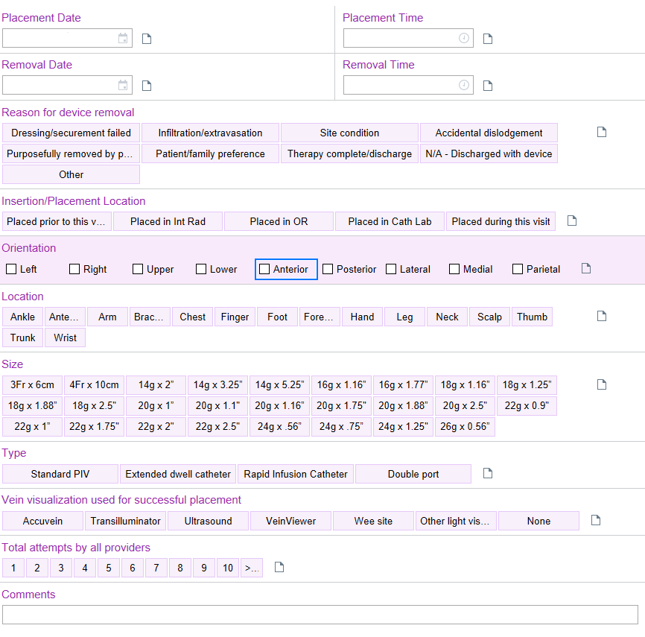

(pt sticker)
IV assessment/new bag start
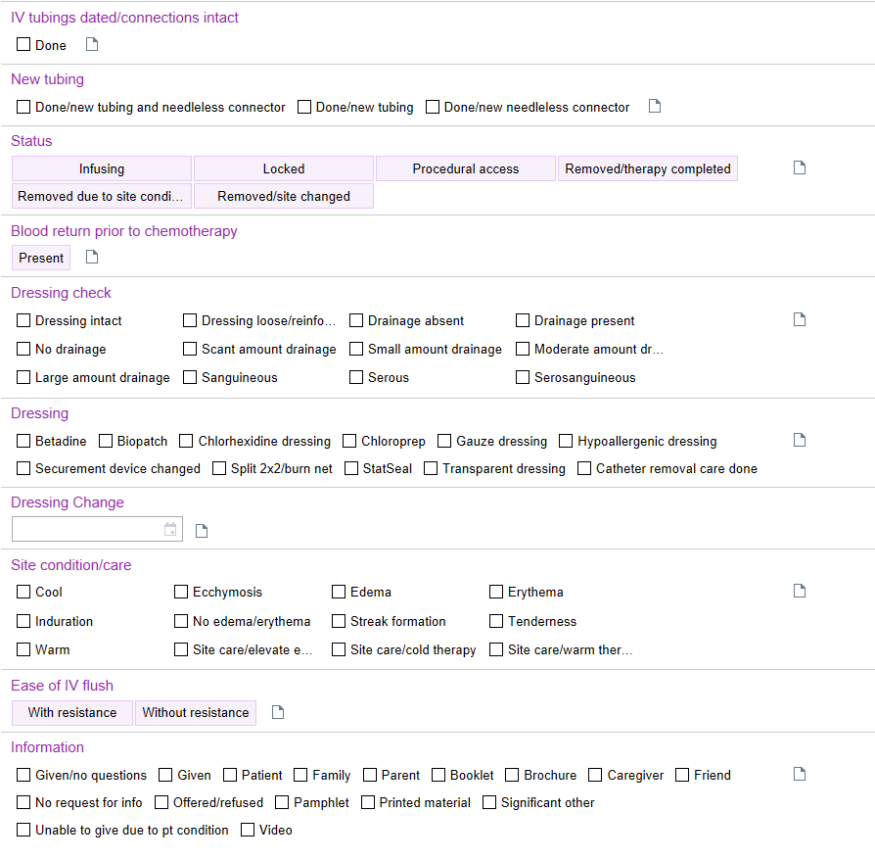
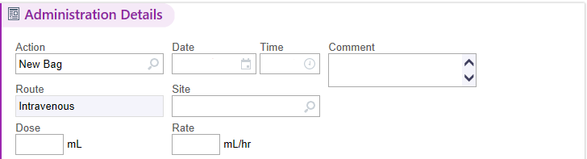
F:/EPIC/Downtime_Procedures/JCHC Med-Surg Downtime Forms/IV Documentation (7/21)

