TIME OUT FORM

Pre Incision
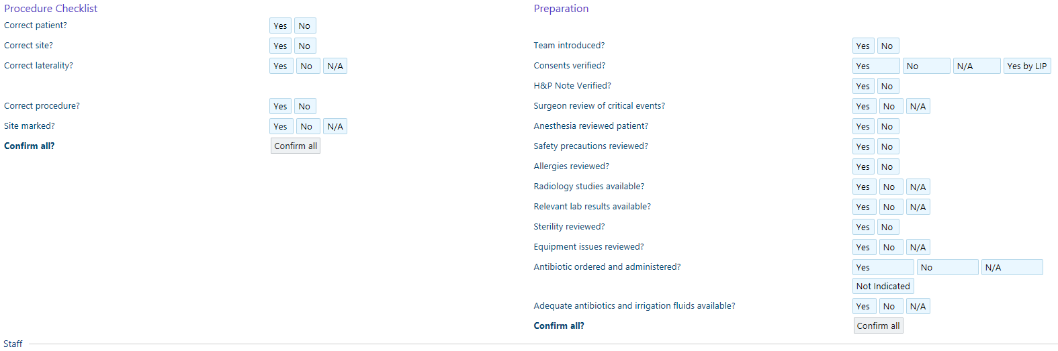

Pre Procedure
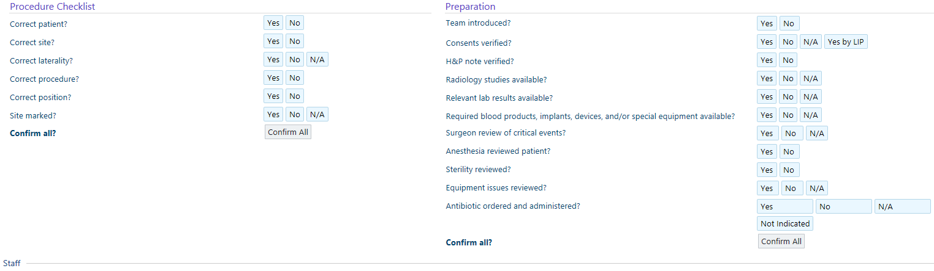

Fire Safety
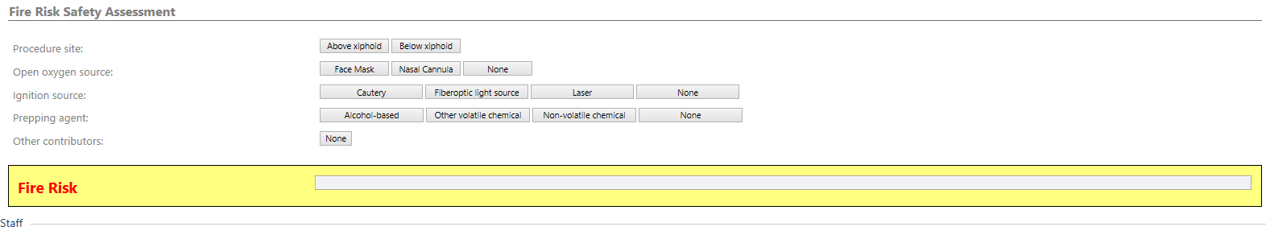

Sign-In
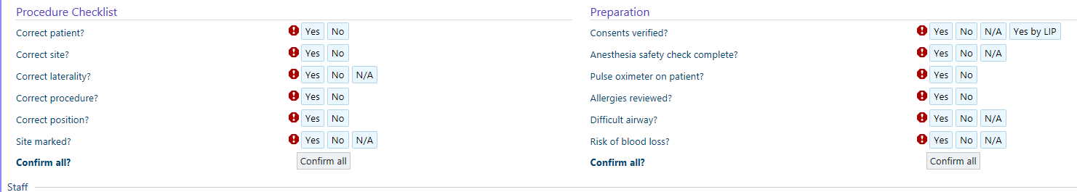

Sign- Out
