ESI pre-op call downtime sheet
- Review with Pt.
  - History
  - Allergies
  - Meds (see list of blood thinning meds to avoid/stop taking)
- USE Pre/Post procedure call (half sheet) for documentation of call in addition to information below.
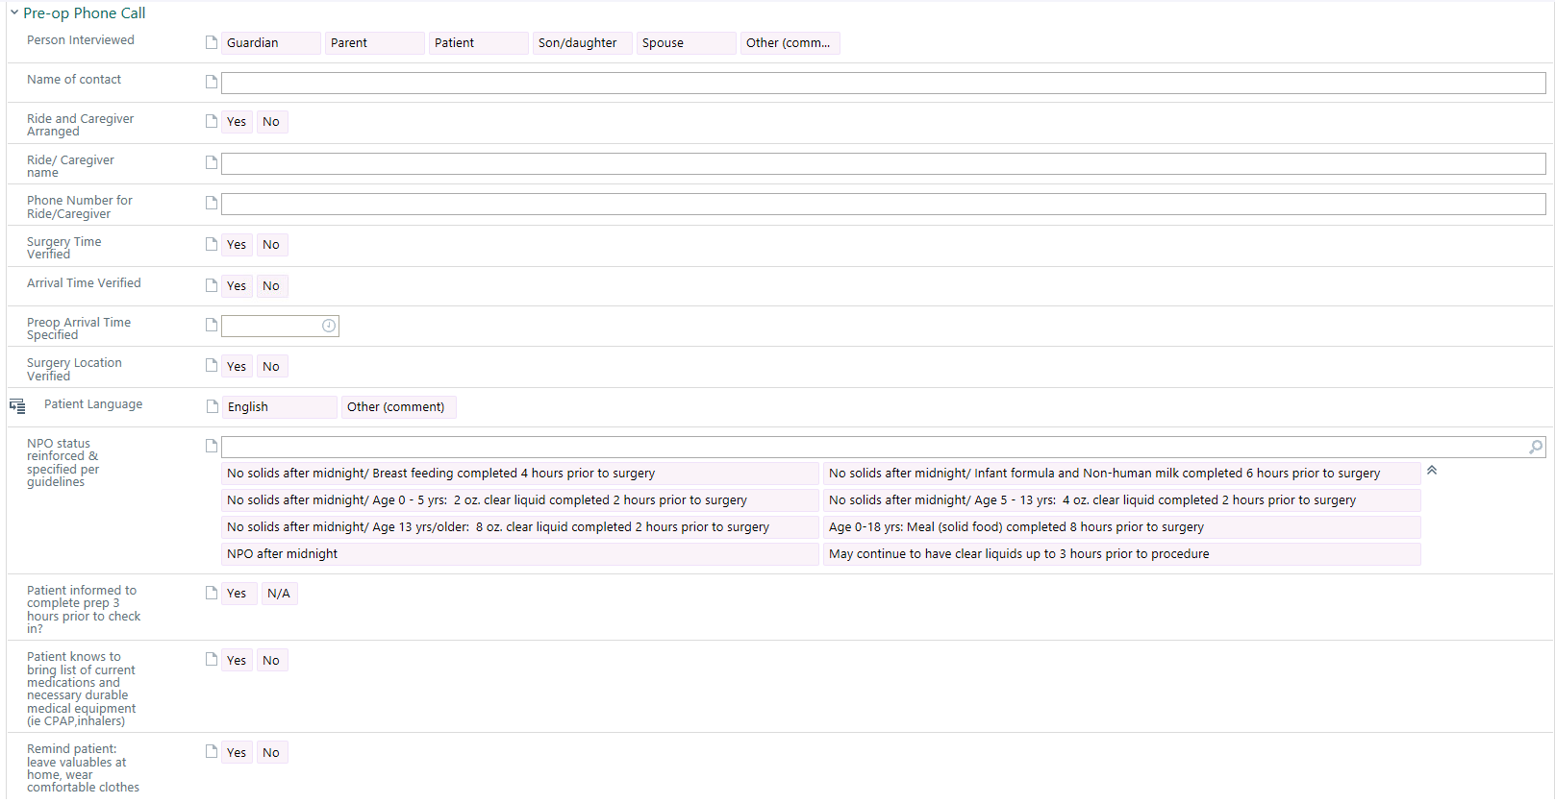

Place this and form and pre/post procedure call (half sheet) with pt. chart. Information can be entered into EPIC prior to pt. procedure if computers running again and time permits. Otherwise it needs to be scanned into the pt. record so favailable for viewing at the time of patient’s actual procedure.

F:/EPIC/Downtime_Procedures/ACU-OR Downtime Forms/ESI downtime pre-op call sheet (6/21)

