Affected Departments: JCHC Operating Room

Purpose(s) / Objective(s):
To help workflows with downtime procedures
Note: -If JCHC has internet availability- can still access Netscaler- follow Netscaler instructions
Double click on Epic Netscaler icon on desktop
Log in using your regular Epic login information
-If JCHC has no internet availability then follow this downtime procedure

Procedure(s)/Documentation:
- Case Requests
- Scheduled surgical patient (arrived before downtime)
- Look for printed/written case request form in paper chart
- Use preference card that was used to pull case from day before to keep track of supplies.
- Unscheduled surgical patient
- Look for printed/written case request from in paper chart
- Get the appropriate preference card from downtime forms binder.
- Make a copy of preference card
- Pull Case
- Use this preference card to keep track of supplies
- These supplies will need added back into EPIC once we are live by the circulating nurse. (Note- the case request will have to be entered by Peri-Op scheduler prior to being able to complete this step. Registration will also have to admit the patient before you will be able to update patient charting.)
- Orders
- Signed and Held (Order Sets)
- Specific physician order sets will have been printed in ACU and will be available in the chart for access to Intra-Op and PACU phase of care orders.
- Obtain a blank nurse’s notes form from the downtime forms binder and chart any medications given.
- These medications will need to be added once the system is back up in order to drop charges. The circulator for the case is responsible for doing this.
- If necessary to obtain medication from Omnicell

Add a Temporary Patient in Omnicell
If a patient has not yet been added to the hospital ADT system due to downtime or another reason, their name will not be displayed in Omnicell for manual dispensing. You can dispense items to this patient by adding a temporary patient as described here.
- First sign into Omnicell.
- Press patient care if not already there.

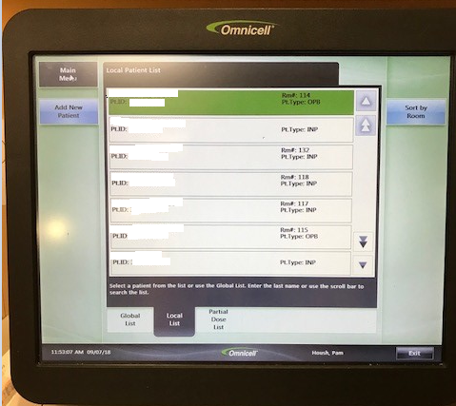

- Press Add New Patient.
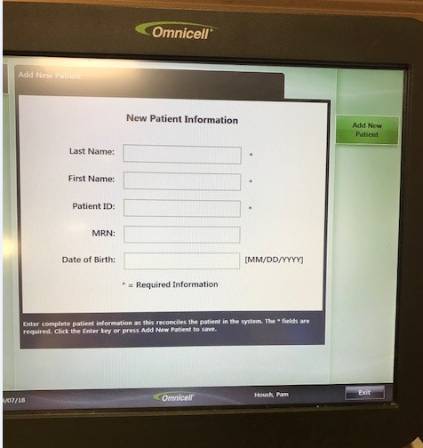

- On the Add Patient screen, enter available information.
Last name, first name, and temp(orary) patient ID entries are required, as indicated by the caution symbols on these fields. Press the caution symbols to display additional information.

- When required entries are complete, press Add New Patient to arrive at the screen where meds can be retrieved. The stocked meds tab will need to be used.

- PACU orders
- Obtain PACU orders from downtime forms binder and have CRNA fill out and sign.
- Obtain a blank nurse’s notes form from the downtime forms binder and chart any medications given.
- These medications will need to be added once the system is back up in order to drop charges. The circulator for the case is responsible for doing this.
- Place the signed order set in the patient chart. This original paper copy will be put with the rest of the chart in the HIM wire basket to be scanned in by them.

- Radiology
- JCHC standard order form – can be found in red downtime forms book.
- Hand write order and have it signed by physician
- Call 4154 to notify Radiology they are needed in ACU
- Radiology will come and complete test
- Place original order with chart in HIM basket to be scanned by them

- Lab
- JCHC standard order form – can be found in red downtime forms book.
1. Pathology and culture orders will have to be written on this form under “other”
- Send paper order to lab
- Lab will call result or send printout from machine
- After EPIC is back up, ACU/OR staff will need to go back and enter the order and when it was collected into the EHR.

- Pharmacy
- Automated dispensing cabinet not functioning
- ACU/OR will call pharmacy to medications needed if the automated dispensing cabinet is down during business hours.
- Another option is to use Emergency Department or MedSurg dispensing cabinet if one of those is functional.
- If outside of pharmacy hours and no automated dispensing cabinet is functional contact pharmacy manager to assess the situation and provide needed medications during the downtime.

- If outside of pharmacy hours and no automated dispensing cabinet is functional contact pharmacy manager to assess the situation and provide needed medications during the downtime

- Documentation- Go to the downtime forms binder and obtain:
- Surgical Consent (if not already obtained in ACU, MedSurg or ER)
- Fill out Consent to operation, anesthetics and other medical services found in downtime binder.
- Confirm procedure description with ordering surgeon.
- Surgeon will sign and date this form.
- Obtain signature from patient prior to procedure.
- Place original paper copy in chart to go to the OR with the patient.
- This form will stay with chart and be placed in wire basket for HIM to be scanned in by them.
- Anesthesia Consent (if not already obtained in ACU, MedSurg or ER)
- Anesthesia provider will obtain Informed consent for anesthesia sedation analgesia form from downtime binder.
- CRNA is responsible for filling out this form and obtaining patient signature.
- CRNA provider will sign and date.
- Place original paper copy in chart to go to the OR with patient.
- This form will stay with chart and be placed in wire basket for HIM to be scanned in by them.
- Time out forms- Note: Once Epic is back up the circulating RN will need to complete time out in EPIC in order for quality data to pull to reports.
- Fire Safety
- Pre Incision or Pre Procedure
- Sign In
- Sign Out
- Peri-Op Nurse Forms:
- OR Nurse’s Notes
- Surgical Site infection study
- Blank Nurse’s Notes- for orders and narrative as needed
- Count sheet
- Charge sheet
- PACU record
- Blank Photograph page - as needed
- Anesthesia Forms:
- Anesthesia Record
- Anesthesia Quality/Appropriateness form
- PACU order form for CRNA have provider fill out and sign
- Physician Forms:
- Internal Providers
- Obtain provider post op orders and OR dictation template from downtime forms binder and have physician fill out and sign.
- Place original paper copy in HIM wire basket to be scanned in by them.
- External Providers
- Obtain post op order sets and have physician fill out and sign.
- Place original paper copy in HIM wire basket to be scanned in by them.
- Will dictate post procedure as normal.

- Fill out all appropriate forms for current case. Note: Will have to hand write patient identifiers on all pieces of paper.
- Patient Name
- Date of Birth
- Date of Surgery
- MRN if available
- Get Ariel instructions from Staci on how to print labels.
- Paper clip all forms together and place on empty desk in Peri-Op scheduler’s office. Note: Once EPIC is back up we will enter necessary information PRIOR to sending patient chart to HIM to be scanned in. The circulating RN will be responsible for completing this for all cases circulated during downtime.

Additional Info:

Related Form(s):

Resources:

